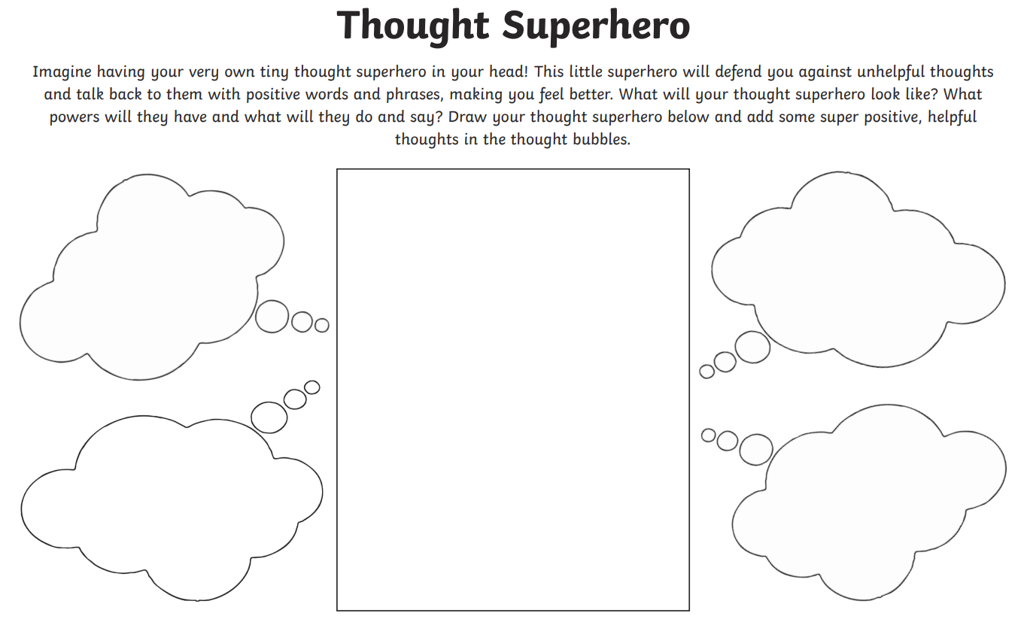
Tuesday 5th October
Helpful and Unhelpful Thoughts

