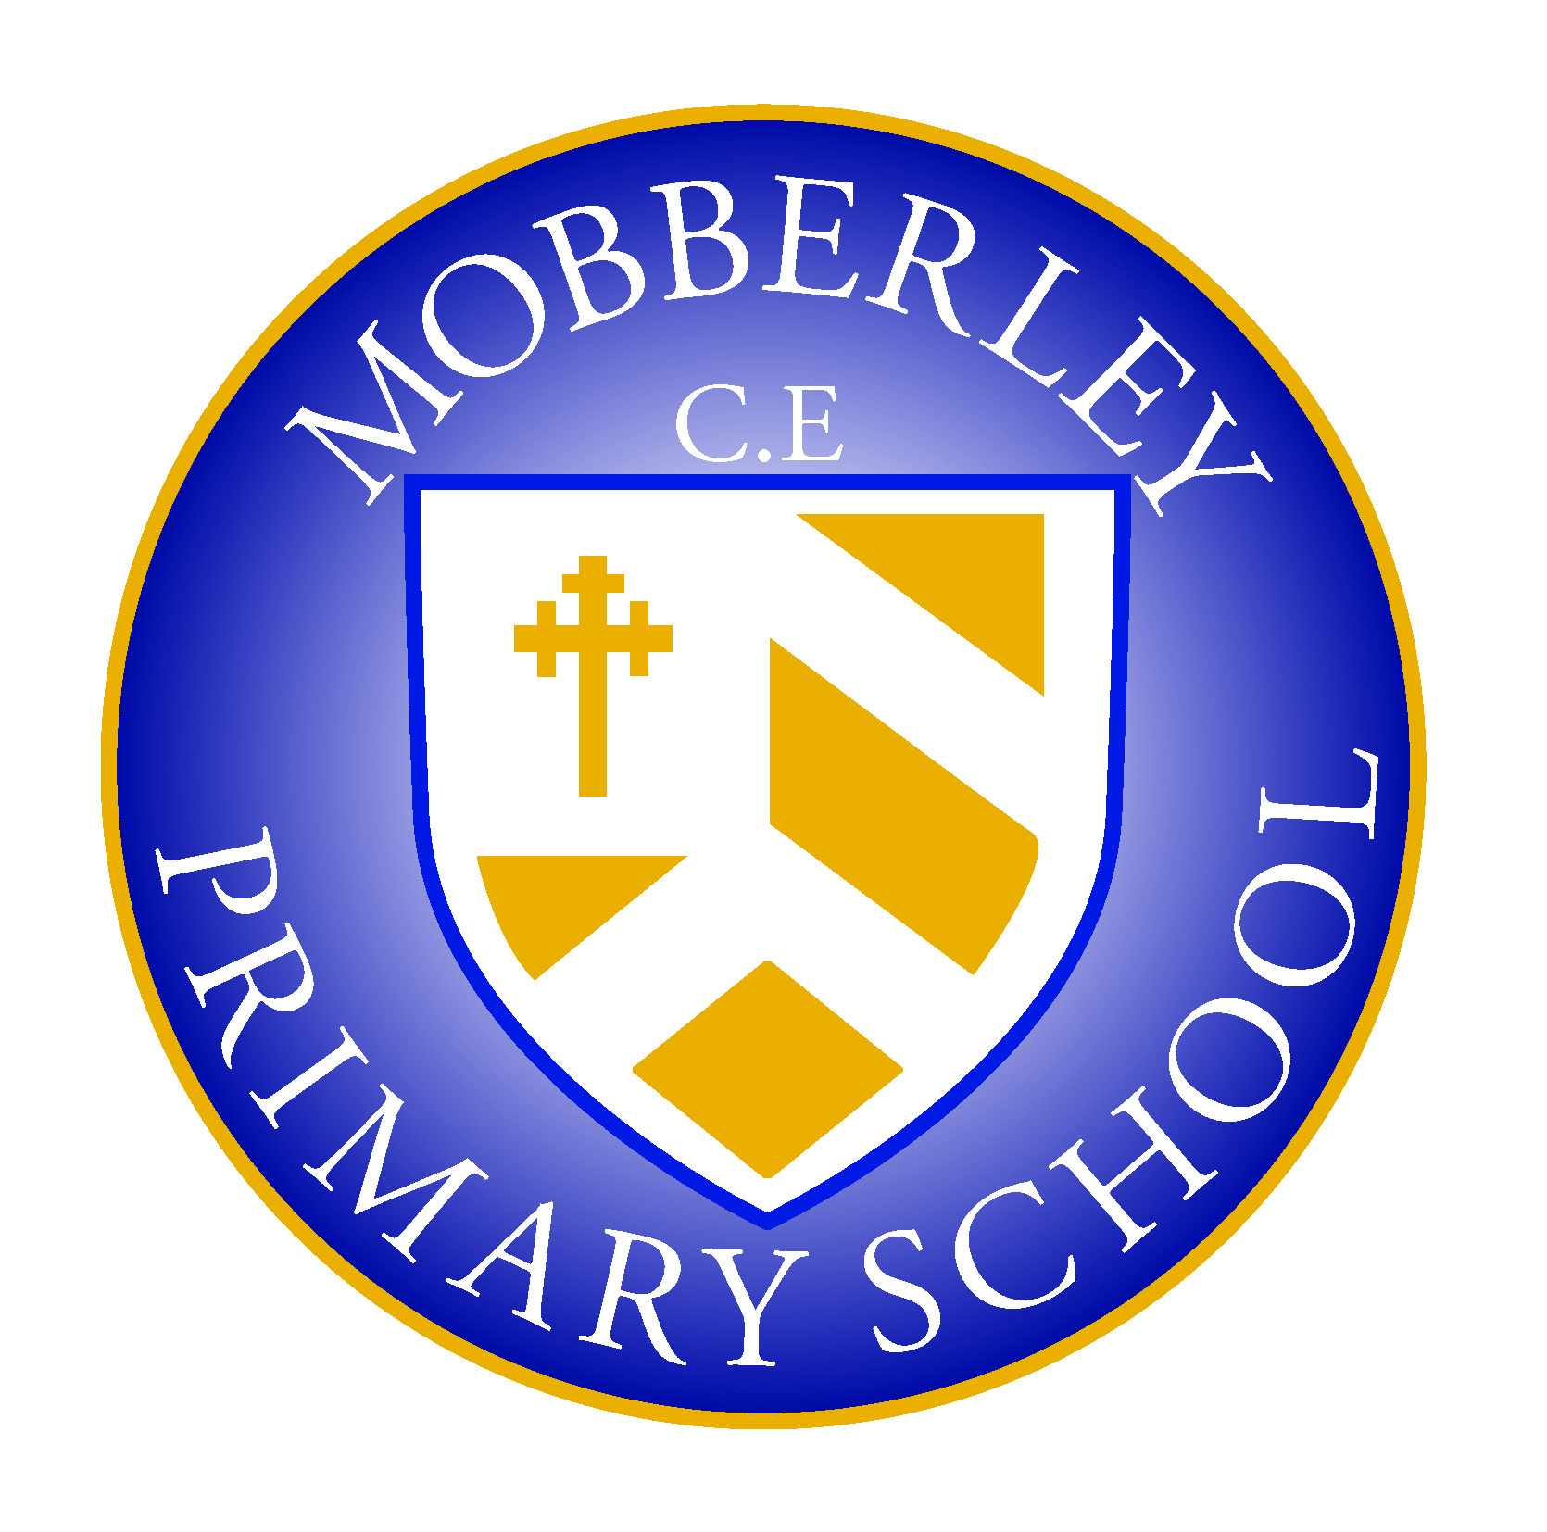
Staff Protocols - Whole school re-opening (Sept 2020)

The following protocols for staff are directly related to DFE guidelines and Public Health advice. These protocols MUST be read and followed in conjunction with this national advice.

Whilst aimed to make daily operations more explicit and easy to follow for all staff, it is vital that each staff member also understands that the following list of protocols is supplementary to the advice outlined by the DFE. It does not replace it or capture every detail. It is expected that all staff are aware of these guidelines and have a responsibility for following them.

https://www.gov.uk/government/publications/actions-for-schools-during-the-coronavirus-outbreak/guidance-for-full-opening-schools

- Clinically Vulnerable groups of people will not need to shield after 1st August 2020. However, if up to date medical advice recommends further shielding in autumn for an individual, they should remain working from home if at all possible. If any staff receive medical advice to shield from September, the member of staff must inform the Headteacher or SLT team leader immediately so provision can be arranged.

- The above is also relevant for pupils too. If, up to date medical advice recommends a child needs to continue to shield, they should NOT attend school.

- No visitors/staff/children/families/contractors can enter the building if they have symptoms. A record must be kept of all visitors through the school’s sign in procedures.

- All non-essential visitors to school, e.g. non-essential maintenance, reading volunteers, etc. have been asked not to visit and should not be on the premises.

- Groups of children (or ‘bubbles’) will not mix together or come into contact with each other for the vast majority of the school day if at all possible. Guidance states that schools should ‘not look upon this as an all or nothing approach’ but instead, aim to minimise the potential for bubbles to mix. Procedures at Mobberley will be put in place to ensure that this potential is indeed minimised.

- Guidance states that all staff can operate across different classes and year groups in order to facilitate the delivery of the school timetable if necessary. This is particularly relevant for school staff that deliver PPA or support with SEND provision across the school.

- Where staff need to move between classes and year groups, they should try and keep their distance from pupils and other staff as much as they can, ideally 2 metres. The official guidance recognises that this distancing may not be possible with younger children and teachers in primary schools can still work across groups if that is needed to enable a full educational offer.

- Across England, teachers are now expected to deliver the National Curriculum from Sept. However, Mobberley offers some flexibility in this as we understand that many pupils will have learning gaps in core subjects. Therefore, school encourages focus on helping to fill those missing gaps in the autumn term, but we also encourage teachers to consider how all subjects can help contribute to the filling of gaps in core subjects.

- Mobberley Primary School aims to return to our normal curriculum content by the summer term in 2021.

- Staff must help to reduce movement around the school - groups are to occupy one room during the day where possible.

- School will stagger break & lunchtimes so groups are not mixing together/moving around the school at the same time. This will be communicated and reviewed regularly through direct conversations and negotiations with relevant staff. All changes will be documented and circulated to all.

- There will be no group gatherings, such as assemblies. In the first instance, larger group teacher/staff meetings will not take place. Smaller team meetings may be possible in socially distanced groups.

- School will have a 20-min window for Morning drop off and will have a staggered collection time. A one way system will be observed with social distancing of parents at all times.

- At drop-off and collection times –adult to adult contact needs to remain minimal with parents remaining at a safe distance. Parents will not be allowed in the school building.

- All pupils will need to clean their hands/receive hand gel on arrival and be encouraged to maintain safe hygiene practices throughout the day.

- Playtime equipment should not be used by other groups. Each class should have their own ‘bucket’ of equipment that they alone use.

- Sports lessons should take place outdoors if at all possible and each year group should use a set of equipment exclusively. If more than one year group needs to use a specific piece of equipment, it must be cleaned thoroughly between year group usage.

- Classrooms should remain tidy and clutter free. Any unnecessary items can be removed and stored elsewhere in the school or out of the way in rooms.

- Older pupils should also be encouraged to maintain distance wherever possible and not touch staff and their peers where possible. Official guidance states that they know that this will not be possible for the youngest children and some children with complex needs. Social distancing of any sort is not possible in EYFS and will not be attempted. Other hygiene measures will be in place to minimise transmission risks.

- To support distancing, teachers should seat pupils side by side and facing forwards, rather than face to face or side on.

19. School will advise that only 1 parent/carer can escort a child to the school gate at drop off.

- The same staff will be asked to work with their groups as much as possible.

- Hand sanitiser and extra cleaning equipment will be available in all classrooms. Class teachers must ensure that tables/chairs are wiped down at the end of the morning/afternoon sessions. Support staff must ensure that ‘high impact areas’ are cleaned down after morning break/dinner break/half way through the afternoon. Cleaning staff/Caretaker will ensure that all areas are cleaned at the end of the school day.

- The ‘catch it, bin it, kill it’ approach will be promoted in classrooms. Boxes of tissues will be made available in classrooms and bins will be emptied regularly. Classroom bins now have lids to ensure safer storage of rubbish and materials.

- Doors can be propped open safely by using door wedges. Rooms will need to be well ventilated. Windows to be open.

- Children and staff to walk (wherever possible) down the left hand side of the corridors, making way to allow others to pass when necessary. Corridors have been maker out to aid this ‘zoning.’ The need to pass others in the corridors should be minimal due to these restrictions being in place.

- Staff supervising break times should ensure that children don’t gather at the toilets. Allow only one child per toilet visit if possible (but with a common sense approach). Encourage every child to follow safe hand washing rules after each visit and periodically throughout the day. Guidance advises that toilet blocks do not need to be blocked off for individual bubbles, as long as they are regularly cleaned.

- Outdoor learning is encouraged wherever possible. However, groups from different year groups or bubbles should not mix and times outdoors, such as play time and lunch, will be staggered. Playgrounds will be split in two to help keep groups separated. Break times will be communicated and reviewed regularly by conversation with relevant staff. Any changes will be put in print and circulated to all staff.

- Outdoor equipment/apparatus/play equipment/climbing frames can be used but must be cleaned daily.

- During the first half term, all children will have lunches in classrooms. Packed lunches will be brought to the children in their classrooms by Mid-day staff.

29. Staggered lunches and breaks will mean that the use of the staff room will also be limited for staff. The hall is a larger space with better ventilation and staff can use this for breaks. Staff have a responsibility to continue safe distancing measures when using shared areas.

- Children should have their own individual stationary which should be used for personal use only. Classroom based resources can be shared within the group/bubble as long as they are also cleaned regularly. Staff should use individual class cleaning books if additional focus is needed on ensuring particular resources need extra cleaning.

- Shared areas and surfaces need cleaning daily, and disinfected/bleached frequently. They form part of the school’s daily cleaning schedule and will be thoroughly cleaned by the cleaner/caretaker.

- Official guidance states that ‘pupils and teachers can take books and other shared resources home, although unnecessary sharing should be avoided, especially where this does not contribute to pupil education and development. Similar rules on hand cleaning, cleaning of the resources and rotation should apply to these resources’.

- If anyone has a cough/temperature/feels unwell/loses the sense of taste or smell at school, they must be sent home. They will need to self-isolate and be tested as per the PHE advice. If any child or adult within a bubble is tested positive, the whole bubble will be sent home to isolate for the advised amount of time.

- Official advice says there is no need for PPE to be used as standard in classrooms – face coverings for things like intimate care needs (non-symptomatic of Covid -19) would only be worn where it would be normal practice to do so. However, PPE should be used by staff that are supervising children that are ill and showing symptoms in school while we wait for parents to collect. PPE is available in school for this purpose.

- If a child is waiting to be collected, they should be kept:
- Outside in the first instance (if dry), on a chair and supervised from a distance until parents collect
- Inside in the KS2 shared area (if wet), on a chair and supervised from a distance until parents collect with windows/doors open to aid ventilation.

If this child/adult needs to go to toilet before being collected, they should use the disabled toilet on the main corridor and this must be thoroughly cleaned/disinfected afterwards before anyone else can use it. If the cleaner/caretaker is not available, the toilet should be closed until it can be cleaned.

- If positive cases of Covid-19 are confirmed at the school, then Public Health England will advise the SLT/school on next steps/possible closure.

- It is a requirement that schools have a contingency plan in place to provide remote learning to pupils in the event of a small group needing to isolate (or school closure). Teachers will be expected to provide work where appropriate for them to do so (in the same format as weekly learning packs provided in the Spring term).

- In the autumn term, there will be no school trips planned. However, it is hoped that trips can take place after Christmas, as long as official guidance is followed and they are robustly risk assessed (as in RA as normal and RA for infection control etc.). There is no expectation or encouragement at this stage for any staff to plan additional trips out for any point in the year until the situation becomes much clearer throughout the term.

- In the first instance, there will be minimal extra-curricular clubs facilitated until a period of evaluation and further planning. Only three extra-curricular clubs will operate – Digital wizards (Fri 8-9am), WFA Wed (3.30-4.30pm) and Progressive Sports Mon (3.30-4.30pm.) Clubs will operate with just one year group wherever possible. Where the group is large (WFA) steps will be taken to separate groups onto different pitches and minimise interactions. Groups will not exceed 15 in any case. Separate spaces for registration and dismissal have been put in place.

- After-School Club will operate from two bases, i.e. The hall for older children and the Rec classroom for younger children. Again, spaces will be divided to minimise interaction and each group will not exceed 15 in any case. Additional supervision and cleaning has been put in place for each base. Parents collecting will use two exit points, i.e. the Hall door and the infant playground. A one-way system and social distancing should be observed at all times.

The above guidance supports official advice of minimising contact ‘wherever possible’. The guidance makes clear that adults can work across bubbles (PPA, SEN support) but Mobberley will aim to minimise this as much as possible. Through the above protocols, the school aims to facilitate that the vast majority of staff will only need to operate within their own bubble.

