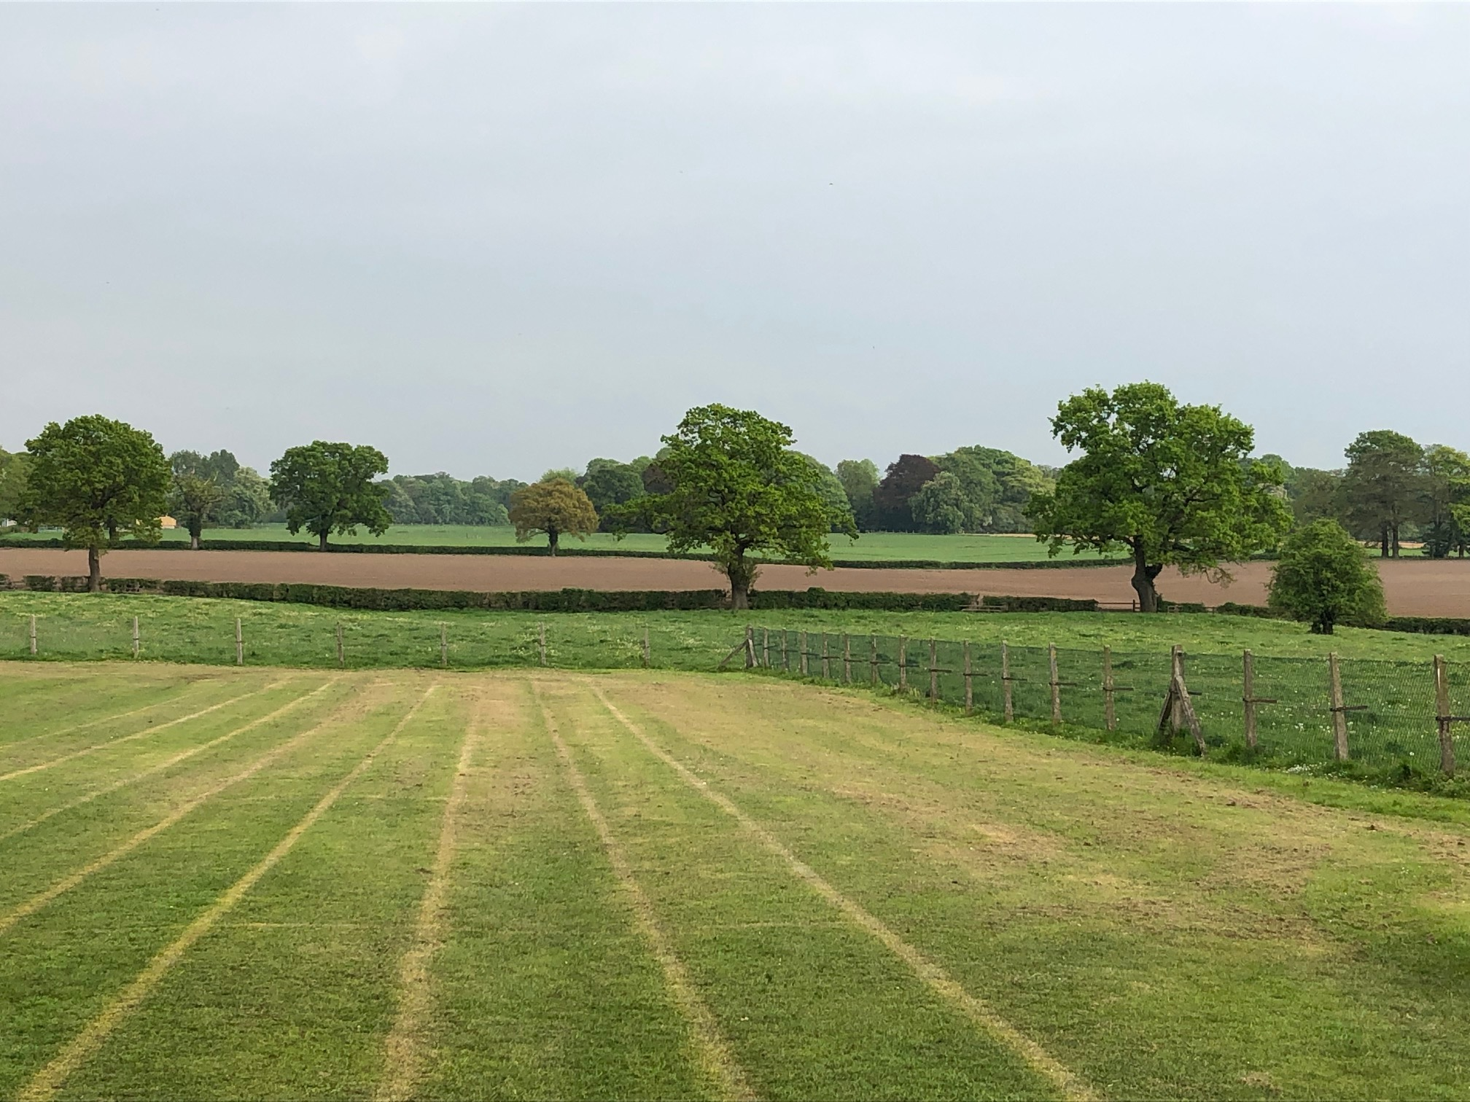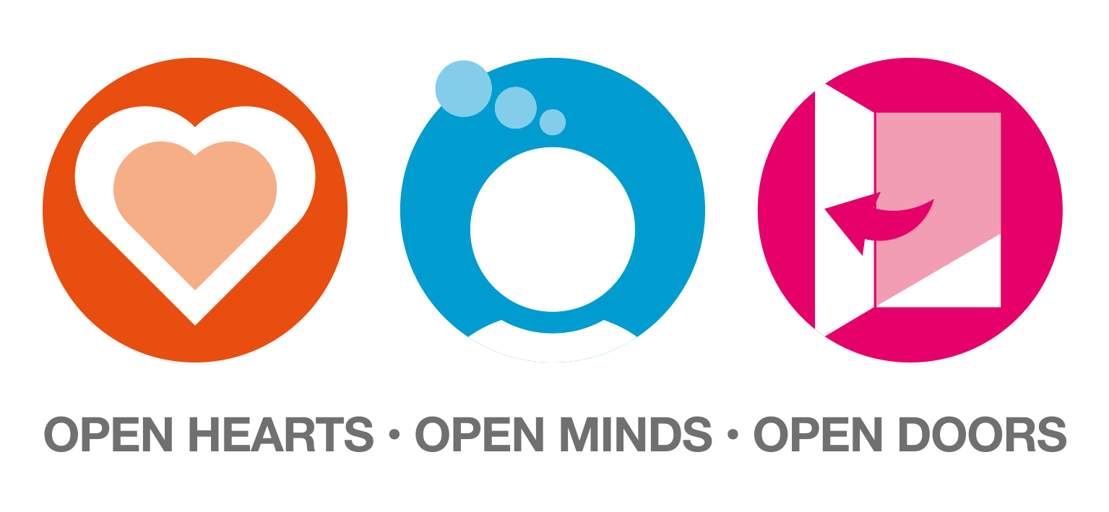http://www.alderleyedgecp.cheshire.sch.uk/Images/bsa.gif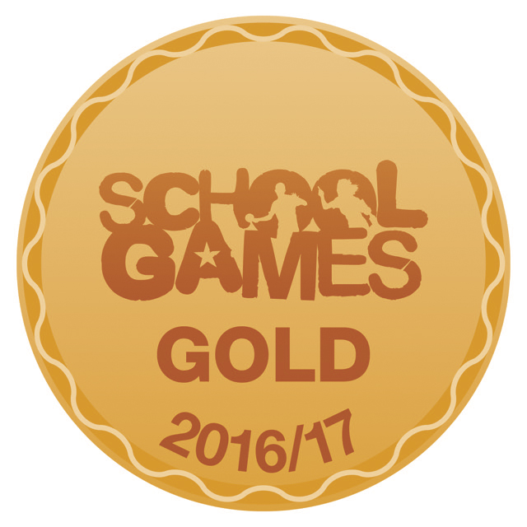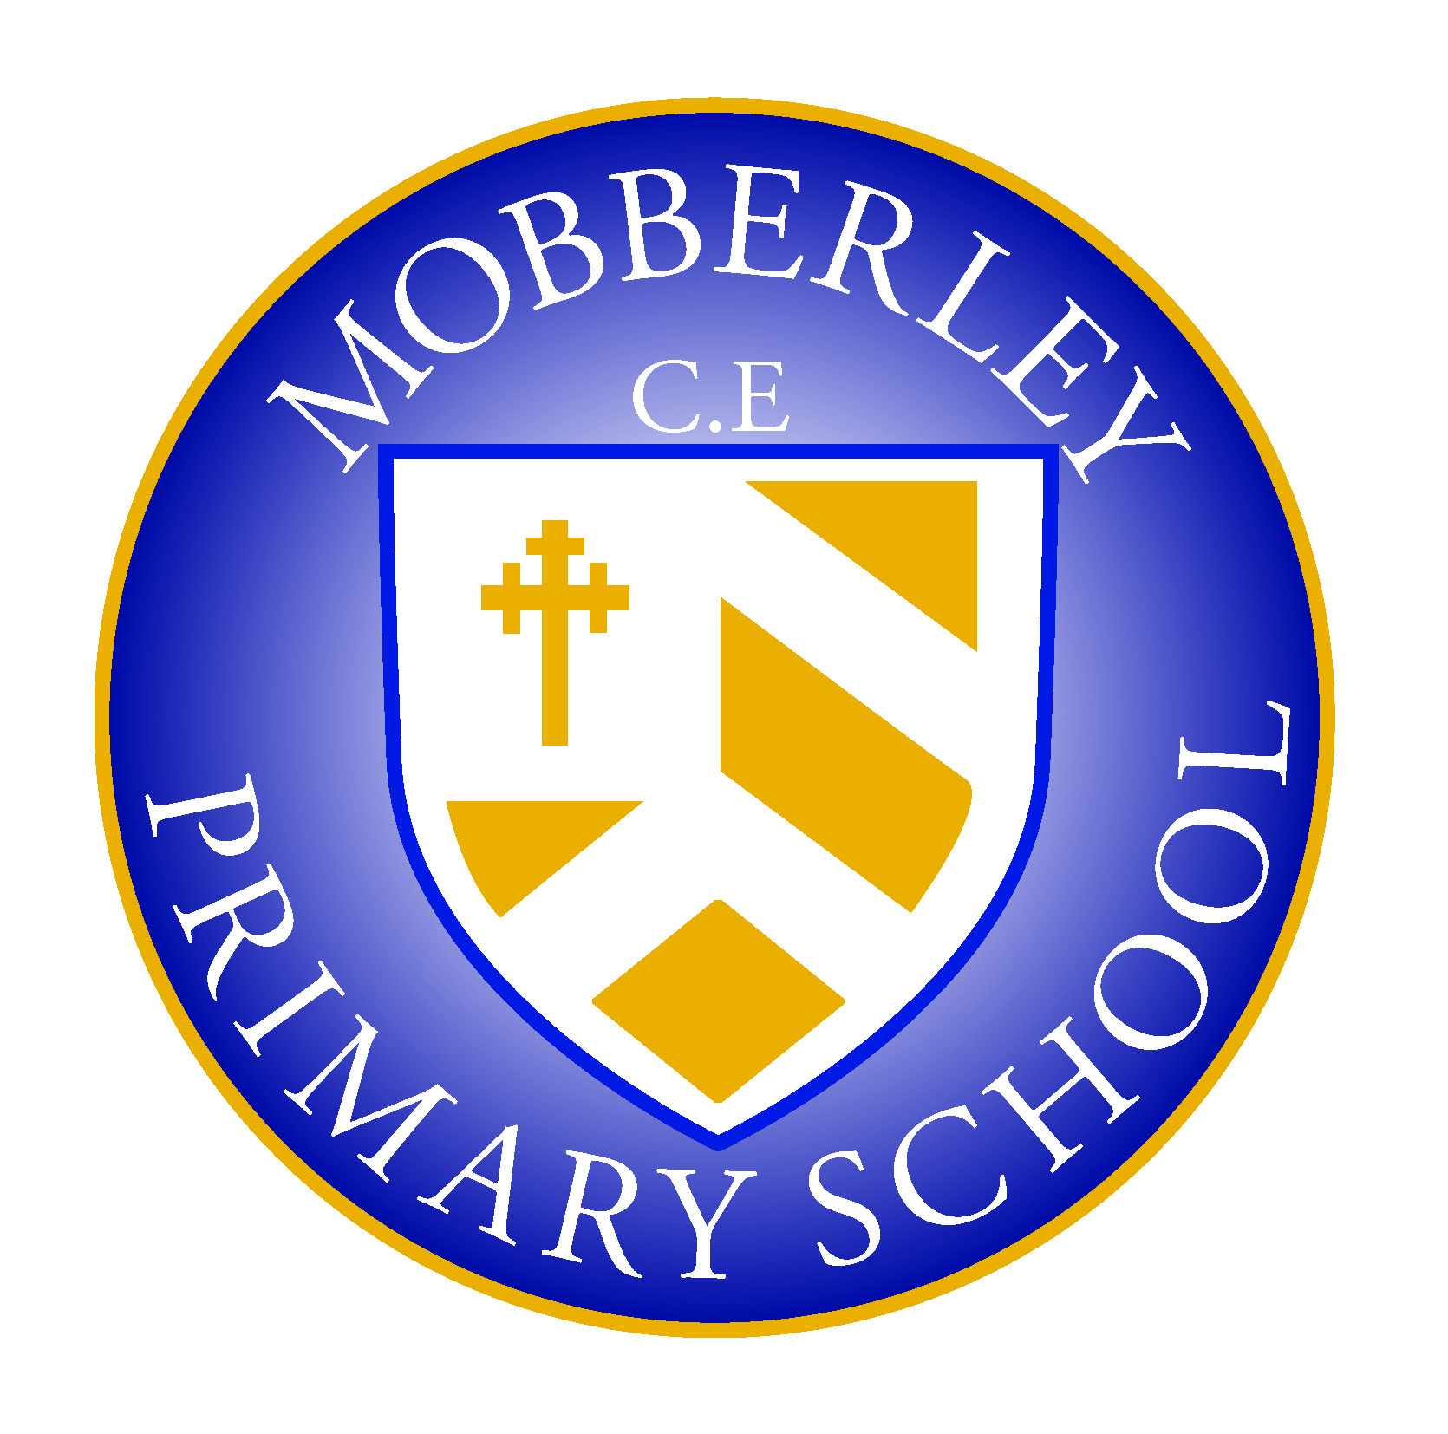

MOBBERLEY CHURCH OF ENGLAND PRIMARY SCHOOL

Church Lane, Mobberley, Cheshire, WA16 7RA

Headteacher: Mr D Stenson B.Ed NPQH

T: 01625 383055 • E: [admin@mobberley.cheshire.sch.uk](mailto:admin@mobberley.cheshire.sch.uk) • W: www.mobberley.cheshire.sch.uk

**Covid-19 Protocols for Parents / Carers on Whole School Re-Opening (Sept 2020)**

The main priority for Mobberley School is to keep all of our children and staff members safe. Therefore, it is important that all families understand and follow some important points. The following protocols and advice for parents and carers is directly related to DFE guidelines and Public Health advice. They **MUST** be followed by all families:

**Important points:**

* If anyone has a cough/temperature/feels unwell or has a loss of smell or taste in your family, your children should NOT be sent to school. If children show symptoms they will be sent home immediately and they will need to self-isolate until they are tested. Parents or families **MUST** be available to collect children if this happens.
* You **MUST** inform school of your most up to date telephone number if you have changed it.
* If a member of your child’s group (or bubble) is tested positive for Covid-19 then all the children in that group will be sent home to self-isolate for 14 days.
* School Drop-off will now take place during the **8.40-9am** window. All siblings can arrive together and enter via the infant/junior gates. The one way system should be observed.
* Pick-Up will now be **3-3.15pm** for Rec, Y1 and Y2 from the infant gate. Y3, Y4, Y5, Y6 will be from **3.15-3.30pm.** Any parents with infant/junior siblings should collect all children **after 3.15pm.** Please observe the one way system and social distancing on the approach to school.
* At drop-off and collection times –adult to adult contact needs to be minimal. You will need to remain at a safe distance (we still encourage a distance of 2 meters) when collecting and dropping off your children from the school staff and from other parents. School will have floor marking to help you with this, much the same as supermarkets and shops.
* Parents must not crowd around gates, doors and entrance ways. They must maintain a safe distance.
* Only 1 parent or carer should escort a child to school.
* Parents will not be allowed into the office or main school building at this stage of reopening.
* Parents should only bring to school the children from their households and not the children of family or friends. Children should only be collected by someone from their own household.
* The Government has made it clear that they expect councils to fine parents who keep their children at home if there is not a genuine health reason or illness.
* Additional cleaning takes place throughout the day to ensure classrooms, toilets and ‘high impact’ surfaces are kept clean and hygienic.

**When your child is in school:**

* Children are not required to wear face coverings.
* Older children will still be encouraged to socially distance wherever possible. Seats and desks will be arranged in order to help social distancing measures.
* For younger children or those with specific additional needs who may find distancing difficult, the emphasis will be on limiting the number of potential interactions.
* Each class of children, or ‘bubble’, will be kept apart from others. Wherever possible, they will not mix together or come into contact with each other. Therefore, playtimes and lunch times will be staggered at different times for your children throughout the day.
* Pupils in groups will largely occupy one room during the day. Movement around school will be limited to only essential trips.
* As a result of the above, school will not be conducting assemblies or group gatherings such as Hymn Practice during this time.
* If there is a shortage of teachers available in school, a teaching assistant or supply teacher can still lead a group. The official guidance explains that this is appropriate in schools if necessary.
* Teachers will teach the National Curriculum. In the autumn term, they will focus on teaching the gaps in the curriculum your child will have missed, especially in English, Maths and Science.
* All pupils will wear uniform apart from PE/Games days when sports kit will be worn
* Expectations of behaviour will be high. If your child refuses to follow safety rules in school, we will need to contact you as parents/carers.

We understand that this time may be worrying for you. It is for all of us too.

However, please rest assured that, as a school, we are doing everything we possibly can to ensure the safety of your families and our staff. This goes further than what is listed above but we may need to add extra measures as we progress.

We thank you in advance for your support and patience.

Sending best wishes at this time,

From all of the team and Governors at Mobberley Primary School