Splatter Painting
Splatter painting is so much fun I'll show you how with step by step instructions and photos. It is a very messy craft though so make sure you cover up nearby furniture and the floor.
You will find instructions and pictures on how to achieve the different effects below. A toothbrush gives a nice fine splatter and a large paintbrush will give you big blobs of colour.
I had fun experimenting with various splatter painting techniques each one giving very different results. Make sure you are wearing old clothes as the paint will go everywhere!

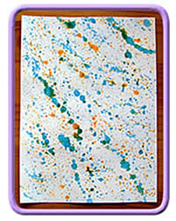

Materials and Equipment
- Paint (any water based paint can be used)
- Small containers for watered down paint
- Water
- Toothbrush
- Paint brushes in different sizes
- Blunt knife or flat edged tool
- Drinking straw
- Paper or card
- Lots of newspaper or plastic table cloths to protect table and furnishings
- Old clothes or apron

Top Tips
This is a great project to do outside on a sunny day.  The painting will dry quickly in the sun and the children can make as much mess as they like without a big clean-up job.  If you have to be inside then you will need to find somewhere to leave the paintings to dry. | 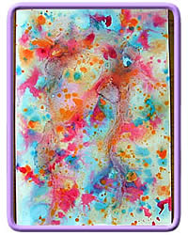  442
If the paintings are very wet they will need to be left flat to dry or the paint will run.

Splatter Painting Tutorial
There are lots of ways to splatter paint onto paper. Here I show you five different methods which all give different results. All of them are messy, though some more than others. This is such a fun activity and an easy way to produce some brilliant paintings.

Using a Drinking Straw
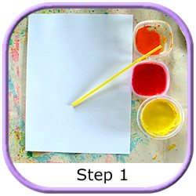 | Mix up your paint so they are quite watery.

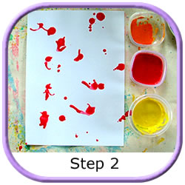 | Dip the end of the straw into the paint.  Put your finger over the end of the straw and move the straw over the paper.  Make blobs of paint on the paper and blow through the straw moving the paint around.

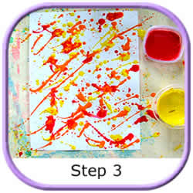 | Keep adding more colours.  The long lines were made by flicking the straw  as I took my finger off the end.

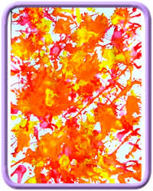

Using A Toothbrush
Mix the paints as above and dip the toothbrush into the paint.  Hold the toothbrush close to the paper and angled so the paint will splatter onto the paper.  Pull the knife or flat tool across the bristles of the toothbrush. | 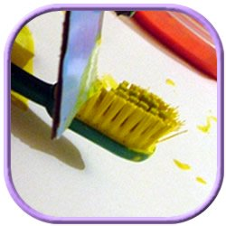
Experiment by adding more or less water to the paint or holding the toothbrush closer or further away from the paper.

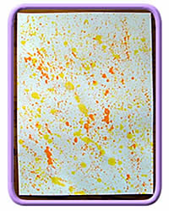

Using A Small Paint Brush
Mix the paints as above and dip the paint brush into the paint.  Hold the paint brush over the paper and tap it onto another paint brush so that the paint splatters onto the paper. | 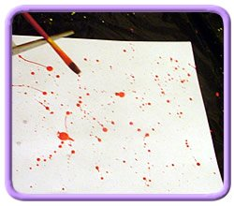
Experiment by adding more or less water to the paint or tap the paint brush gently or sharply for different effects.

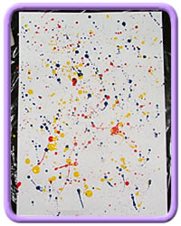

Using A Large Paint Brush
Mix the paints as above and dip the paint brush into the paint.  Hold the paint brush over the paper flick the paint onto the paper.  Experiment by adding more or less water to the paint or flicking the paint brush gently or sharply for different effects. | 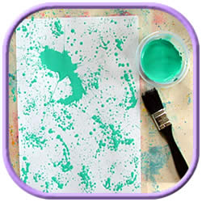

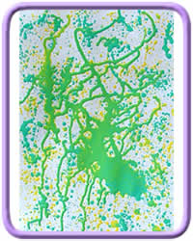

Using Wet Paper
Get the paper wet by either brushing water over it with a clean paint brush or immersing it in a bowl of water and letting the excess drain off.  Choose one of the techniques above to apply the paint.  Experiment by adding more or less water to the paint or paper. | 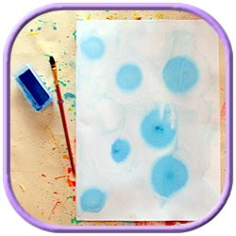
The wet paper will cause the paints to spread out and will soften the patterns.

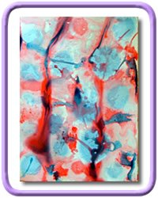

Craft Ideas
You can make your own homemade gift tags using your paintings.  If you have done your painting on paper but would like to make it into a gift tag it's easy.  Cut out the best bits of your design and glue onto a piece of card. | 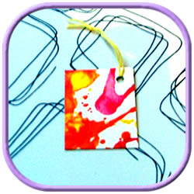
Once dry stack them together with a plain piece of paper between each one.
Place them beneath a pile of books or something heavy to flatten them.

