June 2020
SC – I am beginning to understand what makes a place special to Christians.
Look at the pictures and photographs of different churches and talk about what we might see, hear and feel if we went inside a church. Think about St Wilfrid’s Church as a special place in our community.
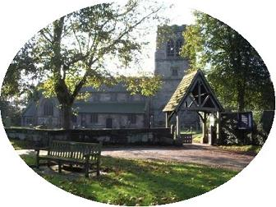
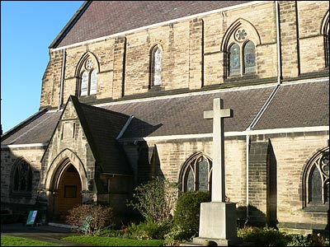
St. Wilfrid's Church, Mobberley

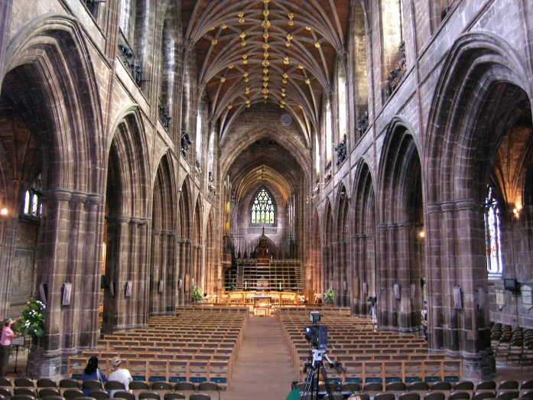
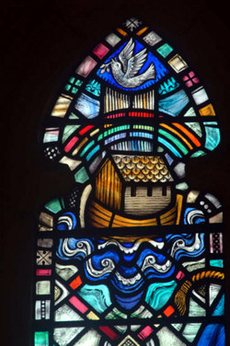
Inside Chester Cathedral Stained Glass Window

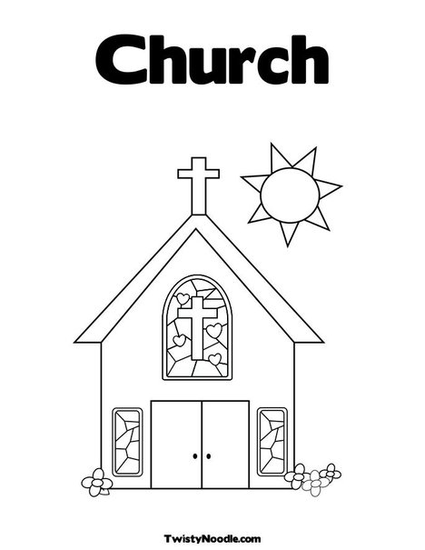
Church is a very special place to Christians.
Write some words to show how you feel when you go in to a Church.

