How waterproof is it?
This activity is great for learning about properties of materials, particularly how waterproof they are. It could be a bit messy so perhaps best to try in the bath or outside.
We’re going to test some materials and find out which have waterproof properties.
Equipment
- A container
- Water
- Small soft toys
- Materials to test for example foil, paper, food bag, fabric
- Sellotape
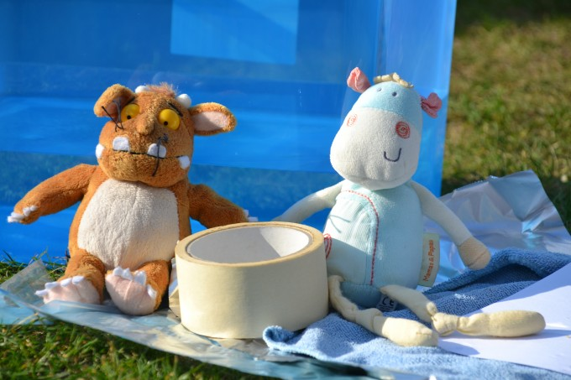
Method
Half fill your container with water.
- Wrap a dry soft toy in one of your materials. Check for gaps where water could seep in.
- Carefully place the wrapped toy in the water for a few seconds.
- Remove the toy, is it dry?
Can you think of things we should try and keep constant for this investigation?
You should try and use the same amount of material for each test and keep the toys in the water for the same amount of time. Can you think of anymore?

How will you tell if water got through the material?
Can you feel the toy? Or could you weigh it before and after?
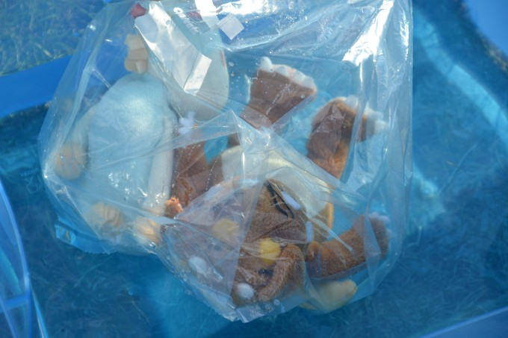
How does it work?
The word ‘material’ just means what an object is made from. Examples of materials are plastic, fabric, metal, wood etc.
Different materials have different properties, which make them useful for different functions. For example, glass is used in windows because it is transparent, we can see through it.
Water cannot penetrate waterproof materials. We would expect the foil and plastic bag to be waterproof, as this is what makes them useful for wrapping food, keeping it dry and protecting from smells. Raincoats often have a plastic coating because plastic is waterproof.
We would not expect the tea towel to be waterproof as tea towels are absorbent which makes them great for drying dishes.
Can you think of any natural waterproof materials?
Rubber and wax are examples of natural waterproof coatings that are used to make materials waterproof. Leaves often have a waxy coating to protect the leaf and help it retain water.
Can you think of anymore?
Have lots of fun experimenting!!

