Easter Colouring Competition Results

Congratulations to:

Nat Kirkwood in Year 2 and Poppy Wheatley in Year 4!

Fantastic effort!

I will give out prizes, once we are back in school.

Our winners:

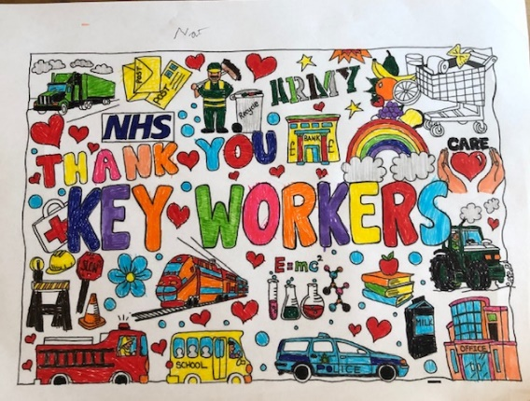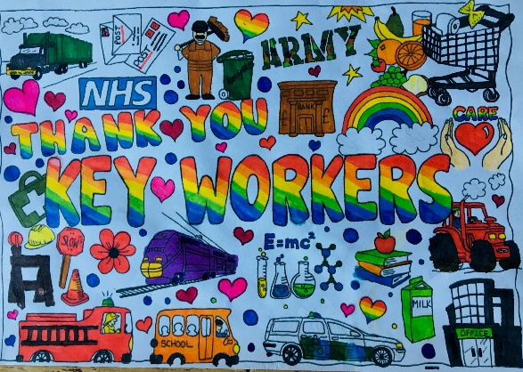

Well done to everyone who entered - it was wonderful to see your beautiful work. Thank you for supporting all the Key Workers out there, keeping us safe!

A special mention to Owen Baines in Year 3 whose brilliant poster is displayed in his dad’s police car!

I am looking forward to seeing you all back in school!
Mrs Kozyra

