Can you write about some of the pictures?
Look at the pictures and write about what you can see. You can start your sentence with
I can see ……
It is ………
Don’t forget to use a capital letter to start your sentence, finger spaces between words and a full stop at the end of the sentence.

Try to use your lovely cursive handwriting.

Try carefully to sound out the words and try and remember some tricky words too!
Please don’t worry about printing the pictures, you could draw one of the pictures or draw your own picture in your book then write about it.
Enjoy writing some super sentences!
Write About the Picture
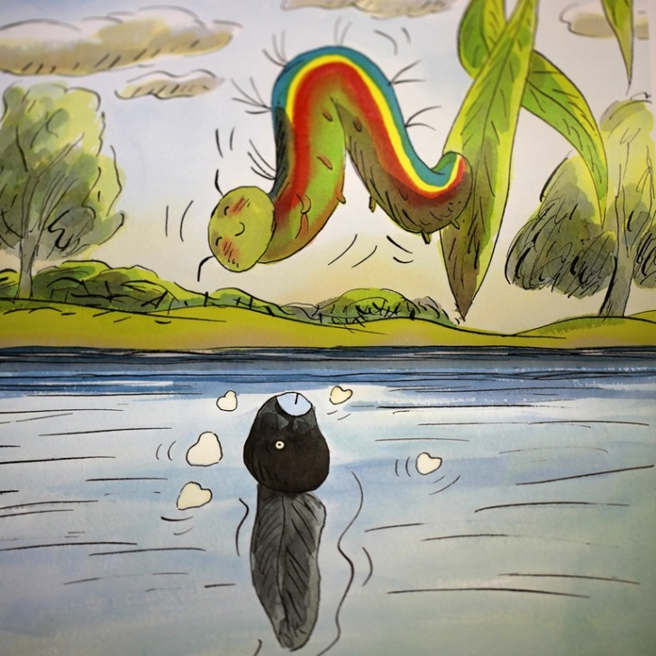
____________________________________________________________
Write About the Picture
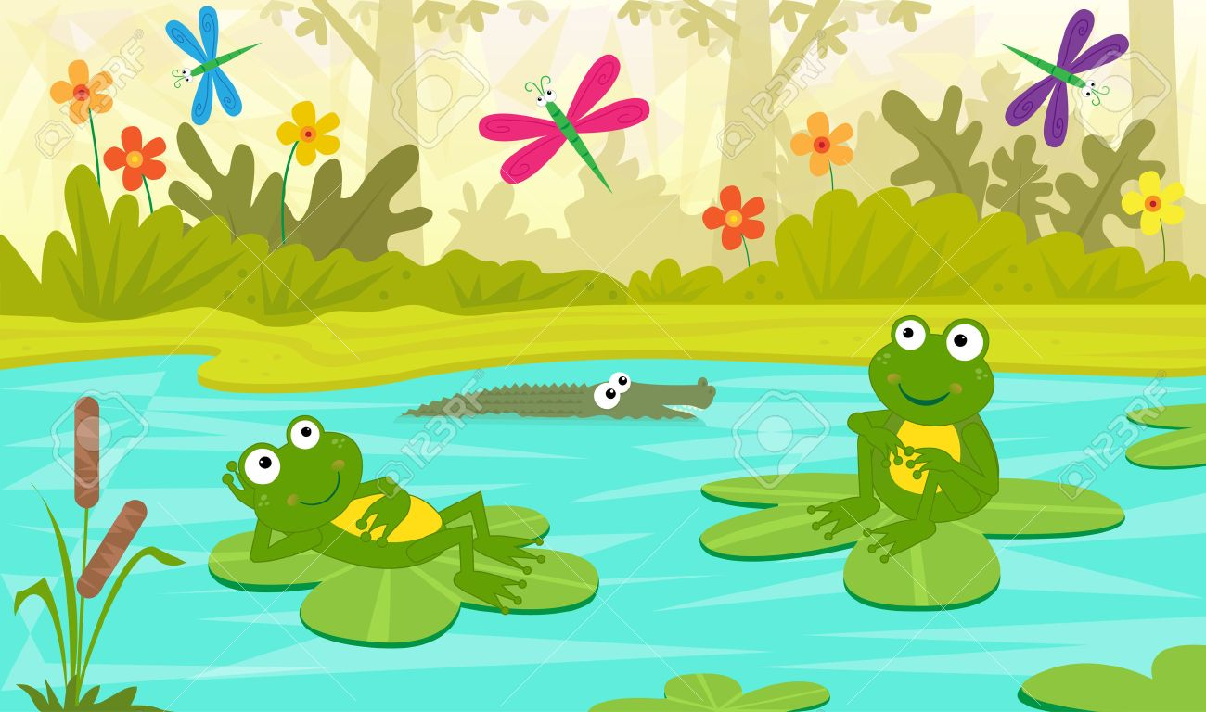
____________________________________________________________

Write About the Picture
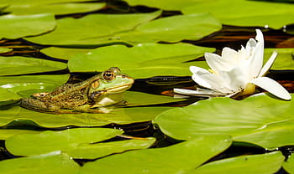
____________________________________________________________
Write About the Picture
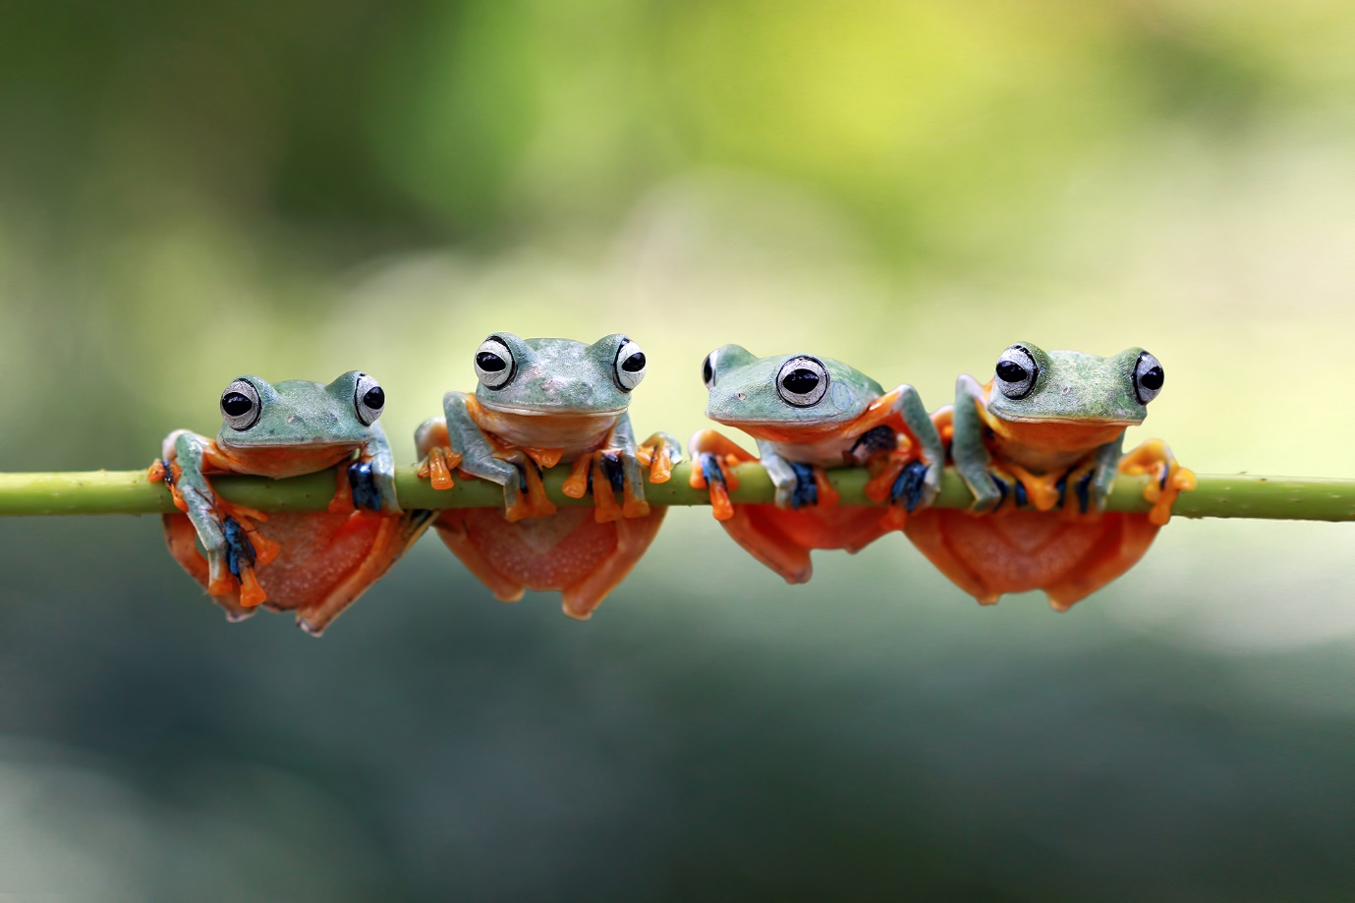
____________________________________________________________
Write About the Picture


