Animal Camouflage
Some animals have body coverings that help them to blend in with their habitat.
This is called camouflage.
Draw a line to connect each animal with the camouflage habitat that it belongs to.
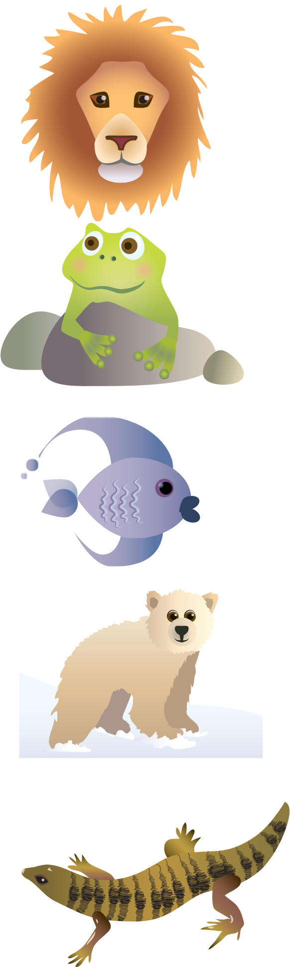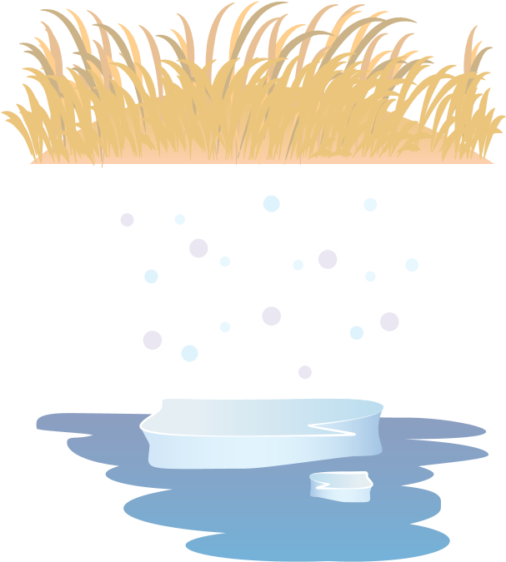

In the spaces below, write down the key colour that each animal relies on to camouflage itself in its habitat.
