What should my child be able to do during Year 6 ?

In Year 6, your child should maintain positive attitudes to reading and understanding of what they read.

They can also understand what they read.

- Read and talk about a wide range of fiction (stories), poetry, plays, non-fiction and reference books
- Find and talk about themes in and across a wide range of writing e.g. using first person when writing diaries or autobiographies
- Make comparisons within and across books e.g. about plot, theme etc.
- Check that the book they are reading makes sense to them, talking about what they understand and exploring the meaning of words in the context they have read them in
- Ask questions to improve their understanding
- Make inferences (‘read between the lines’) such as about characters’ feelings, thoughts and motives from their actions, and justify these inferences with evidence from the text
- Predict what might happen from the details they have read and those that are implied
- Find relevant information in a text, summarise the main ideas from more than one paragraph and find key details that support these ideas
- Find and explain how language, structure and presentation contribute to the meaning of the piece of writing
- Talk about and evaluate how authors use language, including figurative language and the impact this has on the reader
- Identify the differences between statements of fact and opinion
- Find, write down and present some information from non-fiction texts
- Explain and discuss their understanding of what they have read, including formal presentations and debates, maintaining a focus on what they are discussing and using notes where they need to
- Give reasoned justifications for their views about what they have read

Prefixes and Suffixes
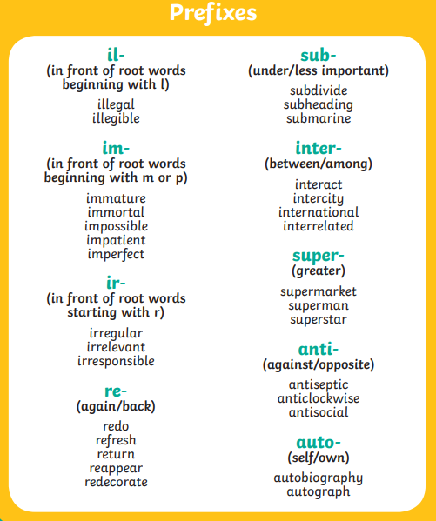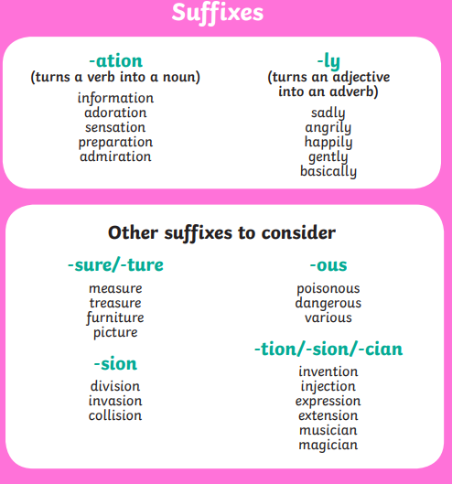
Year 5 and 6 Spelling List
