What should my child be able to do during Year 5 ?

In Year 5, your child should maintain positive attitudes to reading and understanding of what they read.

They can also understand what they read.

- Apply their growing knowledge of root words, prefixes and suffixes (below) both to read aloud and to understand the meaning of new words they meet
- Read and discuss a range of fiction (stories), poetry, plays, non-fiction and reference books
- Find and talk about themes in and across a wide range of writing e.g. using first person when writing diaries or autobiographies
- Make comparisons within and across books e.g. about plot, theme etc.
- Check that the book they are reading makes sense to them, talking about what they understand and exploring the meaning of words in the context they have read them in
- Ask questions to improve their understanding
- Make inferences (‘read between the lines’) such as about characters’ feelings, thoughts and motives from their actions, and justify these inferences with evidence from the text
- Predict what might happen from the details they have read and those that are implied
- With support, find relevant information in a text, summarise the main ideas from more than one paragraph and find key details that support these ideas
- Find, talk about and evaluate the difference between literal and figurative language, talking about how effectively the author has create mood and built tension, and the impact on the reader
- Identify the differences between statements of fact and opinion
- Find, write down and present some information from non-fiction texts
- Explain and discuss their understanding of what they have read, including formal presentations and debates, maintaining a focus on what they are discussing and using notes where they need to
- Give reasoned justifications for their views about what they have read

Prefixes and Suffixes
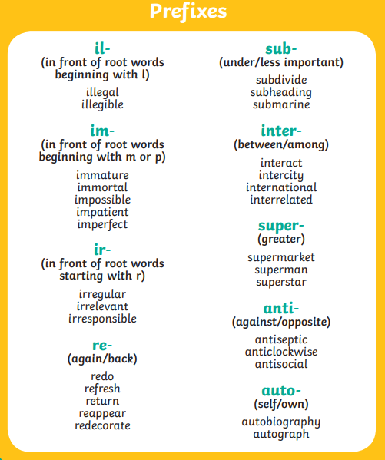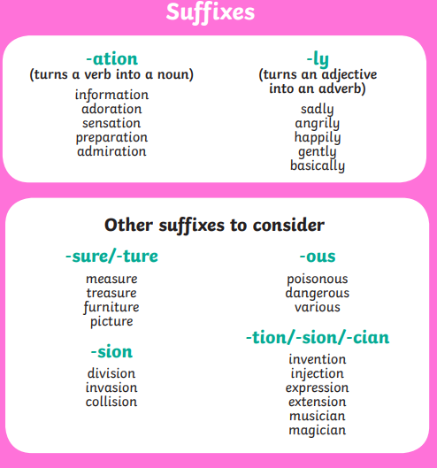
Year 5 and 6 Spelling List
