What should my child be able to do during Year 4 ?

In Year 4, your child should be continuing to develop positive attitudes to reading and understanding of what they read.

They should also begin to understand what they read in books they can read independently.

- Use their growing knowledge of root words, prefixes and suffixes (see below) both to read aloud and to understand the meaning of new words they meet
- Read further exception words, spotting where there is an unusual spelling of a sound within a word
- Listen to and confidently talk about a wide range of fiction (stories), poetry, plays, non-fiction and reference books
- Spot themes in an increasingly wide range of books e.g. friendship, kindness, honesty, jealousy
- Talk about many words and phrases that capture their interest and imagination
- Check that what they are reading makes sense to them, talk about what they understand from the text they have read and explain the meaning of many words in the context they have read them in and ask questions to improve their understanding of the text
- Make inferences (‘read between the lines’) such as about characters’ feelings, thoughts and motives from their actions, and find evidence from the text for most of these inferences
- Predict what might happen from the details they have read in the text and those that are implied
- Identify the main ideas in a text from more than two paragraphs and summarise them
- Find ways that the words, structure and presentation that has been used show the meaning of the text
- Confidently find and write down information from non-fiction texts
- Confidently take part in discussions about both books that are read to them and books they can read for themselves

Year 3 and Year 4 Spelling List

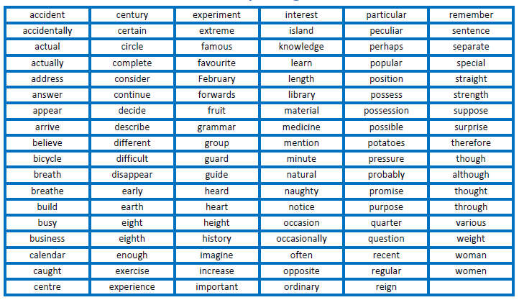

Common Prefixes and Suffixes

