What should my child be able to do during Year 3 ?

In Year 3, your child should be developing positive attitudes to reading and understanding of what they read.

They should also begin to understand what they read in books they can read independently.

- Read more exception words and spot where there is an unusual spelling of a sound in the words
- Listen to and talk about a wide range of fiction (stories), poetry, plays, non-fiction and reference books
- Spot simple themes in a wide range of books e.g. friendship, kindness, honesty, jealousy
- Talk about words and phrases that capture their interest and imagination
- Check that what they are reading makes sense to them, talk about their understanding and explain the meaning of some words in the context they have read them in
- Ask some questions to help them to understand what they are reading
- Make inferences (‘read between the lines’) such as about characters’ feelings, thoughts or motives from their actions, and find evidence to support these
- Predict what might happen from details in the text they have read, and from details that have been implied
- Identify the main ideas in a text from more than one paragraph and summarise them
- Find and write down some information from non-fiction texts
- Join in with discussions about both books that are read to them and books they can read for themselves

Phonemes

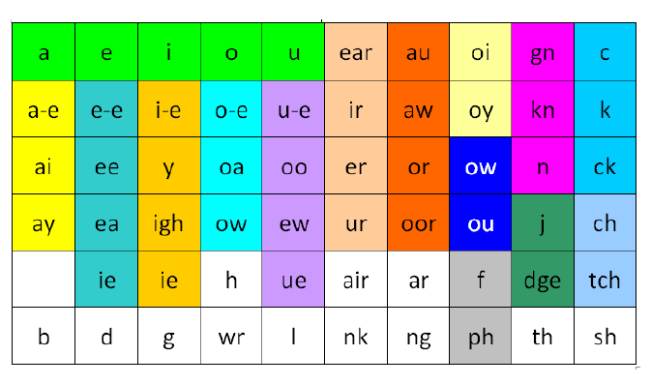

Alternative pronunciation of graphemes

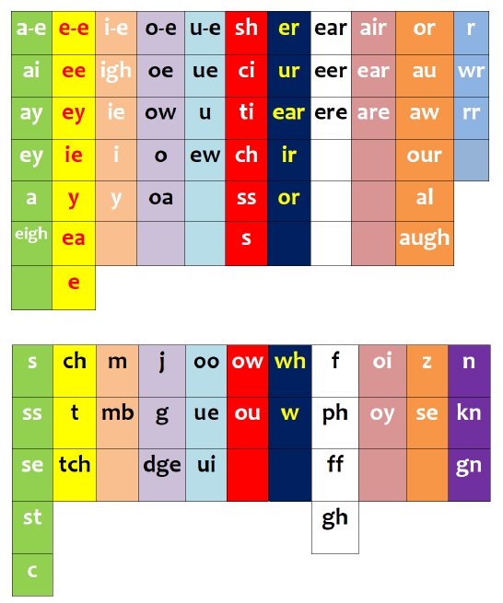

Common Prefixes and Suffixes

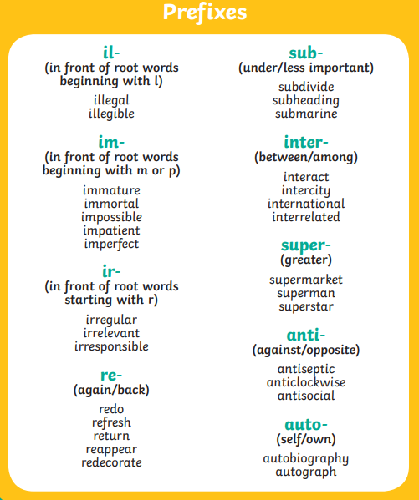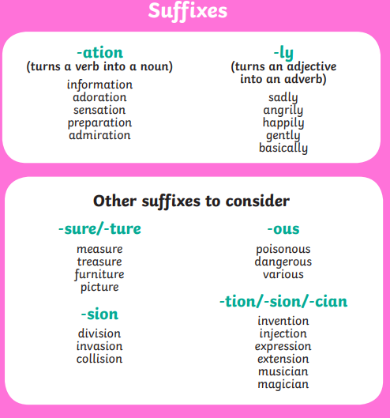
Common Suffixes
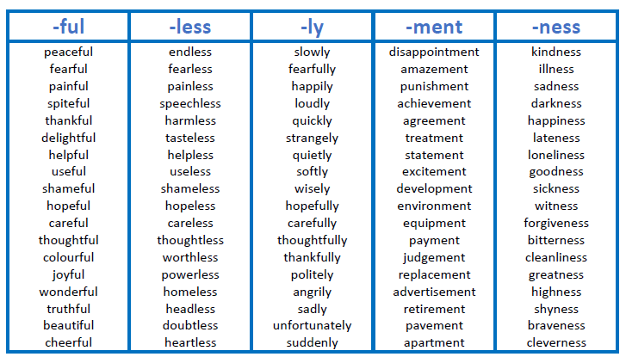

Year 3 and Year 4 Spelling List
