What should my child be able to do during Year 2 ?

Read by blending the sounds in words that have the common graphemes (letters or groups of letters) for all 40+ phonemes (sounds) (see additional resource)

- Read most words of two or more syllables accurately
- Read most words containing common suffixes (word endings) (see below)
- Read most common exception words (see below)
- Read most words accurately without the need to sound out and blend so they can focus on understanding what they are reading in books that are appropriate to their age
- Sound out new (unfamiliar) words accurately, without too much hesitation, in books that are appropriate to their age
- Check a book they are already able to read fluently makes sense to them, and correct their own mistakes when reading
- Answer questions and make some inferences (‘read between the lines’) about a book they are already able to read fluently
- Explain what has happened so far in what they have read in a book they are already able to read fluently

Phonemes
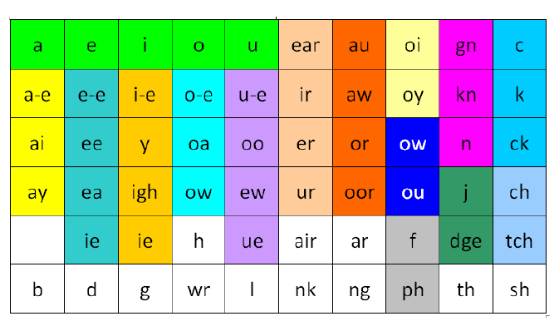

Alternative pronunciation of graphemes

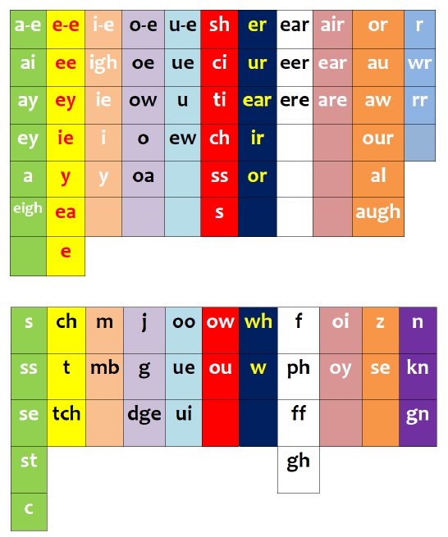

Common Suffixes
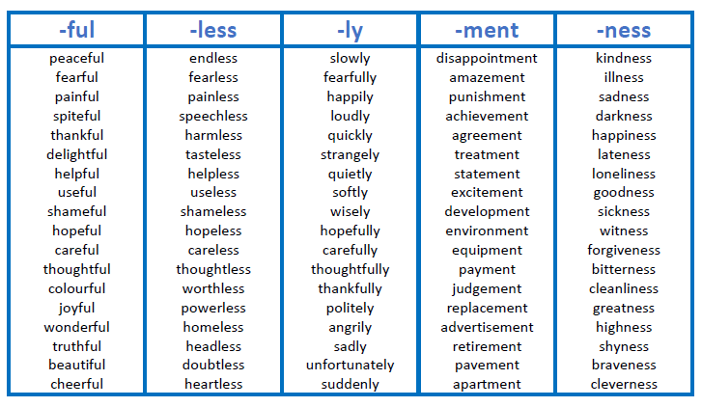
Year 2 Common Exception Words

