What should my child be able to do during Year 1?

- Say the correct sound to graphemes (letters or groups of letters) for some of the 40+ phonemes and many alternative sounds for graphemes (see below)
- Read accurately by blending sounds in unfamiliar words using GPCs they have been taught (see below)
- Read words that contain the GPCs they have been taught and -s, -es, - ing, -ed, -er and -est endings
- Read other words with more than one syllable that contain the GPCs they have been taught
- read aloud accurately decodable books that match their developing phonic knowledge without needing to use other strategies to work out words
- Read all capital letters and the days of the week
- Read words that use contractions e.g. he’s, I’m, we’ll and know that the apostrophe shows there are missing letters e.g. he’s = he is, I’m = I am, we’ll = we will
- Listen to and talk about stories, poems and non-fiction books that are harder than they could read on their own
- Talk about several well-known stories, fairy stories and traditional tales and retell them
- Talk about the meaning of words and link new meanings to words they already know
- Check that the book they are reading makes sense to them and correct themselves if they make a mistake while reading
- Talk about the main events in a story they have read
- ‘Read between the lines’ using the actions and words of the characters e.g. Tom stamped his foot and shouted, ‘Stop!’ = Tom is angry
- Predict what might happen in the rest of the story

Phonemes

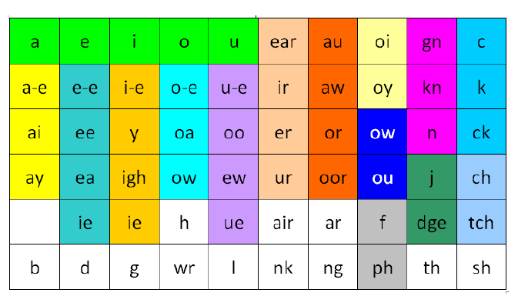

Alternative pronunciation of graphemes (GPCs)

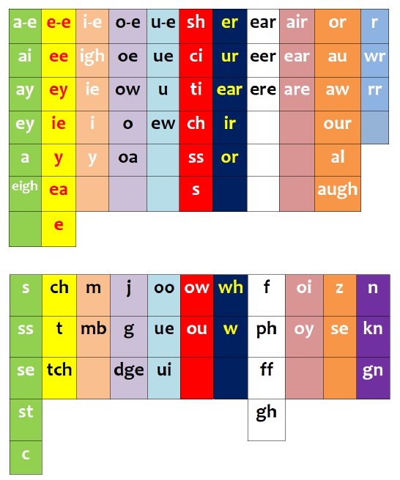

Year 1 Common Exception Words

