QUESTIONS YOU CAN ASK YOUR CHILD WHEN READING WITH THEM – KEY STAGE 1
Reading for Pleasure and Enjoyment | Word Reading and Decoding | Knowledge of Vocabulary
Did you choose this book? Why?  What did you like about the text? Why? What did you dislike about the text? Why?  Would you read the book again? Why? Why not?  Would you recommend the book to your friend? Why? Why not?  What will you read next? | What do you do if you are stuck on a word?  Where do you start reading the word? Where do you look first?  When you blend those sounds together, what word does it say? Can you tell me the word?  Are there any clues in the word?  Does it look like any other words you know?  Can the pictures help you? | What word in the text tells you…?  The author uses this word ______What does it mean?  The writer uses words such as ______to describe _______. What does this tell you about _______?  The writer uses words such as ______to describe _______. How does it make you feel?  Find and copy a word that describes how…
Key Aspects of the Text | Sequence of Events | Infer
Which character ______?  Where/when does _______ take place?  What did _______ look like?  How did _______ feel? Why?  Who was ______?  Where did ________ live?  Who are the characters in the book?  What happened in the story?  How does the _______ help me to find information in this book? | What happened after __________?  What happened before ___________?  Which of these events happened last?  Use three sentences to describe the beginning, middle and end of this text?  Sum up the story in ______ words | Why do you think _______?  How do you know that _______?  When do you think ________?  How can you tell that ________?  Why did _________?  How do you feel about ________?  Can you explain why _______?  How does __________ feel?
Prediction |  | Other Reading Ideas
What do you think will happen next?  What do you think would happen if ______?  What do you think will happen to _______? Why do you think this?  Where do you think _______? | 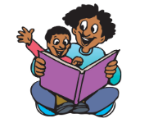  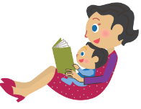  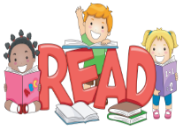 | Signs when out and about  Comics/Magazines  Recipe books  Instructions for a game/toy  Visit the library

