

 ***ASK AND IT WILL BE GIVEN TO YOU: SEEK AND YOU WILL FIND IT:***

***KNOCK AND THE DOOR WILL BE OPENED TO YOU - MATTHEW 7:7***

**Maths Policy**

**Spring 2022 – Spring 2023**

**Here at Mobberley, we believe that our maths curriculum will nurture a love for maths through a secure knowledge of key skills.  We aim to develop confident mathematicians at problem solving and reasoning, while exploring links to the world around us with cross curricular maths.  We aim to develop the children’s problem solving, resilience and reflective skills – skills that are easily transferable across the curriculum.**

**Aims**

We aim for all pupils to:

* Become **fluent** in the fundamentals of mathematics, so that they develop conceptual understanding and the ability to recall and apply knowledge rapidly and accurately.  including the varied and regular practice of increasingly complex problems over time.
* **Reason mathematically** by following a line of enquiry and develop and present a justification, argument or proof using mathematical language.
* Can **solve problems** by applying their mathematics to a variety of problems with increasing sophistication, including breaking down problems into a series of simpler steps and persevering in seeking solutions – including unfamiliar contexts and real-life scenarios.
* Can make **rich connections** across mathematical ideas to develop fluency, mathematical reasoning and competence in solving increasingly sophisticated problems.

**INTENT**

***Why do we teach this?  Why do we teach it in the way we do?***

Mathematics teaches children how to make sense of the world around them through developing their ability to calculate, reason and solve problems.

Mathematics is essential to everyday life, critical to science, technology and engineering, and necessary for financial literacy and most forms of employment. A high-quality mathematics education therefore provides a foundation for understanding the world, the ability to reason mathematically, an appreciation of the beauty and power of mathematics, and a sense of enjoyment and curiosity about the subject.

We aim to support children to achieve economic well-being and equip them with a range of computational skills and the ability to solve problems in a variety of contexts.

At Mobberley, children are encouraged to make mistakes in a safe and supportive environment. They are supported to discuss these misconceptions with their peers and staff alike. Here at Mobberley, we place oracy at the heart of our learning through shared work and class discussions. Use of appropriate vocabulary is modelled throughout lessons by both staff and children, allowing everyone to ‘talk like a mathematician’. Once a child can articulate their understanding of a concept, they can truly begin to make connections within their learning.

At our school, the majority of children will be taught the content from their year group only. They will spend time becoming true masters of content, applying and being creative with new knowledge in multiple ways.

**IMPLEMENTATION**

***Teaching and Learning, Content and Sequence***

In school we ensure we follow ‘The National Curriculum programmes of study for Mathematics 2014’ and, The EYFS Framework – Number and Numerical Patterns. We also incorporate the 2020 non-statutory ‘Ready to Progress’ guidance.

As a school we use the White Rose Maths scheme of learning as a guide for small steps in learning. We ensure only high quality resources are used to support learning and these are selected from the NCETM resources **Ready to Progress Documents**(see the yearly overview and ready to progress page),  Gareth Metcalfe’s **‘I see Reasoning’** documents, NCETM **‘Teaching for Mastery’** Resources (<https://www.ncetm.org.uk/classroom-resources/assessment-materials-primary/>) as well as Classroom Secrets etc.

The calculation policy is used within school to ensure a consistent approach to teaching the four operations over time.

At the start of each new topic, ***key vocabulary*** is introduced and revisited regularly to develop language acquisition, embedding as the topic progresses and is highly visible on Maths Working Walls so the children can use them regularly and correctly when using verbal or written explanations in their work.

All lessons begin with a short assessment to support ***retrieval practice*** and develop ***long-term memory***.

Children are taught through clear modelling and have the opportunity to develop their knowledge and understanding of mathematical concepts. Our approach incorporates using ***concrete*** objects, ***pictures***, ***words and numbers*** to help children explore and demonstrate mathematical ideas, enrich their learning experience and deepen understanding at all levels.

***Concrete*–**children have the opportunity to use concrete objects and manipulatives to help them understand and explain what they are doing.

***Pictorial***– children then build on this concrete approach by using pictorial representations, which can then be used to reason and solve problems.

***Abstract***– With the foundations firmly laid, children can move to an abstract approach using numbers and key concepts with confidence.

Children work on the objective at whatever entrance stage they are assessed as being at. Children can ***ACQUIRE*** the skill (fluency), ***APPLY*** the skill (problem solving) or ***DEEPEN*** the skill (reasoning) within the lesson.

Children move through the different stages of their learning at their own pace.

Children who have shown their understanding at a deep level within the unit, will have opportunities to apply these skills in a ***GREATER DEPTH*** activity. This should be challenging and ensure that children are using more than just one skill to be able to answer the mathematical problems.

Reasoning and problem solving are integral to the activities children are given to develop their mathematical thinking.

Resources are readily available to assist demonstration of securing a conceptual understanding of the different skills appropriate for each year group.

Children are encouraged to explore, apply and evaluate their mathematical approach during investigations to develop a deeper understanding when solving different problems/puzzles.

A love of maths is encouraged throughout school via links with others subjects, applying an ever-growing range of skills with growing independence.

**Our Maths’ lesson format:**

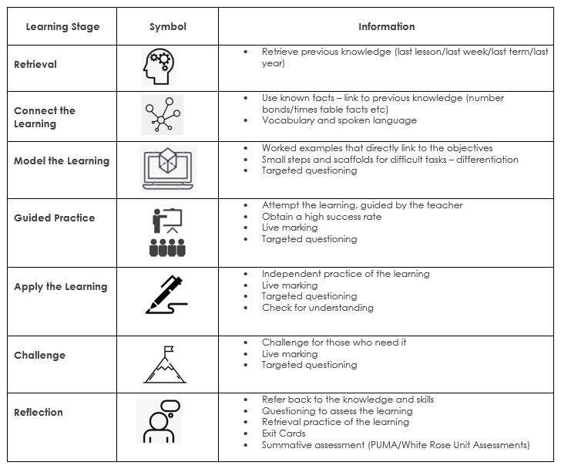

**Maths in EYFS:**

White Rose schemes of learning are used to inform teachers’ planning so that children are prepared with the appropriate mathematical knowledge required to access the Year 1 curriculum.

We relate the mathematical aspects of the children's work to the Development Matters statements and the Early Learning Goals (ELG).

The profile for Mathematics areas of learning are Number and Numerical Patterns).

We provide children with opportunities to practise and improve their skills in counting numbers, calculating simple addition and subtraction problems, and to describe shapes, spaces, and measures.

We provide children with opportunities to engage in maths activities both inside and outside of the classroom. Easily accessible, quality maths resources are provided so that children can self-select and engage freely as well as engaging in planned activities. Whenever possible, children’s interests are used to support delivering the mathematics curriculum.

We continually observe and assess children against these areas using their age-related objectives, and plan the next steps in their mathematical development

**IMPACT**

Our maths curriculum is of a high quality and ensures there is clear progression. In order to ensure we measure impact, we gather a variety of data and feedback to check whether learning has occurred. The information gathered through these methods directly impacts the future planning of teaching and learning opportunities, ensuring that we are responsive to the needs of our learners.

***Formative assessment*** through daily retrieval practice we can check for children’s retention of previously taught concepts.*Formative assessment* takes place on a daily basis and teachers adjust planning accordingly to meet the needs of their class.  Teachers use formative assessment to evaluate the learning during a lesson. They may ask questions to check understanding, or scrutinise independent work in order to identify common misconceptions or share thinking. Such assessment allows teachers the flexibility to intervene in a lesson to remind, redirect or reteach pupils as required.

***Summative assessments*** include White Rose Unit tests once each unit of learning is complete (results will feed into retrieval practices during the next unit of learning). At the end of each term: (White Rose Assessments in KS1 and Rising Stars PUMA in KS2 and KS1/2 SATs in May) and children’s progress and attainment is discussed with senior leaders in pupil progress meetings.

**OUR MATHS LEARNING ENVIRONMENT**

Our curriculum is supported by a rich learning environment. Working walls support children’s learning in every classroom for maths.

* Maths working walls are in constant use throughout individual lessons and across weeks focusing on a particular domain.
* Key vocabulary is displayed.
* Reasoning question stems are on show and used to model reasoning.
* Worked examples are modelled and displayed for reference (sometimes including pictorial and concrete representations).
* Mathematical manipulatives and resources are easily accessible for all children to support their learning.
* Some displays around the school will highlight cross-curricular links with maths.

**Special Educational Needs & Disabilities (SEND)**

Daily mathematics lessons are inclusive to pupils with special educational needs and disabilities. Where required, children’s support plans incorporate suitable objectives from the National Curriculum for Mathematics and teachers keep these in mind when planning work. These targets may be worked upon within the lesson as well as on a 1:1 basis outside the mathematics lesson. Maths focused intervention in school helps children with gaps in their learning and mathematical understanding.

These are delivered by class teachers and trained support staff and overseen by the SENCO and/or the class teacher. Within the daily mathematics lesson teachers have a responsibility to not only provide differentiated activities to support children with SEND but also activities that provide sufficient challenge for children who are high achievers. It is the teachers’ responsibility to ensure that all children are challenged at a level appropriate to their ability

**ROLES AND RESPONSIBILITIES**

It is the role of the Subject Leader to ensure that, along with SLT, the subject is monitored using a range of processes to inform the development of mathematics teaching and learning. Outcomes are shared with colleagues and appropriate actions are implemented. It is the role of the Subject Leader to identify and support the training needs of colleagues.

The Subject Leader engages with professional development and learning and imparts their interest in mathematics to the school community. It is the role of the Subject Leader to ensure that pupil voice is valued and responded to and there is an understanding of the importance and value of mathematics amongst the staff and children.

It is the school’s role to provide effective support for the Subject Leader’s development of mathematics.

It is the responsibility of all staff to inform the Subject Leader of resources that need replenishing or are required to enhance the teaching and learning of mathematics.

**REVIEW**

This policy is monitored through:

* Regular scrutiny of children’s work
* Regular monitoring and evaluation of planning
* Evaluation and analysis of assessment data
* Lesson observations to monitor the quality of teaching and implementation of planning
* Pupil interviews and questionnaires
* Teacher feedback

The mathematics policy will be reflected in our practise. The policy will be reviewed Spring 2023.