

***MATTHEW 7:7***

*** ASK AND IT WILL BE GIVEN TO YOU: SEEK AND YOU WILL FIND IT:***

***KNOCK AND THE DOOR WILL BE OPENED TO YOU***

Mobberley CE Primary School

Calculation Policy

Updated 5 September 2019

Mathematics Mastery

At the centre of the mastery approach to the teaching of mathematics is the belief that **all children have the potential to succeed**. They should have access to the same curriculum content and, rather than being extended with new learning, they should **deepen their conceptual understanding by tackling challenging and varied problems**. Similarly, with calculation strategies, children must not simply rote learn procedures but demonstrate their understanding of these procedures through the use ofconcrete materials and pictorial representations. This policy outlines the different calculation strategies that should be taught and used in Year 1 to Year 6 in line with the requirements of the 2014 Primary National Curriculum.

Background

The 2014 Primary National Curriculum for mathematics differs from its predecessor in many ways. Alongside the end of Key Stage year expectations, there are suggested goals for each year; there is also an emphasis on depth before breadth and a greater expectation of what children should achieve. In addition, there is a whole new assessment method, as the removal of levels gives schools greater freedom to develop and use their own systems. One of the key differences is the level of detail included, indicating what children should be learning and when. This is suggested content for each year group, but schools have been given autonomy to introduce content earlier or later, with the expectation that by the end of each key stage the required content has been covered. For example, in Year 2, it is suggested that children should be able to ‘add and subtract one-digit and two-digit numbers to 20, including zero’ and a few years later, in Year 5, they should be able to ‘add and subtract whole numbers with more than four digits, including using formal written methods (columnar addition and subtraction)’. In many ways, these specific objectives make it easier for teachers to plan a coherent approach to the development of pupils’ calculation skills. However, the expectation of using formal methods is rightly coupled with the explicit requirement for children to use concrete materials and create pictorial representations – a key component of the mastery approach.

Mathematical Language

The 2014 National Curriculum is explicit in articulating the importance of children using the correct mathematical language as a central part of their learning (*reasoning*). Indeed, in certain year groups, the non-statutory guidance highlights the requirement for children to extend their language around certain concepts. It is therefore essential that teaching using the strategies outlined in this policy is accompanied by the use of appropriate and precise mathematical vocabulary. New vocabulary should be introduced in a suitable context (for example, with relevant real objects, apparatus, pictures or diagrams) and explained carefully. High expectations of the mathematical language used are essential, with teachers only accepting what is correct. The school agreed list of terminology is located at Appendix A to this document.

The quality and variety of language that pupils hear and speak are key factors in developing their mathematical vocabulary and presenting a mathematical justification, argument or proof.



*2014 Maths Programme of Study*

How to use the policy

This mathematics policy is a guide for all staff at Mobberley CE Primary School and has been adapted from work by the NCETM. It is purposely set out as a progression of mathematical skills and not into year group phases to encourage a flexible approach to teaching and learning. It is expected that teachers will use their professional judgement as to when consolidation of existing skills is required or if to move onto the next concept. However, the **focus must always remain on breadth and depth rather than** **accelerating through concepts.** Children should not be extended with new learning before they are ready, they should deepen their conceptual understanding by tackling challenging and varied problems. All teachers have been given the scheme of workfrom the White Rose Maths Hub and are required to base their planning around their year group’s modules and not to move onto a higher year group’s work. These are affiliated to the workings of the 2014 Maths Programme of Study.

Teachers can use any teaching resources that they wish to use and the policy does not recommend one set of resources over another, rather that, a variety of resources are used. For each of the four rules of number, different strategies are laid out, together with examples of what concrete materials can be used and how, along with suggested pictorial representations. The principle of the concrete-pictorial-abstract (CPA) approach [Make it, Draw it, Write it] is for children to have a true understanding of a mathematical concept, they need to master all three phases within a year group’s scheme of work.

.

Content of the Policy

1. Addition
2. Subtraction
3. Multiplication
4. Division
5. Mathematical Language and Question Prompts

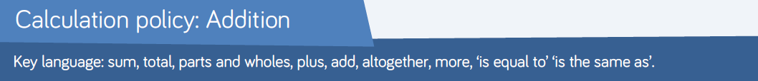

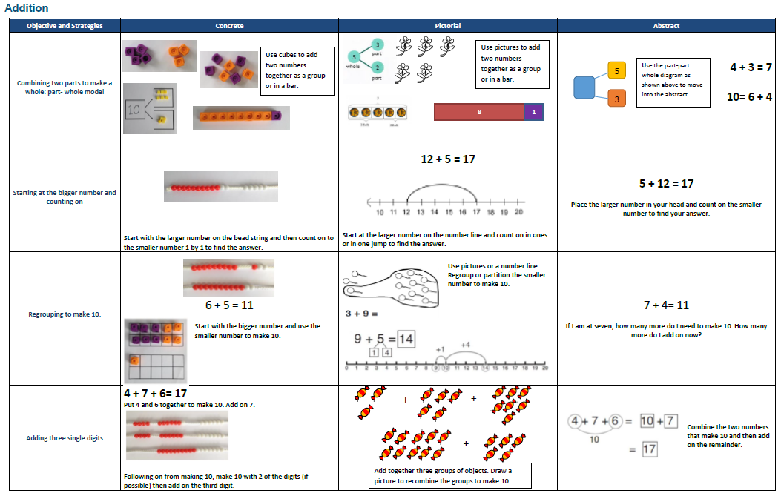

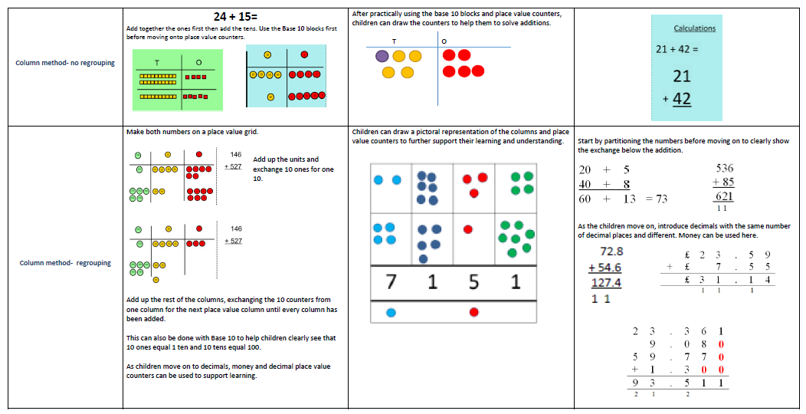

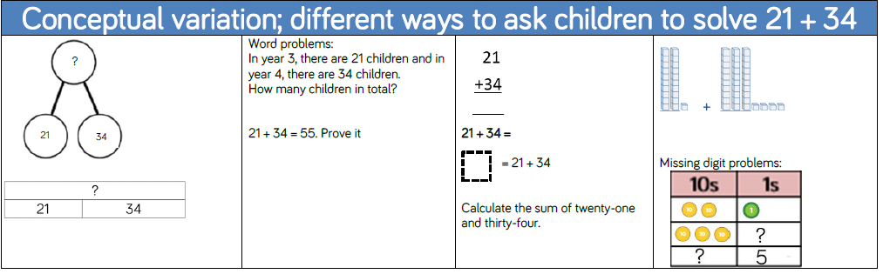

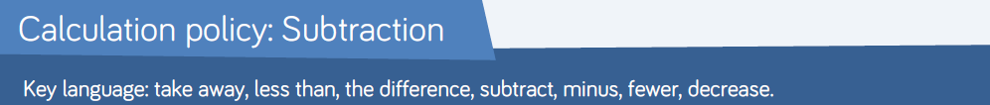

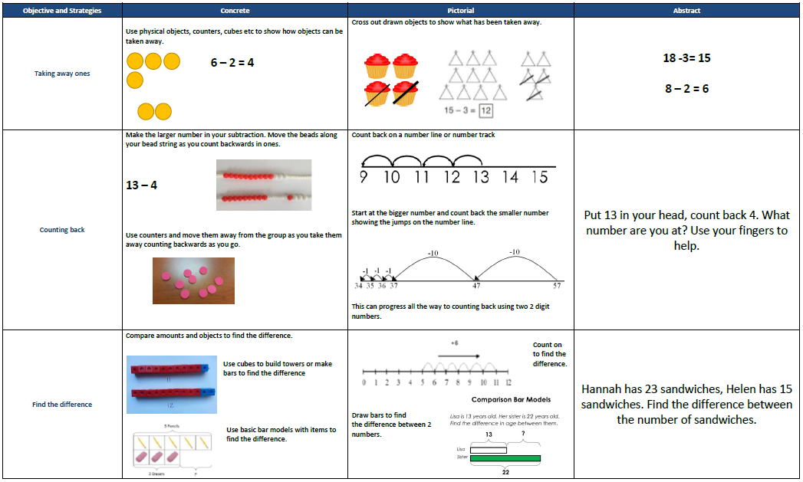

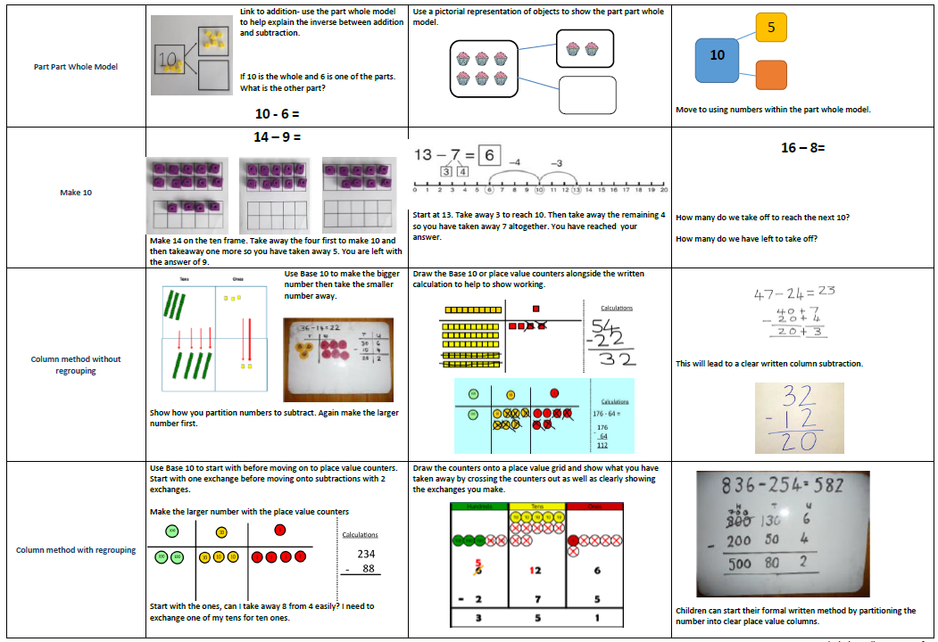

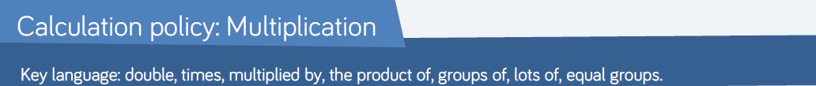

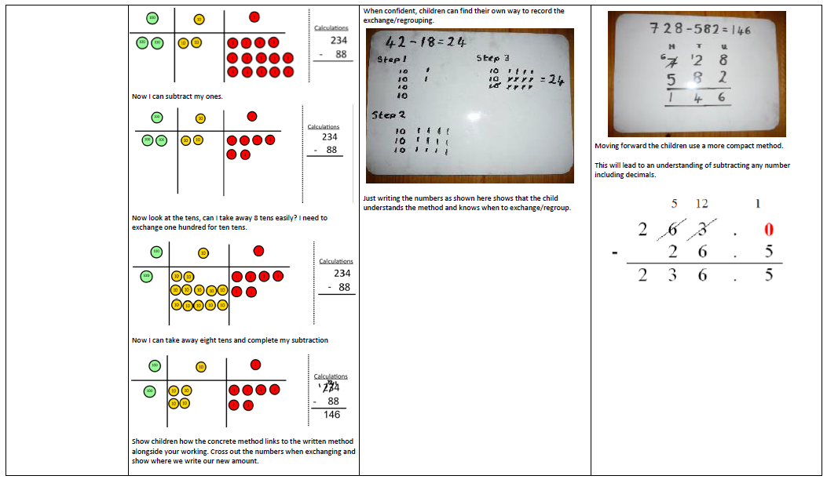

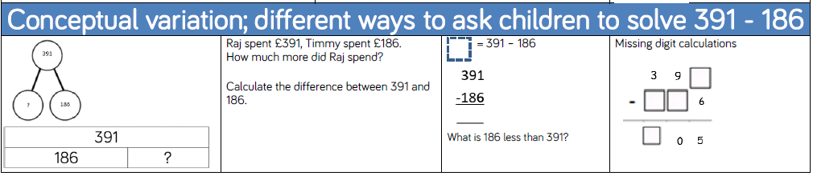



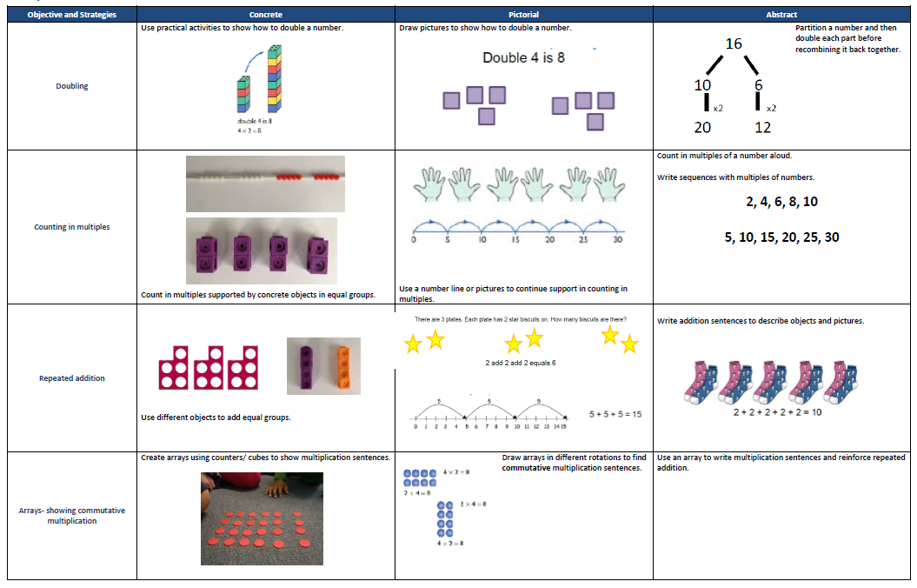

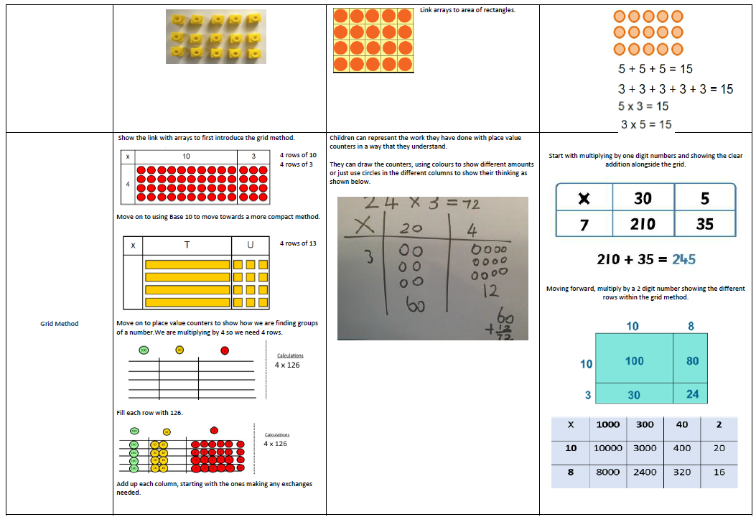

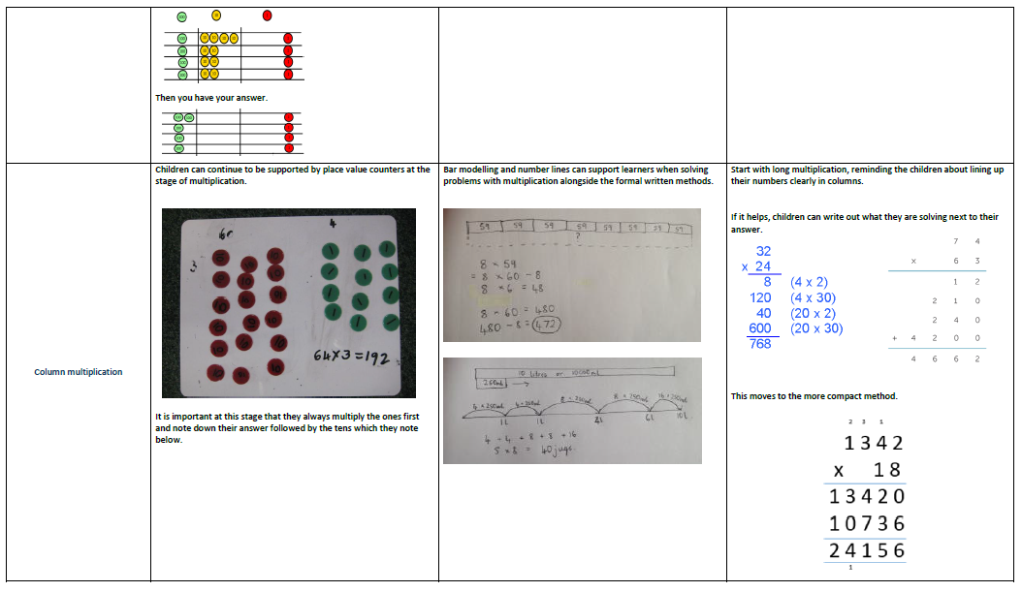

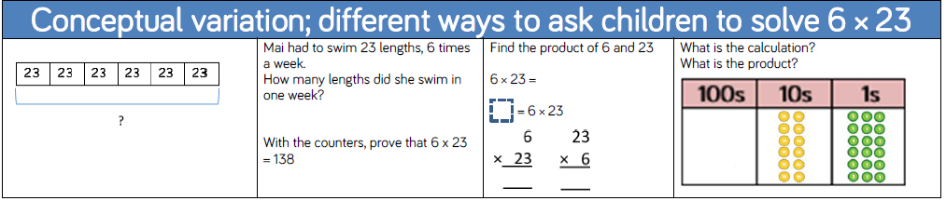

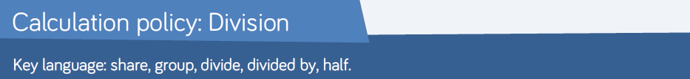

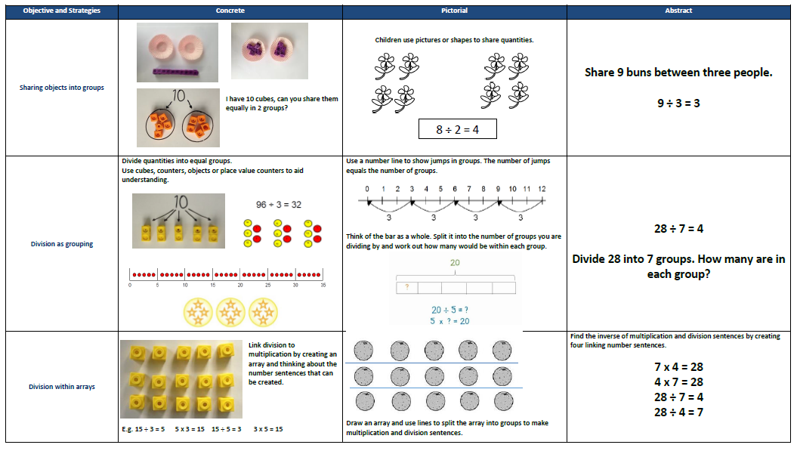

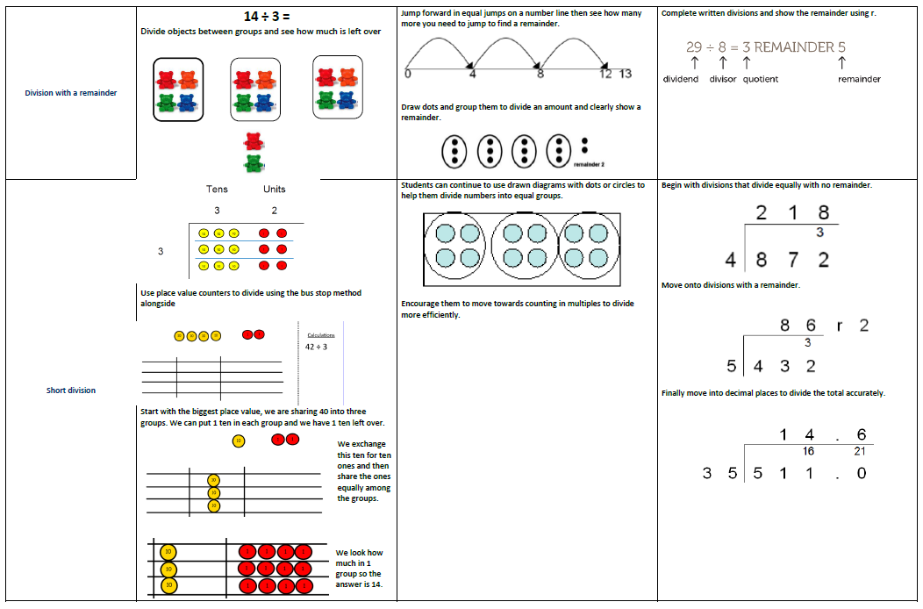

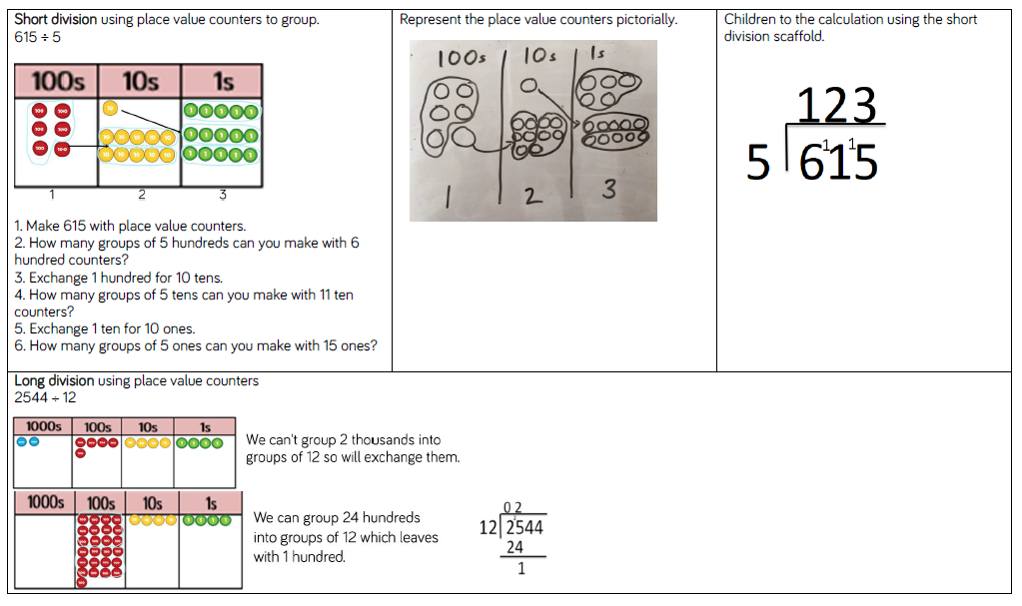

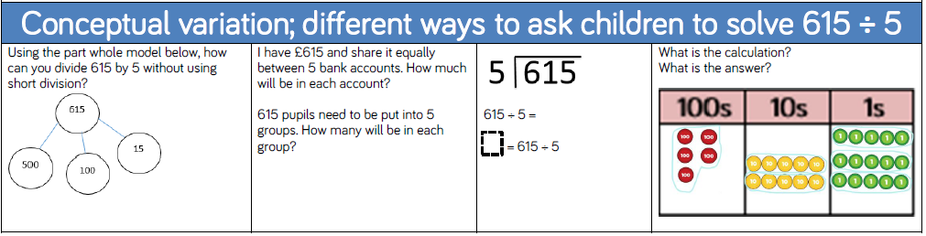

**Maths Language / question prompts for the four operations**

**Maths Language / question prompts for the four operations**

**Language in EYFS**

|  |  |
| --- | --- |
| **Addition/Subtraction**  **One more, one less**  **Add, more, and**  **Altogether, count all of them,**  **count on**  **Take-away, subtract**  **Count what is left, count back**  **Make, equals, total,**  **Is the same as** | **Multiplication/Division**  **Double, half, share**  **How many each? equal groups**  **Lots of, groups of**  **Repeated addition** |
| **Reasoning Question examples**  **3 + 2 = 5**  **3 + 2 = 6**  **Why can’t both of these number sentences be correct?** | **Problem Solving Examples**  **How many different ways can you put the spots on the ladybirds?** |

**Maths Language/ question prompts for the four operations – Language in Year 1**

|  |  |
| --- | --- |
| **Addition/Subtraction**  **Addition**  **+ add, more, plus, count on**  **Make, total**  **Altogether**  **Double, near double**  **One more, two more, ten more**  **More than**  **How many more to make…?**  **How much more is…?**  **How many altogether?**  **Subtraction**  **- Subtract, take away, minus, count**  **back**  **Leave**  **How many are left (over)?**  **One less, two more, ten more**  **Less than**  **How many fewer is… than…?**  **Difference between**  **Half, halve**  **Equals**  **= equals, equal to, is the same as** | **Multiplication/Division**  **Multiplication**  **Multiples, lots of, groups of**  **Multiplication**  **Arrays**  **Repeated addition**  **Double**  **Division**  **Halve, share, share equally**  **How many in each…?**  **One each, two each, five each**  **Equal groups** |
| **Reasoning Question examples**  **What do you notice?**  **20 – 12 = 8**  **20 – 8 = 12**  **Can you make up some other number sentences like these using three numbers?**    **What number goes in the missing box?**  **9 + __ = 10**  **10 - __ = 9**  **Can you prove this using your fingers?**  **Danielle says, “I know 50 is in the ten times table so I know it is also in the five times table.” Is she correct? Explain why.**    **Amrit is counting in twos. She**  **says the number 11. Explain the**  **mistake she has made.** | **Problem Solving Examples** |

**Maths Language/ question prompts for the four operations**

**Language in Year 2**

|  |  |
| --- | --- |
| **Addition/Subtraction**  Add, addition, more, plus  Make, sum, total  Altogether  Double, near double,  Ten more, one hundred more  How many more to make?  How many more is ….than…?  How much more is….?  Subtract, subtraction, take away,  minus  How many are left?  Ten less, one hundred less  How many fewer is …. than….?  How much less is…?  Difference between  Half/halve  Equals, sign, is the same as | **Multiplication/Division**  Lots of, group of  Times, multiply, multiplied by  Multiply of  Times  Repeated addition, repeated  subtraction  Array  Row, column  Double, halve  Share, share equally  Equal groups of  Divide, divided by, divided into  Left, left over |
| **Reasoning Question examples**  **Continue the pattern**:  90 = 100 – 10  80 = 100 – 20  Can you make up a similar pattern  starting with the numbers 75, 25  and 100?  **Missing numbers:**  81 + ___ = 100  100 - ___ = 89  **Problem Solving Examples**  Jenny has ten 10ps. How many  ways can she add them together to  make £1?  E.G. 20p + 80p  Can you find the missing number  so each row and column adds up to 100?  Explain how you can use number  bonds to 10 to find the missing  numbers above.  Sam says ‘If I know 9 + 1= 10, I  also know what I add to 90 to make  100.’ Is he right? Prove it  **Multiplication & Division**     Which has more? Four bags of  sweets with 5 in each or 3 bags of sweets with 10 in each? Explain your reasoning.     What numbers could go in the boxes?  20 = x  Prove it. | **Problem Solving Examples**  Jenny has ten 10ps. How many  ways can she add them together to make £1?  E.G. 20p + 80p  Can you find the missing number  so each row and column adds up to 100?    Use the numbers 1, 2 and 3. In  pairs, one child chooses a number. The other child has to  choose another number to add to the first number. The aim is to be the person who reaches 20 first.  You must try to make sure your partner doesn’t reach 20.  **Multiplication & Division**  • Use the number cards to make multiplication and division sentences.  How many numbers up to 20 can you make? |

**Maths Language/ question prompts for the four operations**

**Language in Year 3**

|  |  |
| --- | --- |
| **Addition/Subtraction**  Add, addition, more, plus  Make, sum, total, altogether  Double, near double  Ten more, hundred more  How many more to make?  How many more is …than…?  How much more is?  Subtract, subtraction, take (away),  minus  Leave, how many are  left/leftover?  Ten less, hundred less  How many fewer is … than…?  How many less?  Difference between  Half/halve, quarter, two quarters,  three quarters, third  Equals, sign, is the same as | **Multiplication/Division**  Lots of, groups of  Times, multiply, multiple of,  multiplication, multiplied by, product  Once, twice, three times…..ten  times  Times as big/long/wide  Repeated addition, repeated  subtraction, array  Row, column  Double, halve  Share, share equally  One each, two each, three each….. |
| **Reasoning Question examples**    **Multiplication & Division** | **Problem Solving Examples**    The answer to the addition is 201.  All the digits used are either 1 or 9.  Fill in the boxes. |

**Maths Language/ question prompts for the four operations**

**Language in Year 4**

|  |  |
| --- | --- |
| **Addition/Subtraction**  Add, addition, more, plus  Make, sum, total, altogether  Double, near double  Ten more, hundred more  How many more to make?  How many more is …than…?  How much more is?  Subtract, subtraction, take (away),  minus  Leave, how many are left/leftover?  Ten less, hundred less  How many fewer is … than…?  How many less?  Difference between  Half/halve, quarter, two quarters,  three quarters, third  Equals, sign, is the same as  Increase, decrease, inverse | **Multiplication/Division**  Lots of, groups of  Times, multiply, multiple of,  multiplication, multiplied by,  product  Once, twice, three times…..ten  times  Times as big/long/wide  Repeated addition, repeated  subtraction, array  Row, column  Double, halve  Share, share equally  One each, two each, three each  Divisible by |
| **Reasoning Question examples**    Place one of these symbols in the circle  to make the number sentence correct: >,< or =    Justify your answers | **Problem Solving Examples**  I am thinking of a number. It is greater than 1500 but smaller than 2000. The digits add up to 13. The difference between the largest and smallest digit is 5. What could the number be?  A chocolate factory usually produce 1568 caramel bars on a Saturday but on a Sunday production decreases and they make 325 fewer bars. How many bars are produced at the weekend in total?  All of the digits below are either a 3 or a  9. Can you work out each digit?  7338=???? + ????  Miss Wood orders some new whiteboard pens for Year 5 and 6. There are 160 children in Year 5 and 6. If she orders 6 boxes of 27 pens, will she have enough?  Show your calculation.  An ice cream sundae is made from one scoop of ice cream, one topping and one sauce.  **How many different ice cream**  **sundaes can be created from 5**  **different flavours of ice cream, 3**  **different toppings and 4 different sauces?**  What could the numbers in the multiplication be? Every digit is different.  ??? x 3 = ???? |

**Maths Language/ question prompts for the four operations**

**Language in Year 5**

|  |  |
| --- | --- |
| **Addition/Subtraction**  Add, addition, more, plus  Make, sum, total, altogether  Double, near double  Ten more, hundred more  How many more to make?  How many more is …than…?  How much more is?  Subtract, subtraction, take (away),  minus  Leave, how many are left/leftover?  Ten less, hundred less  How many fewer is … than…?  How many less?  Difference between  Half/halve, quarter, two quarters,  three quarters, third  Equals, sign, is the same as  Increase, decrease, inverse  Ascend, descend | **Multiplication/Division**  Lots of, groups of  Times, multiply, multiple of,  multiplication, multiplied by,  product  Once, twice, three times…..ten  times  Times as big/long/wide  Repeated addition, repeated  subtraction, array  Row, column  Double, halve  Share, share equally  One each, two each, three each  Divisible by  Cubed  Squared  Quotient  To the power of  Square Root  Factor  Multiple |
| **Reasoning Question examples**    **6 x 7 = 42**  How can you use this fact to solve the following calculations?  4200 ÷ 70 =  0.6 x 0.7 =  A five digit number and a four  digit number have a difference of  4365. Give me three possible pairs of numbers.  What number goes in the box?  323 x __1 = 13243  Prove it.  Andrew says that the answer to  166 divided by 4 can be written as ’46 remainder 2’ or as ’46.5’.  Do you agree? Explain your  Reasoning  Tom says ‘*Factors come in pairs, so all numbers have an even number of factors*.’  **Do you agree? Explain your reasoning.** | **Problem Solving Examples**    David has £35700 in his bank. He  divides the amount by 100 **and takes** that much money out of the bank. Using the money he has  taken out he spends £268 on  furniture for his new house. How  much money does David have left  from the money he took out? Show  your working.  I am thinking of a number. When it  is divided by 9, the remainder is 3.  When it is divided by 2, the remainder is 1.  When it is divided by 5, the remainder is 4.  What is my number?  My answer is 5398, what’s the  question? - Create 3 addition  calculations. - Create 3 subtraction questions. - Did you use a strategy? Explain it.  Clare’s age is a multiple of 7 and 3  less than a multiple of 8. How old is  Clare? |

**Maths Language/ question prompts for the four operations**

**Language in Year 6**

|  |  |
| --- | --- |
| **Addition/Subtraction**  Add, addition, more, plus  Make, sum, total, altogether  Double, near double  Ten more, hundred more  How many more to make?  How many more is …than…?  How much more is?  Subtract, subtraction, take (away),  minus  Leave, how many are left/leftover?  Ten less, hundred less  How many fewer is … than…?  How many less?  Difference between  Half/halve, quarter, two quarters,  three quarters, third  Equals, sign, is the same as  Increase, decrease, inverse  Ascend, descend | **Multiplication/Division**  Lots of, groups of  Times, multiply, multiple of,  multiplication, multiplied by,  product  Once, twice, three times…..ten  times  Times as big/long/wide  Repeated addition, repeated  subtraction, array  Row, column  Double, halve  Share, share equally  One each, two each, three each  Divisible by  Cubed  Squared  Divisor  Dividend Quotient  To the power of  Square Root  Factor  Multiple |
| **Reasoning Question examples**  Abdul says “If I add any two 4 digit numbers together is will make a 5 digit number.” Do you agree? Explain why. | **Problem Solving Examples**  Javid has six white mice, three males and three females. Each of  the three couples has 7 female baby mice. The each of these females has 8 babies.  One night Javid’s little sister  Aisha leaves the mice cage open  and 47 escape. How many mice does Javid have left?  What is the closest you can get to  any given number e.g. 256 using  only multiplication and a list of  numbers given e.g. 10, 7, 6, 2, 25,  4?  How do you know this is the  closest? What strategy did you  use?  Using the number 4236, how many  numbers up to 20 does it divide by  without a remainder? Is there a  pattern? What can you say about  these numbers?  Peter paid £21 for 5 presents.  For A and B he paid a total of £6.  For B and C he paid a total of £10.  For C and D he paid a total of £7.  For D and E he paid a total of £9.  How much did Peter pay for each  present?  Nancy is double her sister’s  age. They are both older  than 20 and younger than  50. They are both multiples  of 7. How old are they? |

**Reasoning Question starters and activities**

Reasoning question starters and activities can be applied in all objectives of the maths curriculum.

Below are some helpful examples that can be used with children.

Teachers will also use information from the NCETM progression maps and White Rose planning

to support the use of these with appropriate examples.

Spot the mistake / Which is correct?

True or false?

What comes next?

Do, then explain

Make up an example / Write more statements / Create a question /

Another and another

Possible answers / Other possibilities

What do you notice?

Continue the pattern

Missing numbers / Missing symbols / Missing information/Connected

calculations

Working backwards / Use the inverse / Undoing / Unpicking

Hard and easy questions

What else do you know? / Use a fact

Fact families

Convince me / Prove it / Generalising e.g. Ted thinks that any number

ending in a 4 is in the four times table. Do you agree?

Explain your thinking

Make an estimate / Size of an answer – How did you make that

estimate?

Always, sometimes, never

Making links / Application

Can you find?

What’s the same, what’s different?

Odd one out

Complete the pattern / Continue the pattern

Ordering

Testing conditions – e.g. asking for a number/answer that fits a range of

criteria e.g. a number is 3 digits and is a multiple of 3 and 5. What could

I be?

The answer is…

Visualise