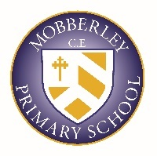
CURRICULUM BREADTH STATEMENT

The background of our pupils, our culture and our climate for learning provide the following drivers that underpin all areas of our curriculum:
- Self – Helping pupils to understand themselves, their beliefs and their feelings
- World – Helping pupils to relate to those immediately around them and in the wider world
- Opportunities – Helping pupils to develop through high quality teaching and experiences
- Thrive – Helping pupils to achieve and become well rounded individuals
We offer a diverse range of experiences that support our Mobberley culture: pupils enjoy a ‘full spectrum’ of academic, spiritual, moral, social, physical, and cultural activities that enrich their lives and give them the confidence and skills for a fulfilled, happy and healthy life.

