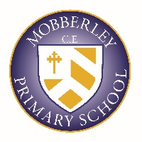
CURRICULUM BALANCE STATEMENT
We believe that all of our children should achieve the feeling of success and accomplishment in a wide range of areas. The ‘Mobberley Curriculum’ provides an excellent mix of academic and personal development for each child. Core and foundation subjects are valued equally. Physical wellbeing and mental wellbeing are both, valued, understood and planned for through our careful consideration of curriculum design.

Spiritual, moral, social and cultural development, along with a well planned and structured programme of personal development, underpins all of our work and is monitored closely to ensure it is having meaningful impact.

We carefully balance the requirement for pupils to reach national expectations in core subjects with our wider curriculum aims of providing a full spectrum of thoughtful and enriching experiences.

