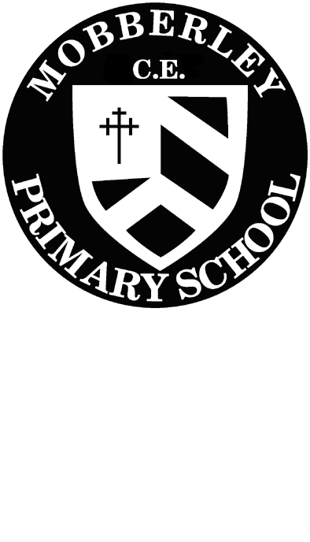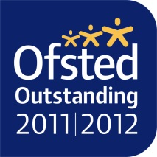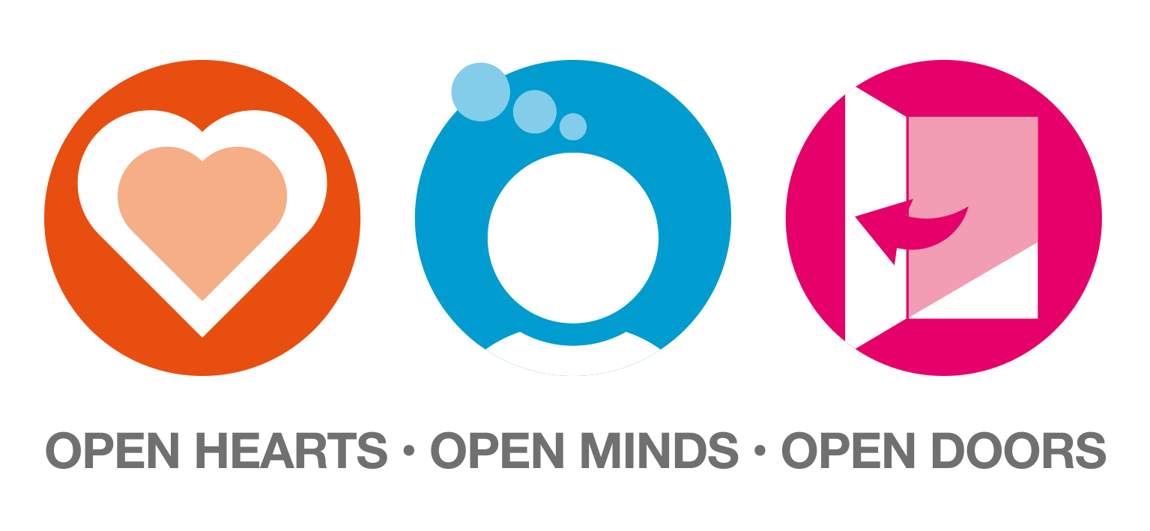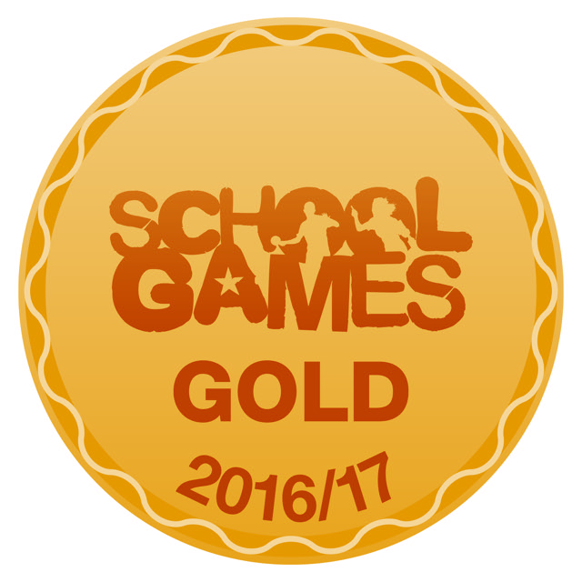

Dear Parents/ Guardians,

MOBBERLEY CHURCH OF ENGLAND PRIMARY SCHOOL

Church Lane, Mobberley, Cheshire, WA16 7RA

Headteacher: Mr D Stenson B.Ed NPQH

T: 01625 383055 • E: [admin@mobberley.cheshire.sch.uk](mailto:admin@mobberley.cheshire.sch.uk) • W: www.mobberley.cheshire.sch.uk

I would like to take this opportunity to welcome you all to Reception Class and to thank you for all your support in settling your children into school and helping them become independent little learners!

This letter will explain the topics for the first part of this term. The children in Reception Class will be following the Foundation Stage Curriculum and our activities will follow the seven areas of learning.

**Prime areas**

* Personal, Social & Emotional Development (PSE)
* Physical Development (PD)
* Communication & Language (CL)

**Specific areas**

* Literacy (L)
* Mathematics (M)
* Understanding the World (UW)
* Expressive Arts & Design (EAD)

The Imaginative Learning project for this half term is ‘Why Do You Love Me So Much?’ with a specific focus on ourselves, our families, our senses and how we use them to explore our environment, our bodies and skeleton, our emotions and feelings and things that make us special and unique. We will also be working on the ‘Why Do Leaves Go Crispy project, focussing on autumn time and Harvest which links very well with our whole school value of ‘Compassion’ and will be studied where relevant through the areas of the curriculum as follows:

L/ CL- A range of topic related story books will be shared for developing reading and writing of simple stories. We will use language to imagine and recreate roles and experiences in our ‘Home’ role play area. The writing area and story area will be equipped with a wide range of fun resources and materials for the children to explore and use whenever they wish.

M- This half term we will be counting forwards and backwards to 20. The children will be counting objects and matching to the correct numerals. We will begin practical addition and subtraction using appropriate mathematical language. In addition, we will be learning the names of and describing 2D shapes. In Reception Class we have a Maths Area which has stimulating interactive mathematical resources for the children to explore and apply their skills.

PSE- ‘New Beginnings’ – During this term we will be identifying and exploring our own feelings and we will play games to make everyone feel welcome and special, taking turns and sharing ideas.

UW- The children will be drawing and labelling their families and will be given opportunities to share special moments and memories. The class will listen to stories and songs related to our bodies and bones and we will learn about the different parts of our body and how to look after ourselves and keep healthy. We will also look at similarities and differences, making some comparisons between each other related to height, eye colour and hair colour. In addition, we will explore changing states of materials through making and moulding a model of our faces, using clay techniques. The children will be using a simple programme on the computer to paint and label a body. During the ‘Why Do Leaves Go Crispy?’ project the children will become ‘Harvest Investigators’ exploring using their senses and talking about what can be seen, heard, smelt and touched on an autumn harvest trail around our field and woodland. They will be making comparisons between different fruits and vegetables from around the world, exploring their tastes and the variety of shapes and colours they come in. We will also be making some vegetable soup to try! The children will be using a simple programme on the computer to paint and label a farmyard at harvest time. In Reception Class the children can choose to use the two computers, ipads and our Alpha touch screen (Interactive Wipe Board) for a variety of activities throughout the day.

RE - Our RE sessions will focus on Harvest stories, prayers, pictures and songs for the first half term. We will then be learning about the Hindu Festival of Light, ‘Diwali’. We will also be discussing the ways in which Christians welcome babies into our world. As we look forward to Christmas we will be thinking about the special birth of Jesus as we prepare for our wonderful Nativity play.

PD- On Monday afternoons we will focus on our ‘Real PE’ scheme where we will be using hoops and quoits and will be practising our ball skills of catching and throwing. The outdoor area will be available for the children to use every day. This will provide a range of equipment, large construction materials and space to promote physical development. Please could you ensure that your child has their PE kit in school at all times. Yoga will be taught every Tuesday afternoon with our specialist Yoga teacher, Miss Quibell

EAD- We will be exploring a variety of mixed media and materials throughout this half term, including observational drawing using mirrors to draw then colour mix and paint our self-portraits. Our finished paintings will create a lovely display to enhance our creative area. After studying our bodies and bones, we will use craft straws and cotton buds to create a relief skeleton picture. A selection of fruits and autumn leaves will be available to create rubbings and for printing patterns. The creative area has a selection of messy materials and resources giving the children the opportunity to create constructions, collages, paintings and drawings. In music we will sing songs and focus on beat and tempo, initially using hand claps and foot tapping/stamping, progressing to the use of a range of percussion instruments to follow a beat or rhythm. There will be opportunities for the children to make their own musical shakers using natural materials and to also use the class musical instruments. The children will also be developing their imagination through role play in our class ‘House.’

**Enrichment activities will include:**

* Harvest Festival in Church – Monday 7th October
* New Starters Photograph for Knutsford Guardian – Monday 14th October
* EYFS Reading/Handwriting Workshop – Tuesday 15th October 9.15am in School Hall
* Individual and Sibling Photographs – Monday 21st October
* Parents Evening – Monday 21st and Tuesday 22nd October
* Library Friday – Friday 8th November (8.45-9.00)
* Fluenz Immunisation – Friday 8th November
* Places of Worship, World Faiths Day – Friday 8th November
* Christmas Fair at Victory Hall – Friday 29th November (4-6pm)
* Library Friday – Friday 1st December (8.45-9.00)
* Infant Pantomime in School – Tuesday 3rd December (pm)
* Reception Class Nativity in School Hall – Tuesday 17th December (9.30am)

Show and Tell The children are extremely keen to bring some small items of interest/certificates/medals etc into class to show us all which is wonderful, but to avoid being overrun every day by things from home we will have ‘Show and Tell’ on a Wednesday afternoon. If your child wishes to bring something in to talk about we will collect them in a box at the start of the day and will talk about them in groups later in the day. Please do not send in any electrical or valuable items.

Homework will initially consist of a library book for you to share with your child at home. This book will be your child’s own choice. Your child may swap this book as often as they like by browsing through the books in the classroom labelled ‘library books’. Please do not worry if they forget as we will change your child’s library book weekly.

Individual reading books will be issued as soon as it is considered appropriate for your child. They will have the opportunity to change their book every day, please remind them in the morning to do so. Once your child has a reading book please try to hear them read **every evening**. Each child now has or will soon have key word sheets, these words are to be read using word recognition (look at the whole word and say) as the majority are tricky words and cannot be sounded out. Please encourage your child to read these every night so that they become more familiar with each new word.

Each week your child will be learning new sounds. Every **Wednesday** the new set of sounds will be sent home at the front of the sounds and handwriting homework book. Please support your child by revising these given sounds and words daily. If no new sounds are sent home please spend time revising **all** previously learned sounds.

Handwriting homework will also be sent home every **Wednesday** to practise our cursive letter formation. We learn our cursive letters in families so they do not normally correspond with the sounds we are learning. Can the homework book please be returned to school the following **Monday.**

Optional holiday homework will be sent home at half term. The activities will be varied and are intended to support your child’s learning in a fun and practical way.

Parents’ evenings will be held on Monday 21st and Tuesday 22nd October when you will have the opportunity to meet with me and to discuss your child’s individual progress.

I hope this gives you some guidance on some of the topics and activities your child will be engaging in this term. If you have any queries at all, please do not hesitate to see me at the beginning or end of the day or speak to one of our Reception Class Team: Mrs Norbury, Mrs Ashworth, Miss Quibell or Mrs Pilkington.

Thank you so much for your support,

Yours sincerely,

Sarah Franklin

Reception Class Teacher