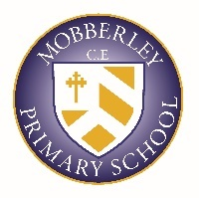
CURRICULUM BREADTH STATEMENT

OUR PUPIL’S BACKGROUNDS, OUR CULTURE AND OUR CLIMATE FOR LEARNING PROVIDE THE FOLLOWING DRIVERS THAT UNDERPIN ALL AREAS OF OUR CURRICULUM:
- SELF – HELPING PUPILS TO UNDERSTAND THEMSELVES, THEIR BELIEFS AND THEIR FEELINGS
- WORLD – HELPING PUPILS TO RELATE TO THOSE IMMEDIATELY AROUND THEM AND IN THE WIDER WORLD
- OPPORTUNITIES – HELPING PUPILS TO DEVELOP THROUGH HIGH QUALITY TEACHING AND EXPERIENCES
- THRIVE – HELPING PUPILS TO ACHIEVE AND BECOME WELL ROUNDED INDIVIDUALS
WE OFFER A DIVERSE RANGE OF EXPERIENCES THAT SUPPORT OUR ‘MOBBERLEY’ CULTURE: PUPILS ENJOY A ‘FULL SPECTRUM’ OF ACADEMIC, SPIRITUAL, MORAL, SOCIAL, PHYSICAL, AND CULTURAL ACTIVITIES THAT ENRICH THEIR LIVES AND GIVE THEM THE CONFIDENCE AND SKILLS FOR A FULFILLED, HAPPY AND HEALTHY LIFE.

