Wednesday 24th February
RE – To begin to understand why pancakes are made on Shrove Tuesday (Pancake Day)
Pancake Day is called Shrove Tuesday. This year Shrove Tuesday was on 16th February, in the half term holiday.
Pancake Day is the day before the start of Lent. People used to try and use up all the foods in their house that they are giving up for Lent.
Think about something you might like to give up for Lent and complete the sentence.
This Lent I will try and give up _______________________.
Pancakes are made from flour, eggs and milk. You can put lots of different things on top of your pancake but think about your favourite toppings and draw a picture of your perfect pancake.
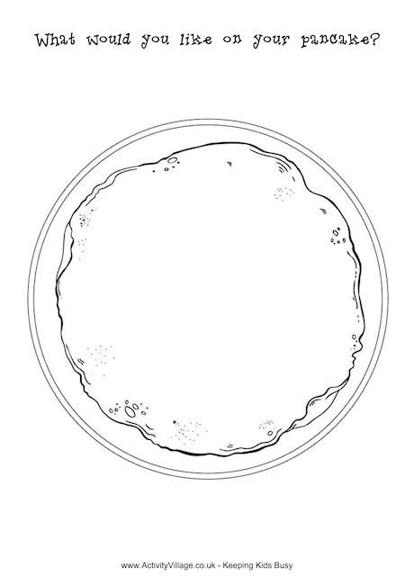
Here is my perfect pancake with my favourite toppings!

