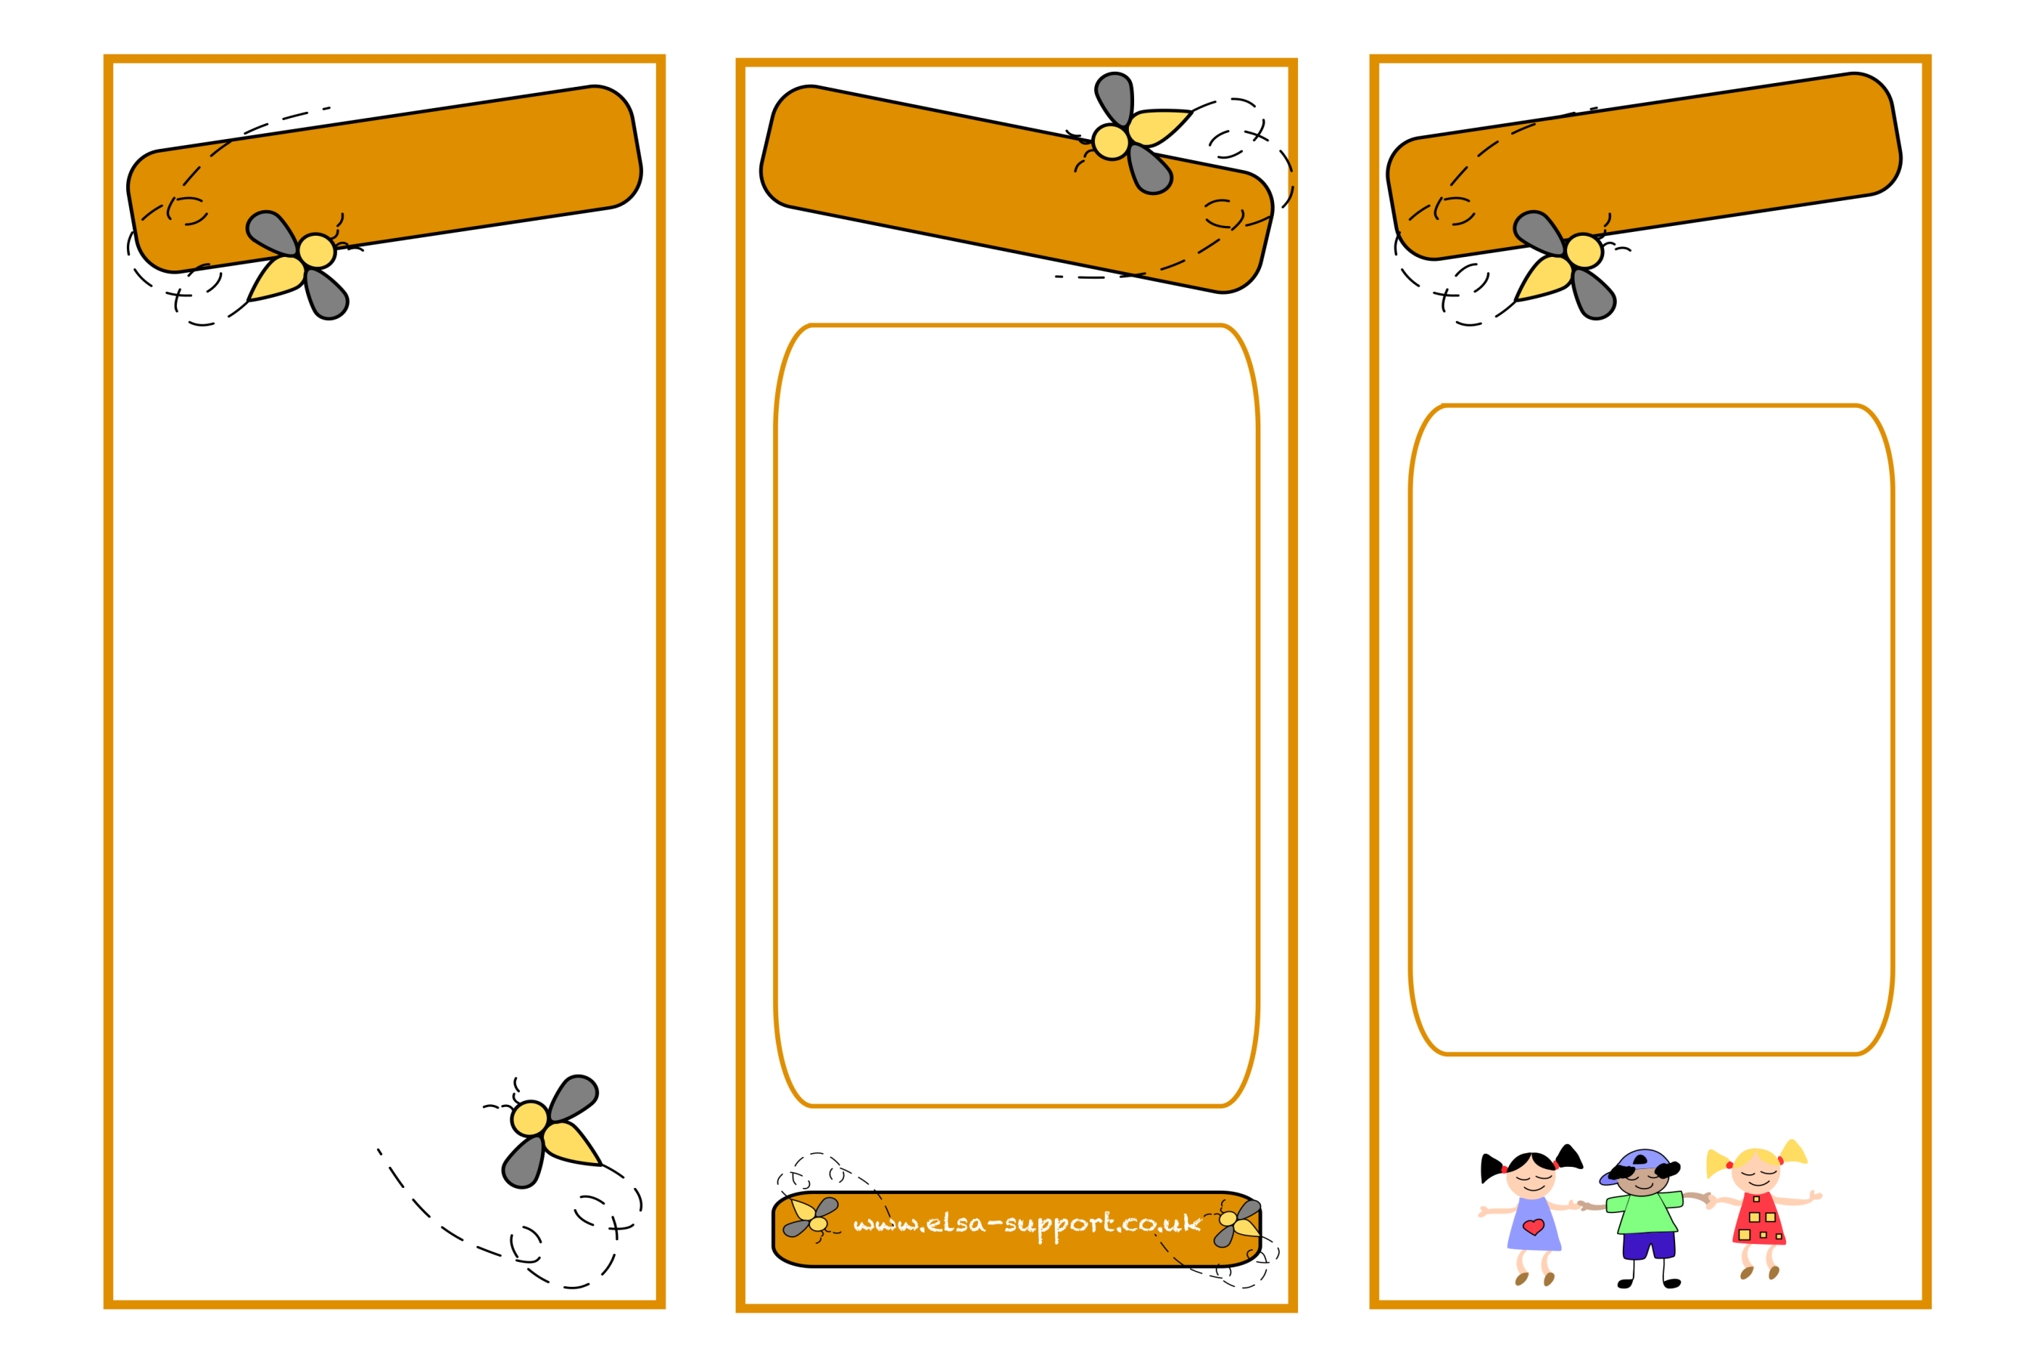

An ELSA is a specialist teaching assistant with a wealth of experience of working with children. ELSAs are trained and regularly supervised by the Educational Psychologists in your Local education authority. An ELSA is a warm and caring person who wants to help your child feel happy in school and to reach their potential educationally. Their aim is to remove the barriers to learning and to have happy children in school and at home.

Please do talk to your child’s teacher in your school if you have any problems with your child.

**Mrs Knowles**

**Loss and bereavement**

**Self-esteem**

**Social skills**

**Emotions**

**Friendship issues**

**Relationships**

**Anger management**

**Behaviour**

**Anxiety**

**Bullying**

**Conflict**

**Relaxation techniques**

**E**motional

**L**iteracy

**S**upport

**A**ssistant

**ELSA**

**What is an ELSA**

**ELSAs can help with**

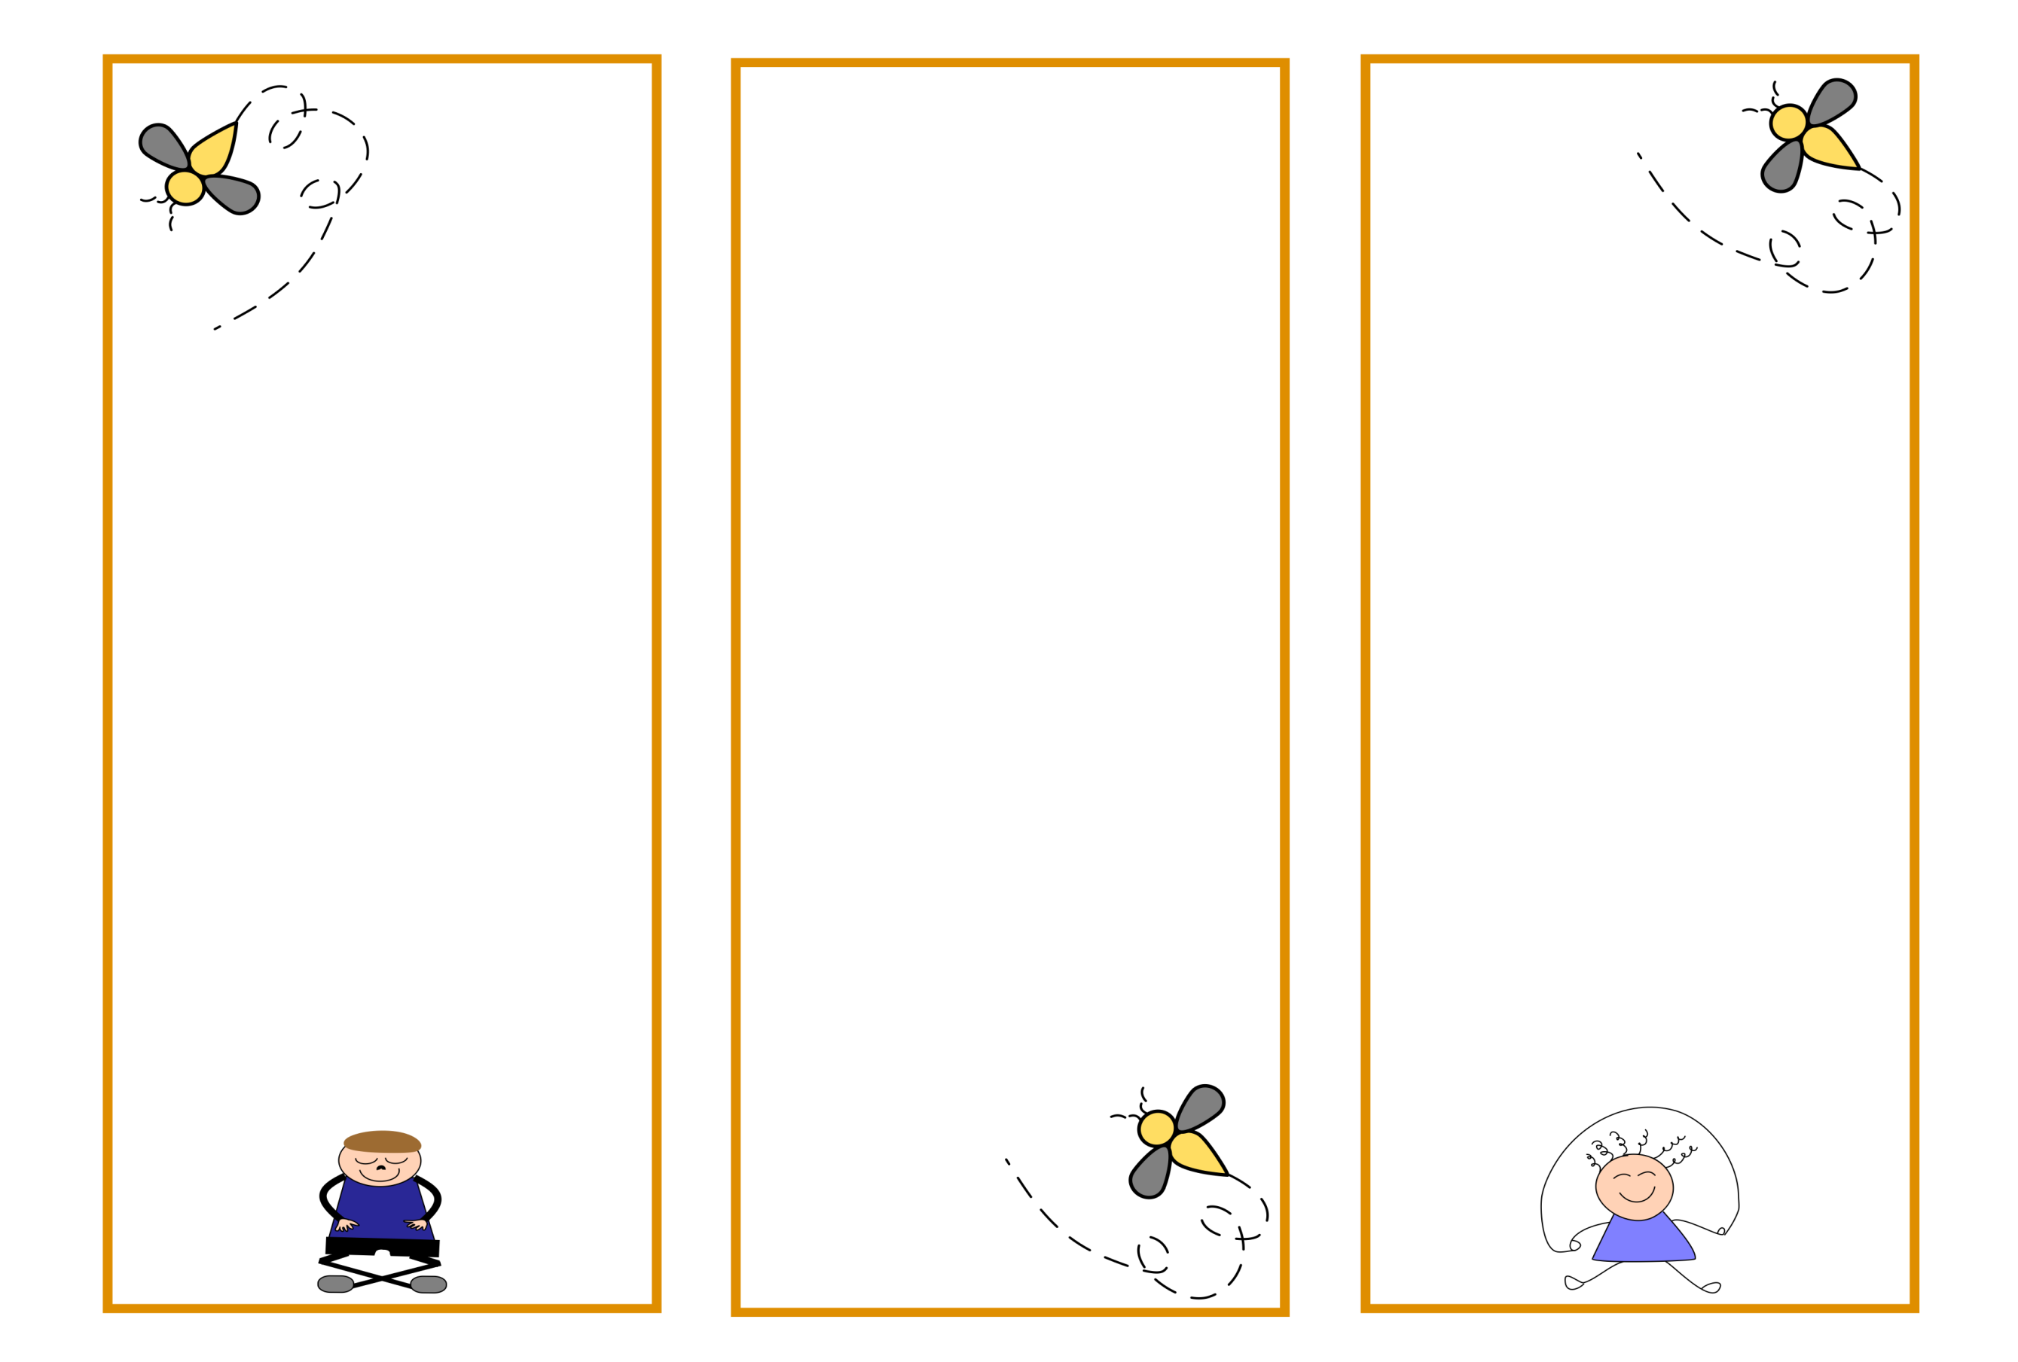

**A loved pet has died**

ELSAs are trained in bereavement and understand that the loss of a pet is probably the first experience of death for your child. They will work with your child to help them feel supported in school.

**Drop-in sessions**

If children in year 2-6 have a worry they can write it down on a worry card and post it in the worry box. They can name their worry if they want to talk about it or leave it unnamed if they just want it looked after. The child will then attend a drop-in session to talk about their worry; some will only need to talk once and some need a follow up.

Children are encouraged to let their worry go if they can’t change the situation or make a plan and then let the worry go. We use a mini shredder to get rid of the worry and think of something good instead.

Staff in Yr.1 and Reception support the children in their classes, resources are available if needed.

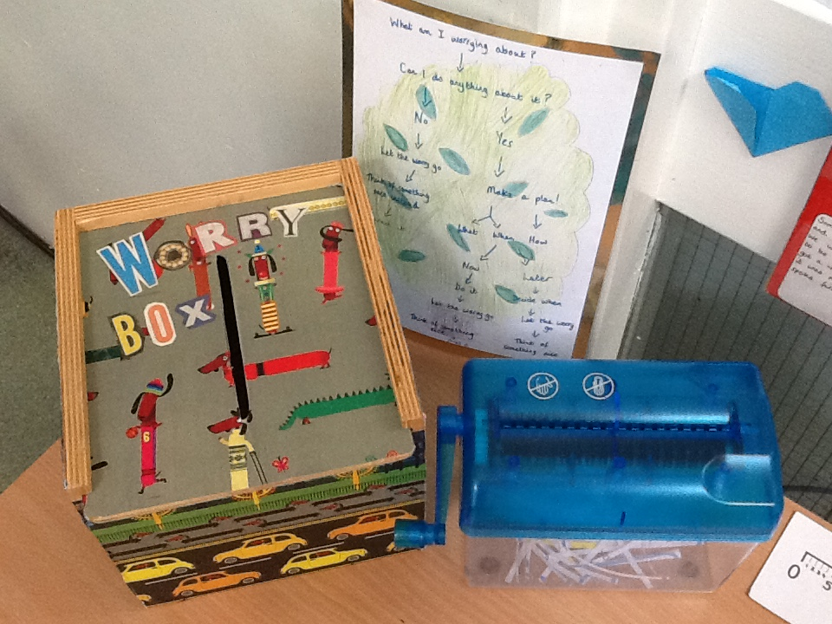

**How are the children identified?**

The class teacher will raise concerns either from their own observations or parent concerns.

**What happens next?**

Teachers complete a referral form and will have a chat with parents who are then given a permission slip that has space for them to share their concerns.

Once permission is obtained the sessions start with various questionnaires for the child to complete, they love filling these in!

Then based on the information collected from teachers, parents and the child areas are chosen to work on and three targets are set, these are reviewed after 6 weeks.

Sessions are once a week in an afternoon slot and last from 30-45 minutes.

Sessions are fun and might include role-play, puppets, games or art and craft. They include time to talk.

**A very angry child**

The ELSA will take the child through an anger management intervention to help them recognise their anger triggers, techniques to avoid those triggers and calming down techniques.

Typical problems

Whole school wellbeing

1:1 Sessions