Write About the Pictures
Here are 5 pictures, one for each day of the week!
Look at the pictures and write about what you can see. You can start your sentence with
I can see ……
Don’t forget to use a capital letter to start your sentence, finger spaces between words and a full stop at the end of the sentence. Try to use your lovely cursive handwriting.
Try carefully to sound out the words using the sound mats and try and remember some tricky words too!
Enjoy writing some super sentences!

Write About the Picture
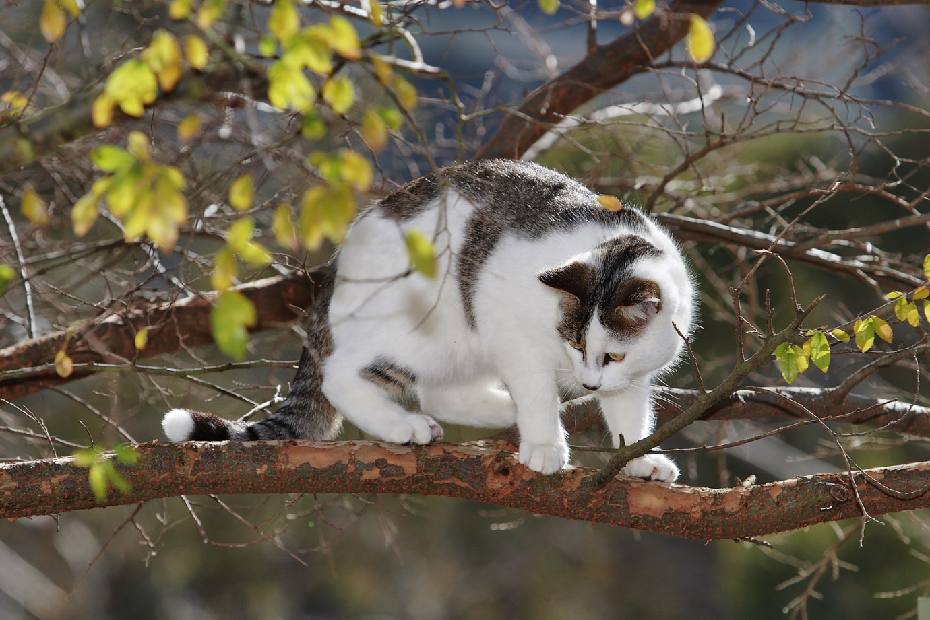

____________________________________________________________
Write About the Picture

____________________________________________________________
Write About the Picture
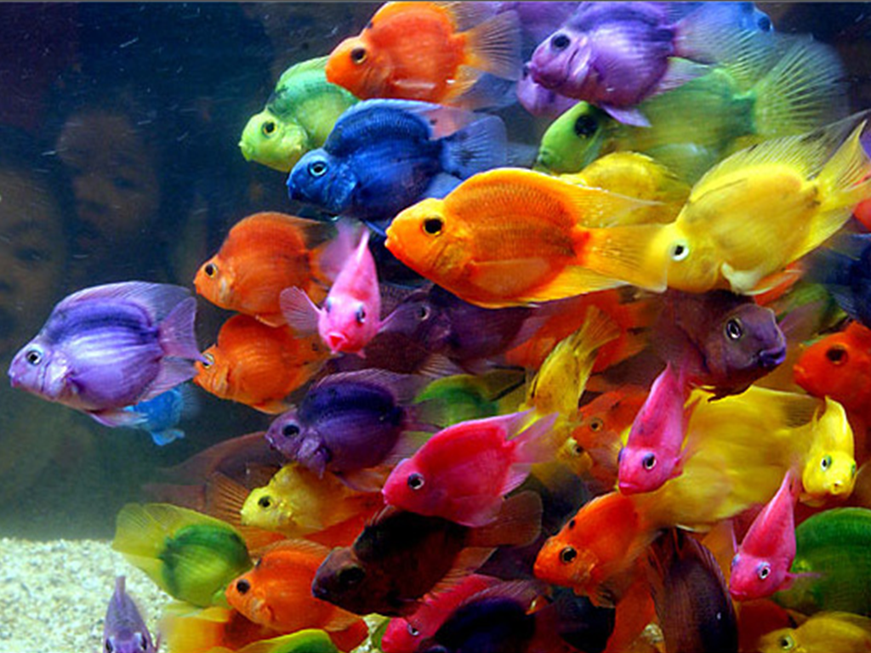

____________________________________________________________
Write About the Picture

____________________________________________________________
Write About the Picture

____________________________________________________________

