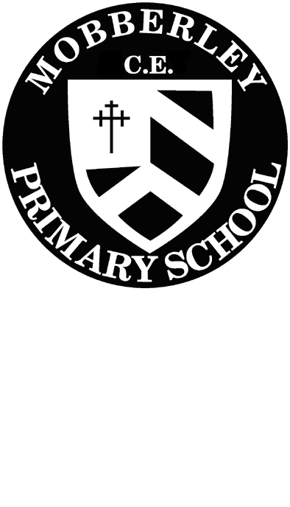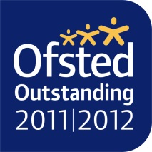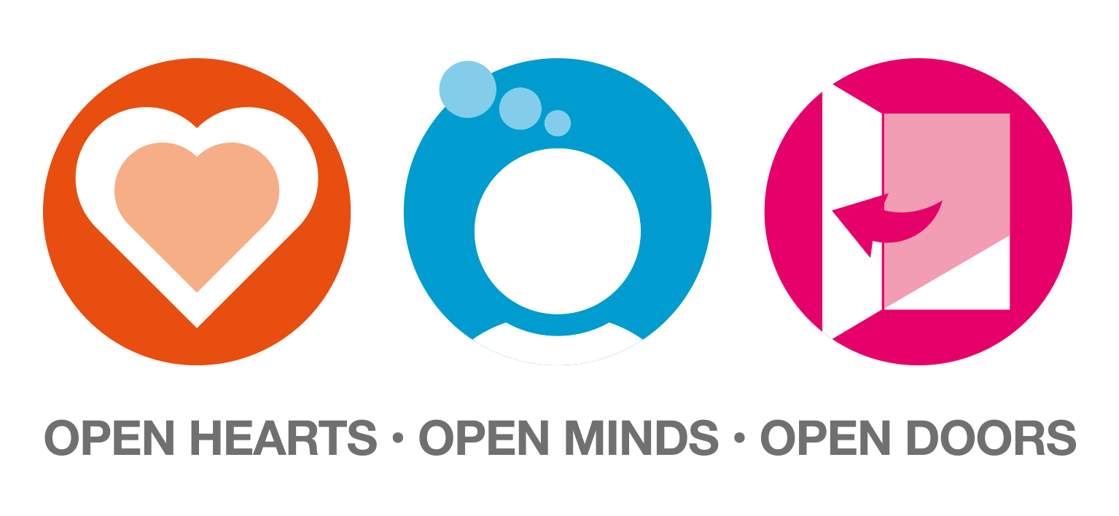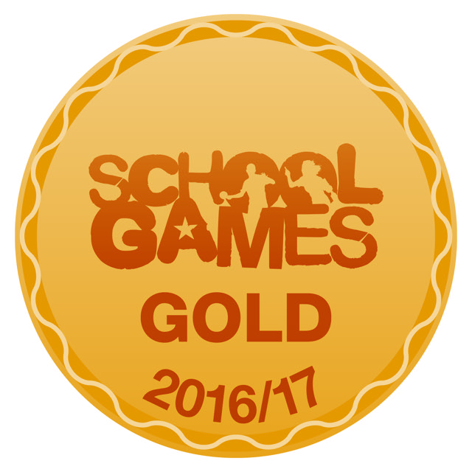

Dear Parents/ Guardians,

MOBBERLEY CHURCH OF ENGLAND PRIMARY SCHOOL

Church Lane, Mobberley, Cheshire, WA16 7RA

Headteacher: Mr D Stenson B.Ed NPQH

T: 01625 383055 • E: [admin@mobberley.cheshire.sch.uk](mailto:admin@mobberley.cheshire.sch.uk) • W: www.mobberley.cheshire.sch.uk

We hope that you and your family are keeping safe and well.

This letter will explain our topics for this busy and exciting Summer Term. The children in Reception Class will be following the Foundation Stage Curriculum and our activities will follow the seven areas of learning.

**Prime areas**

* Personal, Social & Emotional Development (PSE)
* Physical Development (PD)
* Communication & Language (CL)

**Specific areas**

* Literacy (L)
* Mathematics (M)
* Understanding the World (UW)
* Expressive Arts & Design (EAD)

For the first part of the Summer Term will be studying our **‘Are Eggs Alive?’** Topic which started with the wonderful arrival of the chick eggs and incubator. We loved watching them hatching and growing into fluffy chicks in the brooder and we all enjoyed holding or stroking them over the two weeks. A very exciting time for us all! We will also be learning about life cycles and how seasons change with a focus on signs of spring and latterly summer.

The topic for the next part of the Summer Term is **‘Which was the Biggest Dinosaur?’.** This has been chosen by the children and will be studied where relevant through the areas of the curriculum as follows:

PSE- ‘People who help us’ - The children will be learning about and discussing different people who help us in our community. They will also talk about the whole school Global topic ‘Send my friend to School,’ thinking about the important opportunities an education gives to people all around the world.

L/ CL- A range of topic related story books will be shared for developing reading and writing of simple stories. The children have loved reading and acting out the ‘Six Little Chicks’ by Jez Alborough and have produced some wonderful story maps and will be writing parts of the story over the coming weeks. After half term we will be reading and exploring elements of simple non-fiction dinosaur texts. The children will be writing for a variety of purposes such as instructions, lists, letters, labels and stories. We will use language to imagine and recreate roles and experiences in our Dinosaur Museum role play area. The writing area and story area will be equipped with a wide range of fun resources and materials for the children to explore and use whenever they wish.

M- We will continue to do counting and ordering activities to twenty and beyond and will still be counting in ones, twos, tens and fives. The children will be solving problems involving adding, taking away, doubling and halving. This will be taught practically using appropriate mathematical language in a fun way related to our topic. They will begin to find out and know some of the number pairs to ten and we will begin doubling and halving sets of objects and numbers. In shape, space and measure we will be continuing our work on 3D shapes, as well as ordering items by weight and capacity. The children will explore clocks and coins and will learn to use everyday language to talk about time and money. The maths area inside and outside the classroom has various interesting number, shape and measure resources and games for the children to use.

UW- Life cycles and seasonal changes will dominate this half term as we focus on the life cycle of a chicken; from egg, to chick to adult hen as well as looking at the life cycle of a caterpillar to butterfly and tadpole to frog. We will be exploring our school grounds and field for signs of spring and will also plant cress seeds and bedding plants, exploring what plants need to grow. A sense of time is a key focus next half term; the children will be investigating, talking about and describing fossils, dinosaur bones and skeletons. They will be making comparisons between the largest and smallest living things. We will be discussing the word ‘extinct’, sharing ideas and questions and will explore animals alive today that have similarities to dinosaurs e.g. crocodiles. They will be exploring programmable toys (Beebot) and planning and programming a journey through a dinosaur swamp. The children will be using a simple programme on the computer to paint a dinosaur and add a label. In Reception Class the children can choose to use the two computers and our Alpha touch screen (Interactive White Board) for a variety of activities throughout the day.

RE - This term the class will discuss, draw and write about people who are important to them and will explore the qualities that make someone special. The children will also be listening to Bible stories, as well as talking about and identifying how Christians see God and how this has an impact on their lives. Paintings, pictures, symbols and words will be used to describe God and afterwards the children will create their own individual image using a choice of collage materials and paints.

PD- On Wednesdays we will focus on movement, travel, space and gesture through Gymnastics and Dance. On Tuesday afternoons we will continuing our skills in Yoga with our expert Yoga Teacher, Miss Quibell. The outdoor area will be available for the children to use every day. This will provide a range of equipment, large construction materials and space to promote PD.

EAD- Firstly we will be creating a display to show the life cycle of a chicken and will incorporate our own chicks using feathers, paints, chalks and collage. We will be studying the artist ‘Henri Rousseau’ and will think about how animals often camouflage themselves within their environment. After half term we will also be exploring media and materials; planning, designing and making dinosaur and fossil models using a wide range of resources including clay and recycled materials. We will work as a class to draw and paint a massive dinosaur which can be later displayed. We will explore dinosaur skin using a range of collage materials. In music we will investigate pitch and dynamics linking to how a dinosaur moves and the loud and quiet sounds different animals make. The listening station and musical instruments give the chance to investigate this further. The creative area has a selection of messy materials and resources giving the children the opportunity to create constructions, collages, paintings and drawings. The children will have the opportunity to develop their imagination through role play in our class ‘Dinosaur Museum’.

**Enrichment activities will include:**

* Monday 19th April – Friday 29th April – Chicks in Reception Class
* Wednesday 5th May – Nick Sharrat whole school Zoom Session
* Monday 28th June – Lego Workshop
* Monday 7th June- Extra treat- the eggs/ chicks return to Reception Class (Surprise for the children)
* June/July - Reception Class Trip – to be confirmed

**Homework** consists of individual reading books which will be changed three times a week; please try to hear your child read **every evening**. Each child has key word cards, these words are to be read using word recognition (look at the whole word and say) as the majority are tricky words and cannot be sounded out. Please encourage your child to read these every night so that they become more familiar with each new word.

I hope this gives you some guidance on the topics and activities your child will be engaging in during this busy summer term. If you have any questions or queries at all please do not hesitate to see or speak to either of us, or any of our teaching assistant team; Mrs Norbury, Miss Quibell or Mrs Ashworth.

Thank you for your continued and valued support,

Yours sincerely,

Clare Murray Sarah Franklin

Reception Class Teachers