Friday 26th February
Space, Shape and Measure – To measure pictures of pets using cubes/lego blocks/paper clips
Activity – choose something you have at home to measure the pets. You could use lego blocks or oxo cubes or paper clips or anything you find!

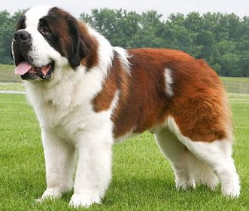

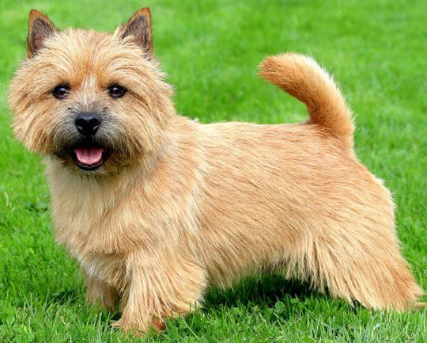

How tall is this little dog?

_____________ How tall is the big dog? ___________

How long is this green snake? _________________

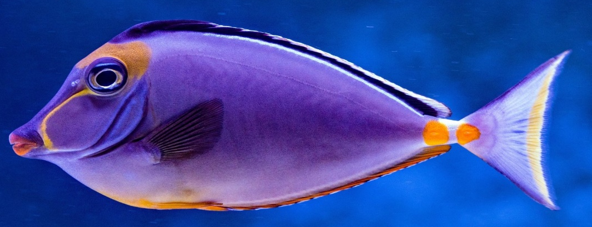

How long is this beautiful blue fish? ________

How long is this colourful fish? ________

How long is the parrot from the tip of her tail to the top of her head?
___________________

