I can measure …… | How many feet long? (Put one foot in front of the other to have a go at measuring with your feet!)
my bed

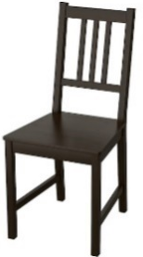
my chair

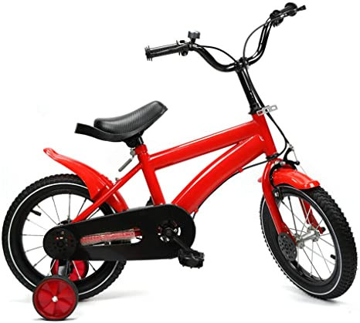
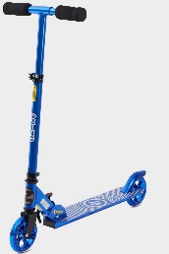
my bicycle or scooter

my sofa

Friday 29th January
Space, Shape and Measure (SSM) - I can use my feet to measure and record how long some things are in and around my home.
Challenge-Have a go at measuring other things in or around your home or garden and draw them in your home learning book. Have lots of measuring fun!

