SEND Report 2021
Data for June 2021.
We have 15 children on the SEND Register.
3 children have EHCP and 12 children are on SEND Support Plans.
We have 3 girls on the SEND register and 12 boys. You can see the breakdown of year groups below.
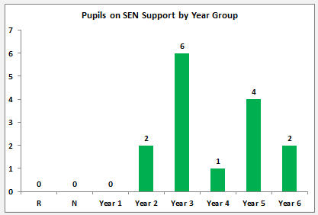
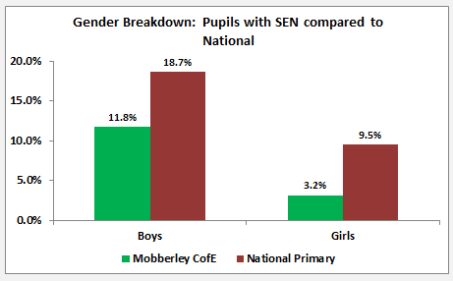

The graph below shows the comparison of our SEN Support children with National data.
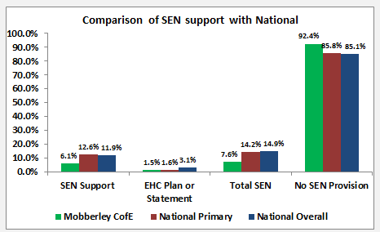
The graphs below show the percentage of children and the broad area of needs that we have at Mobberley C of E School. SEMH = 20%, Cognition and Learning = 40%, Communication and Interaction = 20% and Sensory and Physical = 20%.
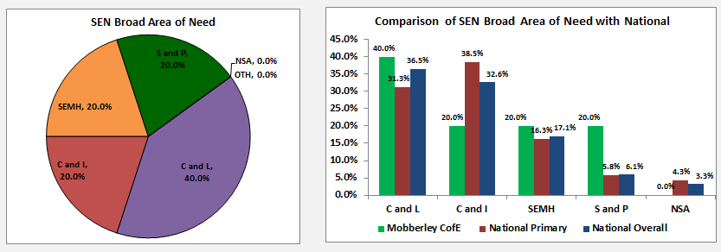
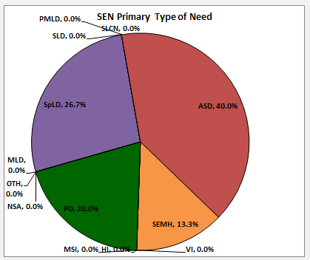
The primary needs are shown in the chart as follows:
Specific learning difficulty – dyslexia 26.7%
Physical Difficulty = 20%
Autistic Spectrum Disorder = 40% (some with ADOS and some on wait list)
Social, Emotional and Mental Health = 13.3%
SEND Progress 2021
Based on teacher assessment of the child’s progress made since September 2020 to June 2021.
Each child = 6.7%
 | Less than expected  (less than 5 points progress since September) | Expected  (5 points progress since September) | Accelerated  (more than 5 points progress)
Reading | 5 (33%) | 7 (47%) | 3 (20%)
Writing | 7 (47%) | 7 (47%) | 1 (7%)
Maths | 4 (27%) | 9 (60%) | 2 (13%)

