SEN information November 2021
We have 202 children in school. We have 15 children are on the SEND register. 3 children have EHCPs and 1:1 support.
We have 10 children on our First Concerns register – this data is not included in the information below.

This chart shows the pupils on SEN Support by Year Group.
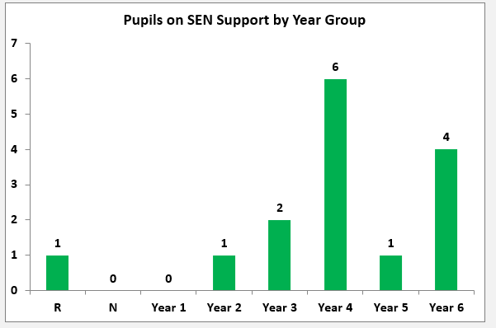

The graphs below shows the percentage of children and the broad area of needs that we have at Mobberley C of E School. SEMH (Social, Emotional and Mental Health) = 33.3%, C and L - Cognition and Learning = 46.7%, C and I - Communication and Interaction = 6.7% and S and P - Sensory and Physical = 13.3%.
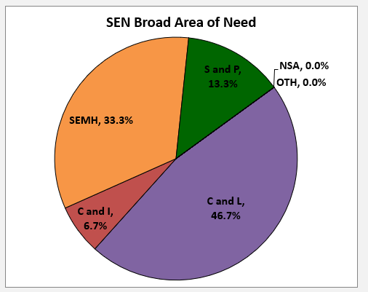
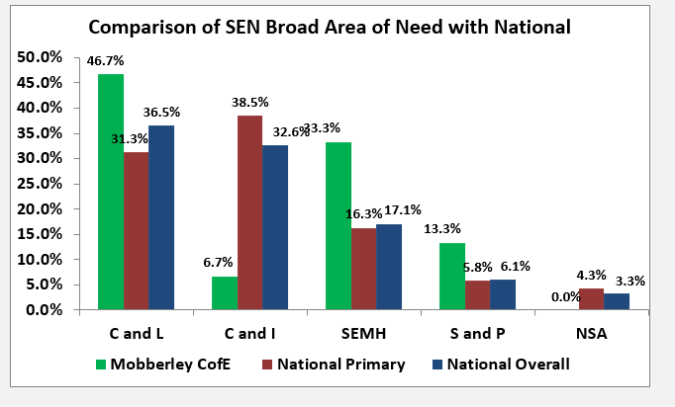
Key:
C and L – Cognition and Learning
C and I – Communication and Interaction
SEMH – Social, Emotional and Mental Health
S and P – Sensory and Physical

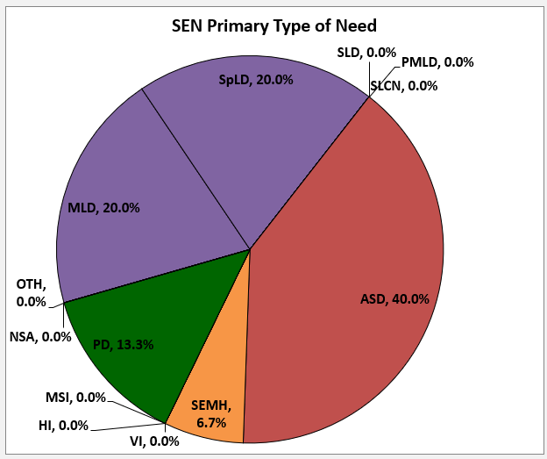
The primary needs are shown in the chart as follows:
SpLD - Specific learning difficulty – e.g. ADHD or dyslexia = 26.7% (some with a diagnosis, others high probability based on school screening)
PD - Physical Difficulty = 13.3%
ASD - Autistic Spectrum Disorder = 40% (some with ADOS and some on wait list)
SEMH - Social, Emotional and Mental Health = 6.7%
MLD – Moderate Learning Difficulty = 20%

EAL (English as an additional language)
The chart below shows the number of children with EAL (English as an additional language) on the SEND register. We currently have 1 child with EAL on the register.
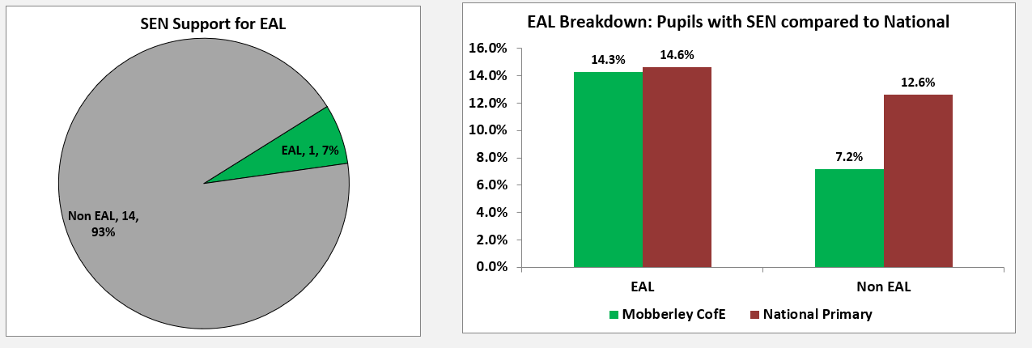
Gender Breakdown
We have 3 girls on the SEND register and 12 boys.
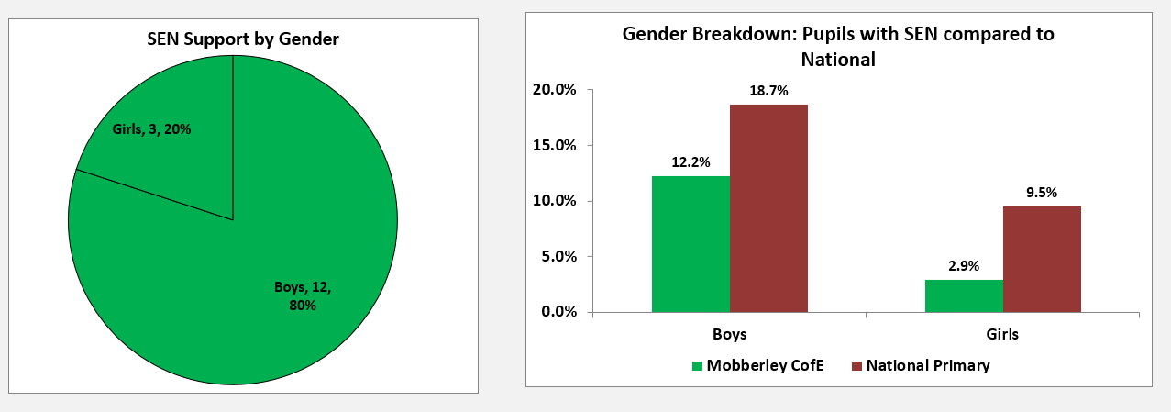
SEND Progress 2021
Based on teacher assessment of the child’s progress made since September 2020 to June 2021.
Each child = 6.7%
 | Less than expected  (less than 5 points progress since September) | Expected  (5 points progress since September) | Accelerated  (more than 5 points progress)
Reading | 5 (33%) | 7 (47%) | 3 (20%)
Writing | 7 (47%) | 7 (47%) | 1 (7%)
Maths | 4 (27%) | 9 (60%) | 2 (13%)

