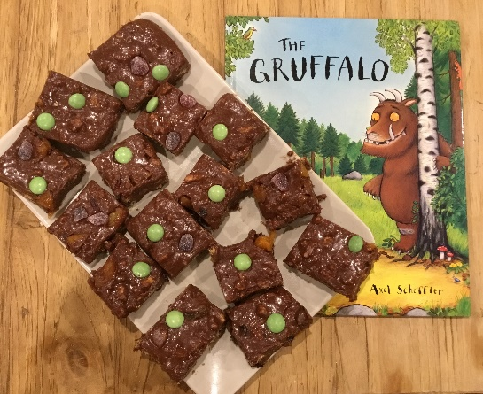
No Bake Gruffalo Crumble Recipe

Ingredients:
- 400g Digestive biscuits
- 150g Milk Chocolate
- 150g Dark Chocolate
- 100g Butter
- 75g / half a cup Golden Syrup
- 70g Dried Apricots (Orange eyes)
- 70g Raisins (Black tongues)
- Purple Jelly Tots (Purple prickles)
- Green Smarties (Poisonous warts)

1) Place biscuits in a food bag and use a rolling pin to bash into small pieces or use your hands if it is easier.

2) In a glass bowl, ask a grown up to help you melt the chocolate, butter and golden syrup over a pan of simmering water.

3) When melted remove the bowl from the heat and add in all the dry ingredients (except smarties and jelly tots) and mix well.

4) Spoon the mixture into a silicone tin or otherwise line a shallow square tin with cling film.

5) Using the back of a large spoon or potato masher, press down on the mixture to level and compact.

6) Add green smarties and purple jelly tots on top to decorate.

7) Put in the fridge for 2 hours to set.

8) Cut into squares and enjoy your Gruffalo Crumble.

