Message from Mrs Eadie 1st March (WK7 - 2021)

Hello everyone,
I hope you are all keeping well and looking forward to coming back to school and seeing all your friends again. This is the last musical message from me and I am sooo looking forward to seeing you all back in school next week!
As usual there are lots of activities for you to choose from. Please don’t try to do everything but anything you do please send me and see if you can win this week’s new music award!
Please send your work to me at my e-mail address. jeadie@mobberley.cheshire.sch.uk

My favourite song in the Daily Big Sing this week is Wednesdays The Dinosaur Gang especially for KS1.

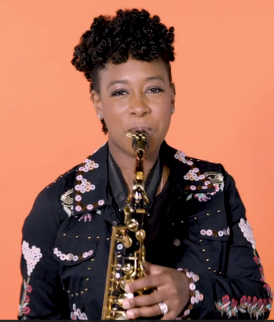
EYFS/KS1 Calling all Band Jammers! Yolanda Brown’s Something ‘bout that noise
Lesson 2/5
This week we are using Yolanda’s song to explore sounds and discovering how our bodies can be used to make music. We shall continue to explore DYNAMICS and how musical RHYTHMS can be made with our bodies to help Yolanda add dramatic dynamics to her new song.
Lesson 2 - Make Some Noise! on Vimeo
and the second one is a link to Yolanda’s song – Something ‘bout that noise!
https://youtu.be/vOCHxGKikVo
Using the ‘What Is Making That Noise?’ activity sheet.
• Watch the video of YolanDa performing her song and tick the instruments you see/hear.
• Extra challenge: can you link the correct name to the instrument?
• Can you colour in the LOUDEST instrument used in red and the QUIETEST in green?

When you have finished watching can you help YolanDa use her body to add dynamics to her song?
Using the ‘My Body Percussion Song’ activity sheets, can you explore different ways of making noise with your body and help YolanDa decide how she can make loud and quiet body percussion sounds?

KS2 WARM UP, LEARN, JOIN IN! (approx 15 mins)
https://www.bbc.co.uk/teach/ten-pieces/ten-pieces-musical-menu/zmypxbk?dm_t=0,0,0,0,0
The voice, words and syllables, instruments, performance and composition are the themes for this week’s BBC Ten Pieces Musical Menu activity.

WARM UP – Sing along with Lucy and Jess from the BBC Singers. They are using a song that some of us already know, I love the flowers!
LEARN – Singer Kizzy Crawford tells the story of a girl from Wales who stood out from the crowd. Listen to her story then watch as she sings alongside a Welsh traditional instrument, the tabwrdd drum.
JOIN IN – Learn how write your very own one-word song using your voice and body percussion inspired by Gerald Barry’s Canada! (A very bizarre song which is bound to make you laugh!)

YR4....Just for you this week. Have a listen to Thursday’s Daily Big Sing. The most beautiful song about a River Journey! You might find some lovely noun phrases that you can use in your river work.

LOVE MUSIC TRUST LESSONS

KS1 This week we are to investigate the WOODWIND section of the orchestra. Your first clip to watch is from the BBC National Orchestra of Wales. https://youtu.be/KEt1Mm8sSkA I love how an instrument on its own sounds quite weak and thin, but when they are played in a small group with harmonies they sound so much more beautiful - richer, thicker and strong. Listen to that contrabassoon and tell me how that makes you feel!! It is so deep and dark. It makes my tummy feel rumbly as it vibrates through those very low sounds.
https://www.youtube.com/watch?v=5PMmJ7CqmoQ In their House of Sound Greg Foot and Fran Scott explain how woodwind instruments work and make all sorts of different sounds. They find out that lots of woodwind instruments are not even made of wood , and to prove the point Fran makes a woodwind instrument out of a carrot simply by making a few holes in it. Greg and Fran demonstrate that the pitch of a woodwind note depends on the amount of air that is vibrating inside the instrument. To prove this they conduct a fun experiment in which they make simple flutes out of drinking straws and make them play higher notes just by cutting bits off to make them shorter. You could even make your own pan pipes out of drinking straws!

KS2 https://youtu.be/oJ_zgSd-DBE
This week we are continuing on our journey with music from around the world. This week we are going to be listening to and learning about a great GENRE (style) of music. Have a listen and see if you can guess what it is. The links on the LMT lesson will take you to your activity for this week.

YEAR 6 https://youtu.be/6XGtp_Br6L0 LOCKDOWN BRASS LESSONS!
You will be pleased to hear that this is the last remote lesson from Mr Birch (hopefully!). As from next week we will have Mr Birch back with us in the classroom and I’m sure he will be impressed by your amazing progress on your instruments! I hope you have enjoyed your lockdown lessons and are ready to come back next week with your new found brass skills!
This week you will be:- 1. Learning a new rhythmic rhyme called coffee pots which will help with our note values.
2. Recapping the Harmonic Challenge learned earlier
3. Learning and playing a new song called Play Together

If you have still not accessed the first lesson on instrument care, please can I suggest you do so before you carry on playing! https://youtu.be/DV07Ldw4QJo Lockdown lesson 1
https://youtu.be/odEWdFsi79o Lockdown lesson 2

https://youtu.be/_uUKb_q5eQ8 Lockdown lesson 3
https://youtu.be/PUmvRj3_d0M Lockdown lesson 4
https://youtu.be/LezXQlc8aVk Lockdown lesson 5


DAILY BIG SING
Welcome to the LMT’s daily big sing where this week we are going to explore our wonderful planet Earth and all the lovely places you can visit.

Monday Down in the Jungle https://youtu.be/FCkxCC5MTnQ
Our warm up exercise today is making a cup cake!
Tuesday The Desert Song https://youtu.be/G2Du_o-eZo8
The warm up song today is a ‘round’ song which means several people sing the same song but at different times, so if you have a brother or sister or other person in your house you could do this together. It is called Laudinelle (Which means ‘give us praise’ in Italian)
Wednesday The Dinosaur Gang (Great Song!) https://youtu.be/gr2uM2hwSrQ
Calypso is our warm up song today
Thursday The River Journey https://youtu.be/QChAJCGWvww
Mrs O’Leary’s lantern starts our singing today!
Friday Mountain Air https://youtu.be/gqHGUdCjxCE
This is a jolly little number. Well worth learning

SING UP https://www.youtube.com/singup
Have you joined in with our #feelgoodfifteen# yet? How about joining us at 9am on Tuesday morning for 15 minutes to get our brains warmed up with song ready for your daily lessons. Tune in on Tuesday 2nd March @9am for the seventh of their weekly series of live sessions, run by a range of fabulous vocal leaders. You can access it either on the Sing up Youtube channel or their Singup at home channel https://www.singup.org/singupathome where they will live stream for anyone wanting to watch. Don’t worry if you miss it as each video will be saved so you can catch up afterwards. Let’s all enjoy the benefits of singing at home!

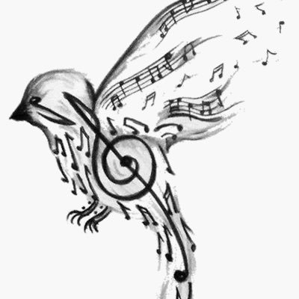


Mrs Eadie
1st March 2021

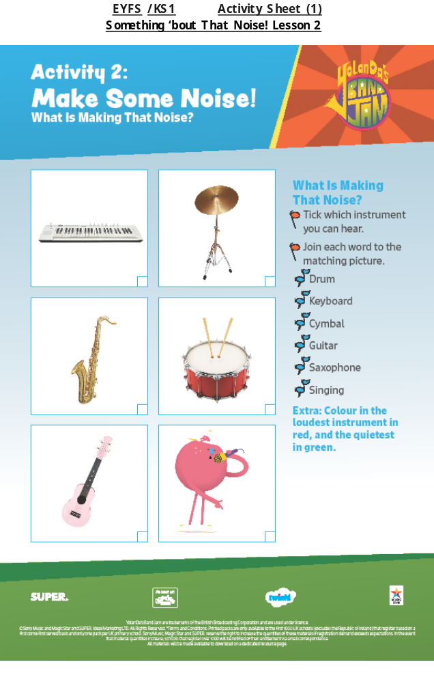
EYFS /KS1 Activity Sheet (2)
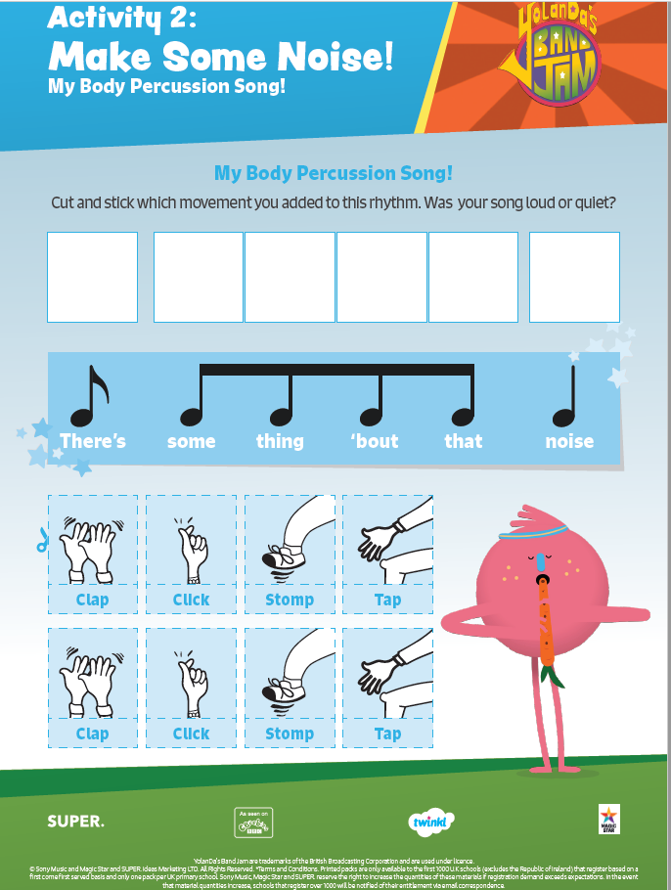
Something ‘bout That Noise! Lesson 2

YR1/YR2 LMT LESSON

The Woodwind Family

Write the name of each of the instruments underneath the picture.

 | 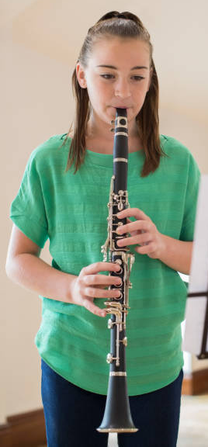 |  | 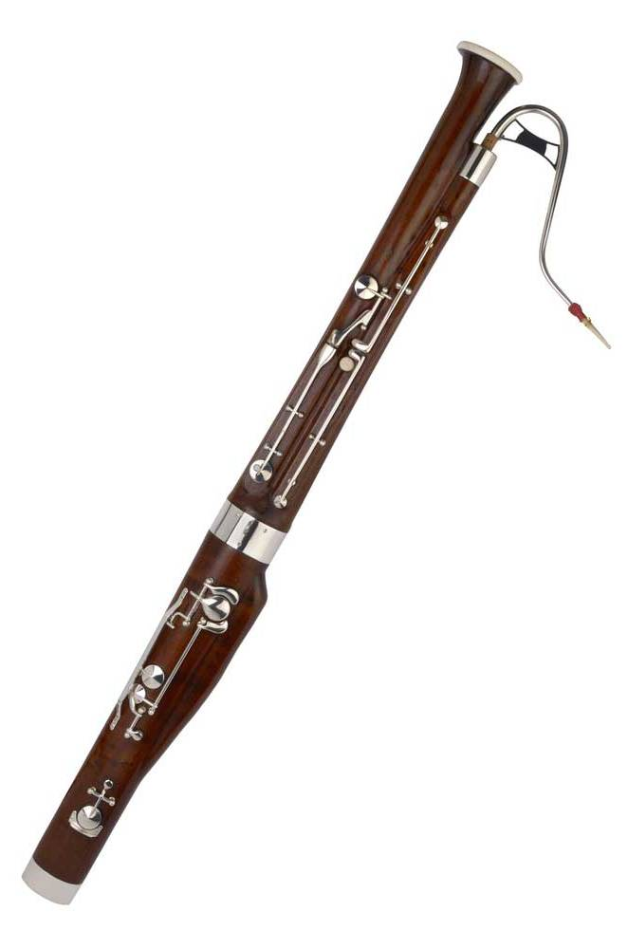

Which of the four instruments is highest in pitch?
----------------------------------------------------------
Which of the four instruments is lowest in pitch?
---------------------------------------------------------
Which instrument does not have a reed in the mouthpiece?
--------------------------------------------------------------
Which one of these instruments do you like the best? Can you say why?
------------------------------------------------------------------------------------------

