Friday 22nd January
Space, Shape and Measure (SSM) – Estimate how many objects (up to 10 or 20) you can see and check how many you have by counting each object, move each object away as you count.
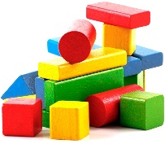
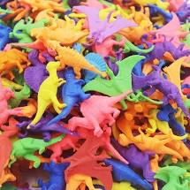
Estimating Activity
Activity Instructions: -
1.Make a pile of objects (Use anything you have at home to complete this activity eg toy animals, little dinosaurs, lego cubes, cars etc) You can have a go with up to 10 or 20 objects.
2.At first make a guess of how many objects you have and write your answer (Estimation).
3. Now count each object moving each one away to help you find the actual number.
Draw a picture of your object  eg car/lego/dinosaur | Estimation  (Can you make a good guess?) | Actual Number  (How many did you count?)
Well done everyone! I hope you had fun completing this estimating and counting activity.
Challenge – Complete more estimating and counting activities!

