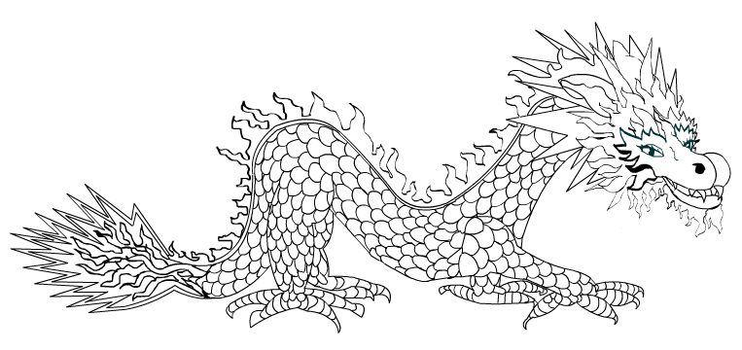
Dragon Puppet – Colour the dragon, then cut out and attach 2 sticks to make the dragon dance.

