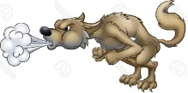
Monday 18th January
Big Bad Wolf ‘Huff and Puff’ Experiment
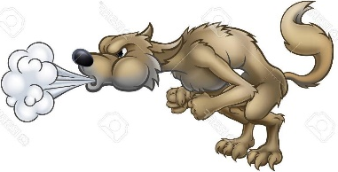
Science - Understanding the World (UW-TW) – To experiment with heavy and light object to see if they can be moved by blowing.
You will need:-
- A pencil and experiment sheet
- A selection of heavy and light objects eg a feather, ball, teddy, leaf, stone, cotton wool etc
Experiment - You are going to pretend to be the Big Bad Wolf and try and blow some objects by huffing and puffing. Choose your objects then draw a picture in the ‘Object’ boxes, now think if it will move by blowing (make a good guess) and write yes or no in the ‘Prediction’ box. Afterwards have a go at huffing and puffing your object and see if it moves. Finally write your answer (yes or no) in the ‘Results’ box. I hope you have lots of fun huffing and puffing like the Big Bad Wolf!
Experiment - Will it ‘Huff and Puff?’
Object  (Draw your objects to be huffed and puffed in the boxes below) | Predictions  (make a good guess)  Do you think your object can be ‘huffed and puffed along?  yes or no | Results  (actual test result)  Did your object move when it was ‘huffed and puffed?  yes or no

