Tuesday 23rd February 2021
To identify vehicles and describe them using adjectives.
How many vehicles can you name?
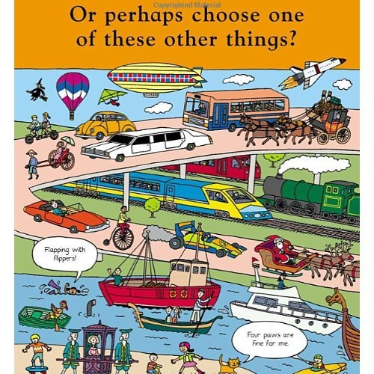
Adjective | Vehicle

