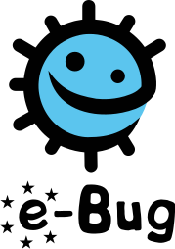

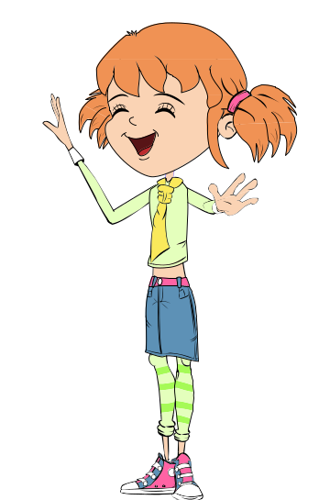
Microbes are living organisms
They are so small we need a microscope to see them
They come in different shapes and sizes
They are found EVERYWHERE!
Some microbes are useful or even good for us
Some microbes can make us ill
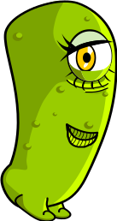
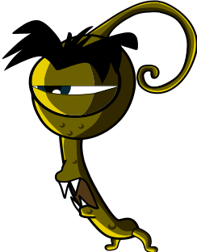
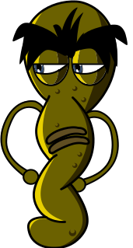
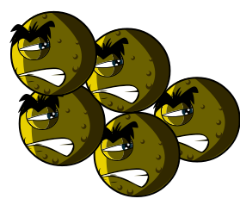
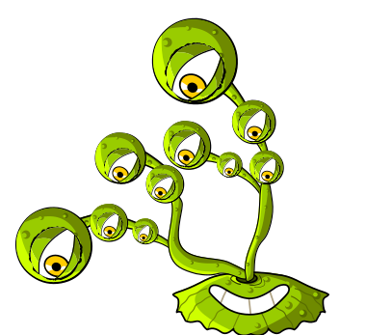
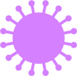
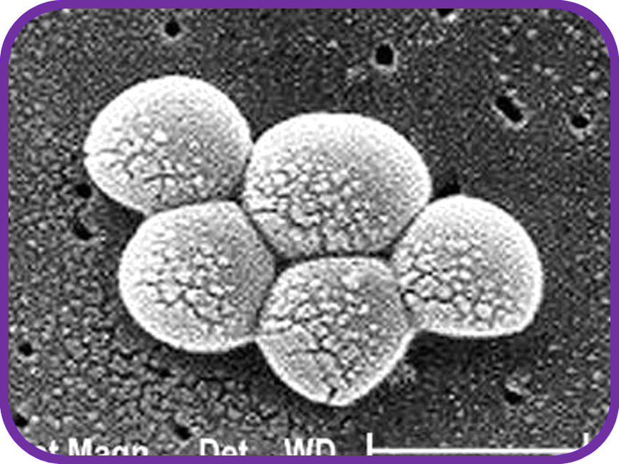
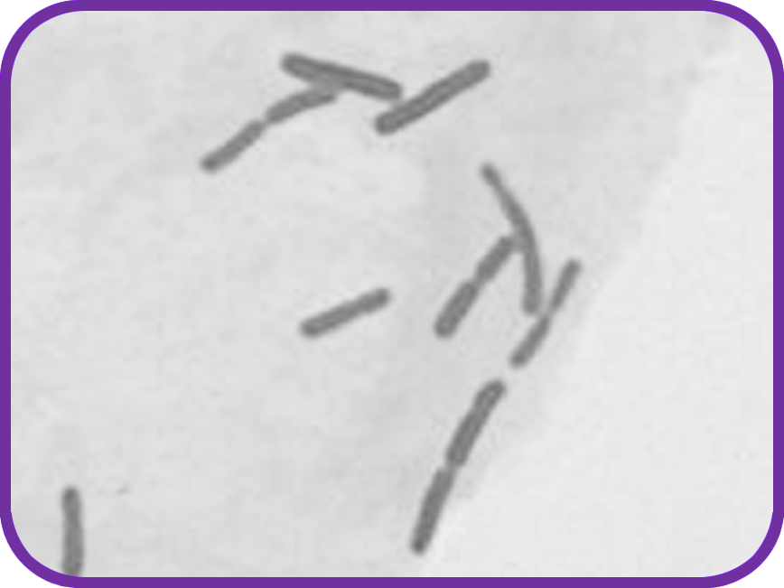
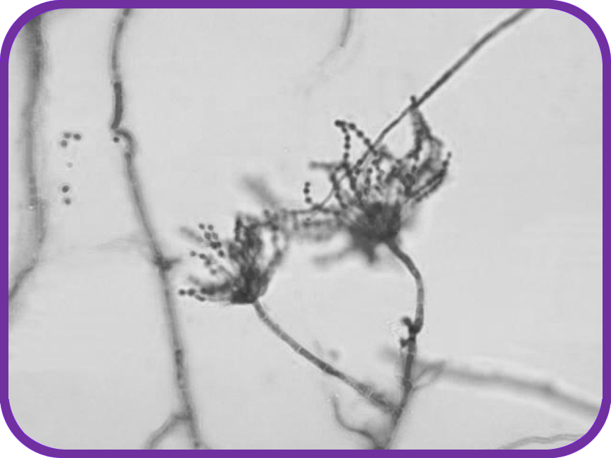
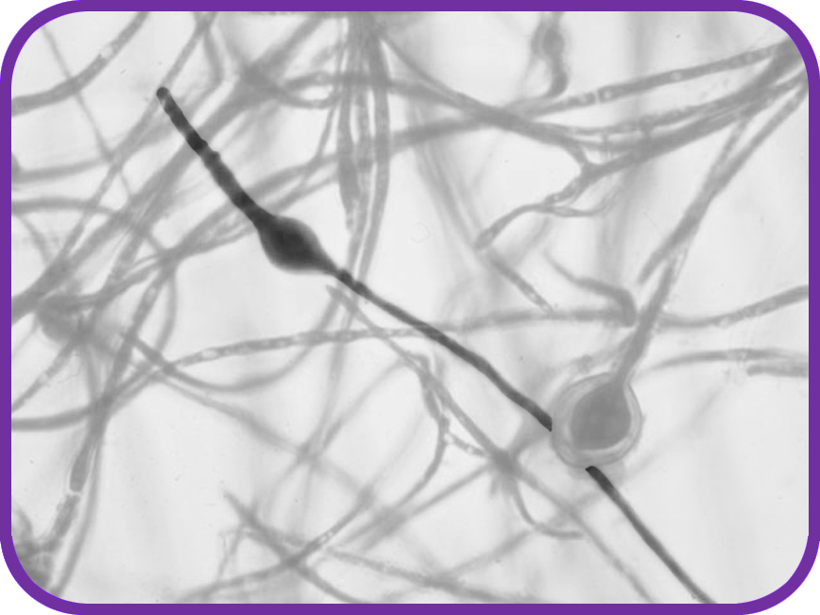
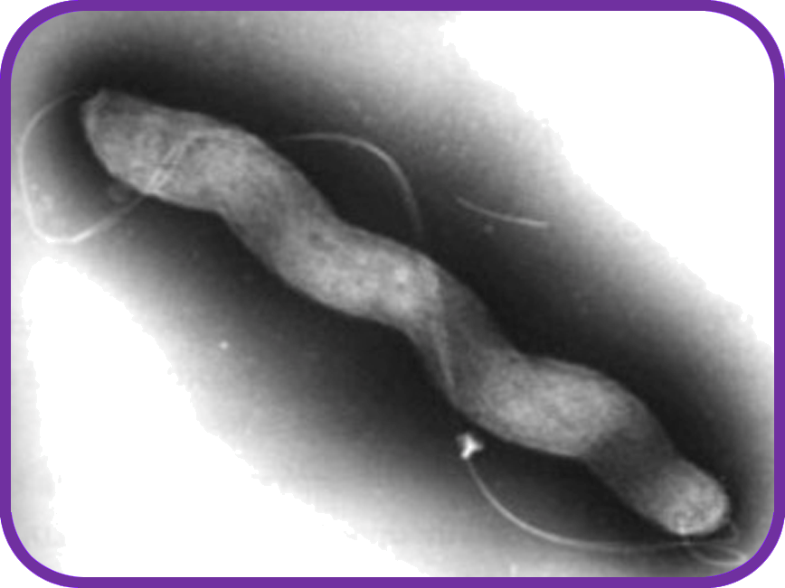
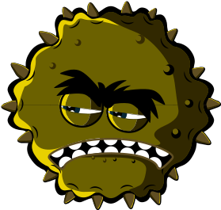
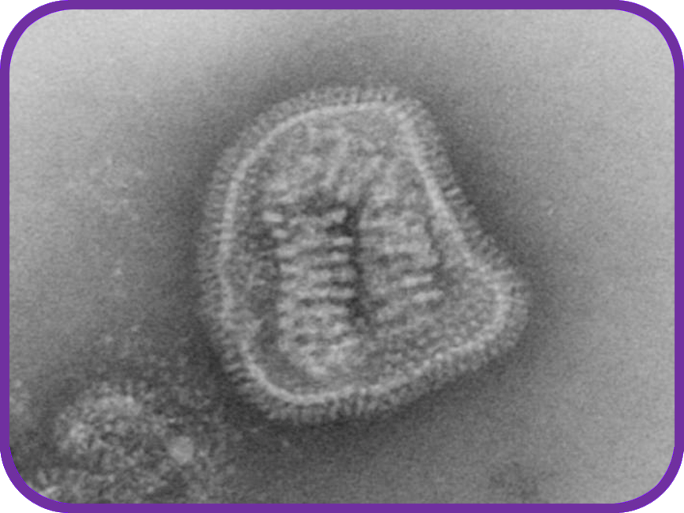
PenicilliumDermatophyte

Fungi are the largest of all microbes.

Fungi can be found in the air, on plants and in water.

Mould, which grows on bread, is a type of fungus.

Some antibiotics are made by fungi!

There are three different types of bacteria. They look like:

Spirals
(Campylobacter)Rods
(Lactobacillus)Balls
(Staphylococcus)

They are so small that 1000s of bacteria could fit on the full stop at the end of this sentence.

Some bacteria are helpful in cooking, for example, making yogurt and cheese.

Some bacteria are harmful and cause infection.

Bacteria multiply very fast.

Influenza

Viruses are even smaller than bacteria and can sometimes live INSIDE bacteria!

Some viruses make us sick.

Diseases like CHICKENPOX and the FLU are caused by viruses.

Viruses can spread from one person to another but it depends on the type of virus.

SH 1
INTRO
Microbe
Size
There are 3 different types of microbes:

