Wednesday 3rd January 2021
To record ideas about our new text.
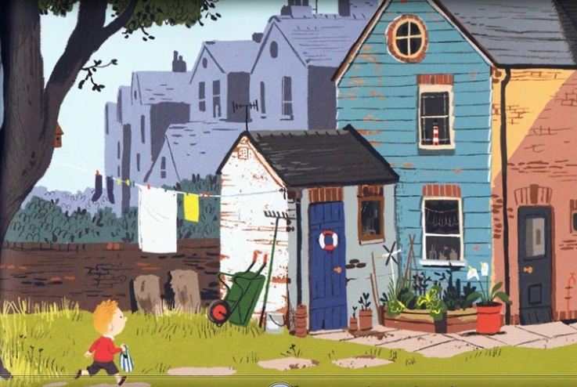

I can see __________________________________________________________
_________________________________________________________________
I can see __________________________________________________________
_________________________________________________________________
I think ___________________________________________________________
_________________________________________________________________
I think ___________________________________________________________
_________________________________________________________________
I’m wondering______________________________________________________
_________________________________________________________________
I’m wondering______________________________________________________
_________________________________________________________________

Thursday 4th January 2021
To describe a setting using noun phrases and prepositions.
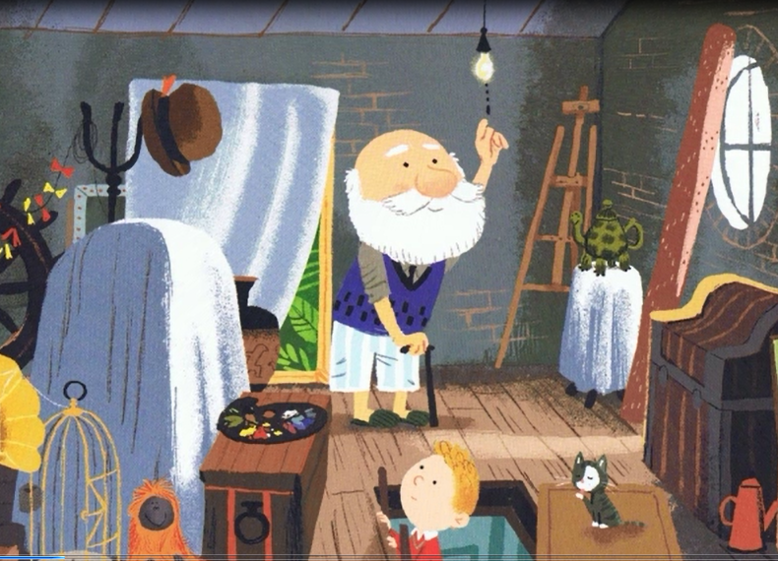

In Grandad’s attic there is ______________________________________
In Grandad’s attic there are ______________________________________
___________________________________________________________
___________________________________________________________
___________________________________________________________
___________________________________________________________
___________________________________________________________
___________________________________________________________
___________________________________________________________
___________________________________________________________
___________________________________________________________
Friday 5th February 2021
To use because and so.
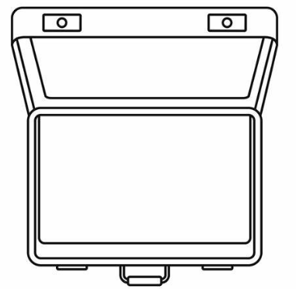

I would take ______________________ because _____________________
___________________________________________________________
I would take ______________________ so__________________________
___________________________________________________________
___________________________________________________________
___________________________________________________________
___________________________________________________________
___________________________________________________________
___________________________________________________________
___________________________________________________________

