25.1.21
No live session – watch Loom video.
To use arrays to write repeated addition and multiplication sentences.
Write the repeated addition and multiplication sentence that matches the arrays. You can count the rows or the columns.
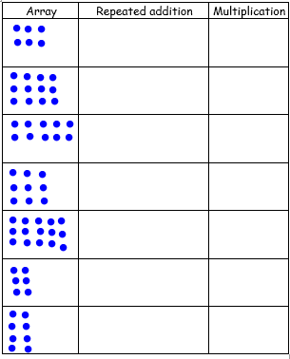

26.1.21
2x tables
Fill in the blanks – counting in 2s all the way to 60!
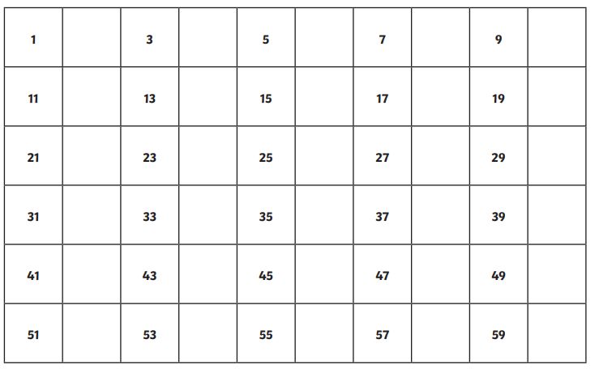
Use your number grid to complete these number tracks. Remember, you are counting in 2s but check if the track is going forwards or backwards!
2 |  | 6 | 8 |  | 12

14 |  | 18 |  |  | 24

60 | 58 |  |  | 52

34 |  | 30 |  | 26

24 |  | 28 |  |  | 34

Tuesday Extra 2x tables questions – use the alien to help you answer!

3 x 2 = ___
7 x 2 = ___
4 x 2 = ___
6 x 2 = ___
9 x 2 = ___
5 x 2 = ___
10 x 2 = ___
1 x 2 = ___
8 x 2 = ___
2 x 2 = ___

27.1.21
5x tables – counting in 5s.
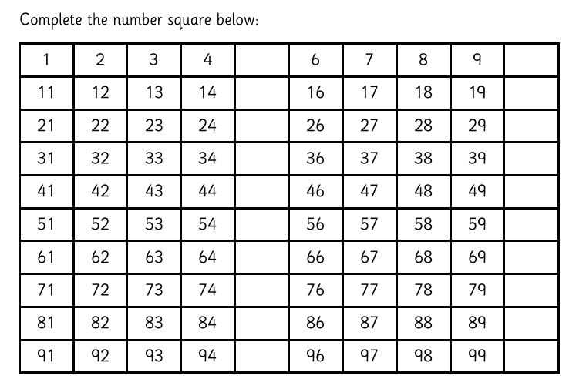
Use your number grid to complete these number tracks. Remember, you are counting in 5s but check if the track is going forwards or backwards!
5 |  | 15 |  | 25

10 |  |  | 25 | 30

40 |  |  | 55 |  | 65

100 | 95 |  | 85

55 | 50 |  |  | 35

Wednesday Extra 5x tables questions – use the alien to help you answer!

3 x 5 = ___
7 x 5 = ___
4 x 5 = ___
6 x 5 = ___
9 x 5 = ___
5 x 5 = ___
10 x 5 = ___
1 x 5 = ___
8 x 5 = ___
2 x 5 = ___

28.1.21
10x tables – counting in 10s
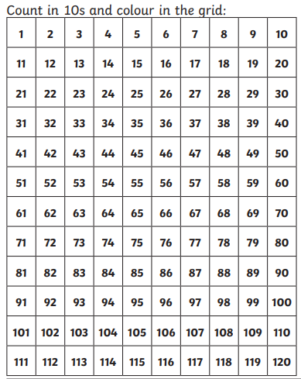
Use your number grid to complete these number tracks. Remember, you are counting in 10s but check if the track is going forwards or backwards!
10 |  |  | 40

30 |  |  | 60

40 |  |  | 70

100 | 90

120 |  |  | 90
Thursday Extra 10x tables questions – use the alien to help you answer!

3 x 10 = ___
7 x 10 = ___
4 x 10 = ___
6 x 10 = ___
9 x 10 = ___
5 x 10 = ___
10 x 10 = ___
1 x 10 = ___
8 x 10 = ___
2 x 10 = ___

