15.1.21
No live session – Listen to/watch the powerpoint and recap ways to divide
Solve these questions by sharing.
12 ÷ 3 =

16 ÷ 4 =

8 ÷ 2 =

Solve these questions by grouping.
12 ÷ 2 =

15 ÷ 5 =

10 ÷ 2 =

Solve these questions on a number line.
100 ÷ 10 =

0

60 ÷ 5 =

0

19.1.21
Draw arrays to show multiplications
2 x 3 =
3 x 4 =
3 x 3 =
2 x 5 =
7 x 2 =
4 x 4 =
2 x 10 =
6 x 2 =
20.1.21
Solve multiplication calculations using arrays and repeated addition.
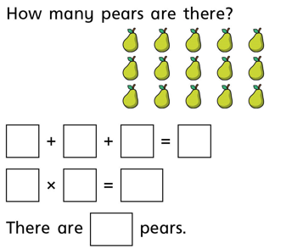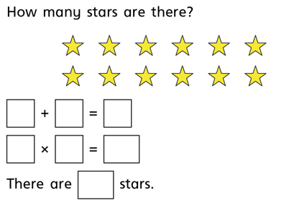
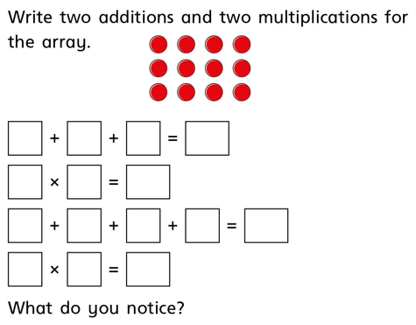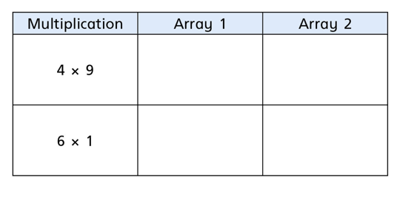
22.1.21
Doubling numbers
