Monday 1st February 2021
No live session
Complete the two tally activities below during the video.
Then, complete your independent tally chart by finding out which fruit your family and friends like the best.

Video activities:
Tally
Cars
Bikes

Tally
Children
Adults

Task
Our Favourite Fruit
Give 5 choices of fruit and ask your family and friends what they like best.
Fruit | Tally | Total

_______________________ was the most popular fruit.

_______________________ was the least popular fruit.
Tuesday 2nd February 2021
To draw tally charts.
Complete tally for pencils, rubbers and rulers.
Then complete tally for horses, dogs, chickens, frogs, sheep.
 | Tally | Total
Pencils
Rubbers
Rulers

 | Tally | Total
Horses
Dogs
Chickens
Frogs
Sheep

Year 2’s Favourite Colours
Let’s find out and fill in the tally chart together!
 | Tally | Total

Wednesday 3rd February 2021
To draw a pictogram (1:1)

Complete the pictogram watching the virtual walk.
Key = 1 animal
Birds
Frogs
Octopuses

Now, let’s complete a pictogram of our classes favourite sports!

Year 2’s Favourite Sports
Key = 1 animal

_______________________ is the most popular sport.
_______________________ is the least popular sport.
I like _______________________ the most.
Thursday 4th February 2021
To interpret pictograms.
How many goals did Mo score? __________
How many goals did Jack and Alex score altogether? _____________
How many more goals did Rosie score than Whitney? ___________________
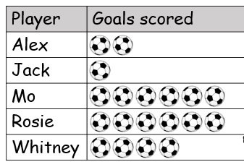

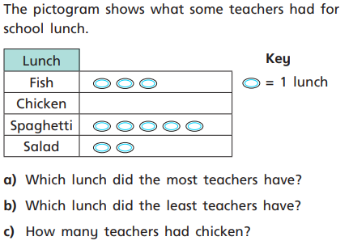

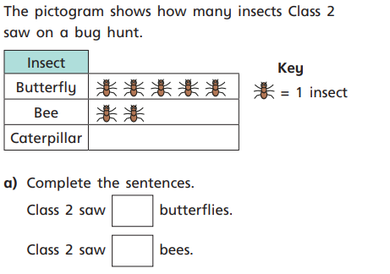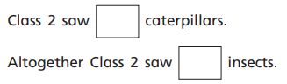

Second Sheet
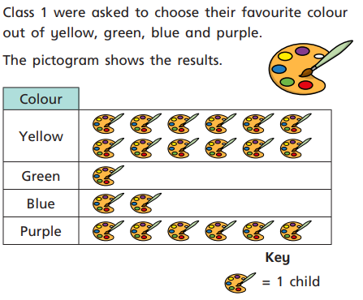
How many children chose yellow? ______
How many children chose green? _______
How many children chose blue and green altogether? _______________
How many more children chose blue than green? _________________

Super Challenge
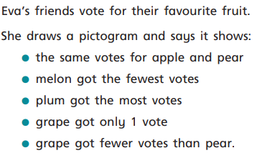
Key = 1 vote
Apple
Pear
Melon
Plum
Grape

