22.2.21
Shape Hunt
Look around you for these shapes, what objects can you see? Write down or draw the different things you find.
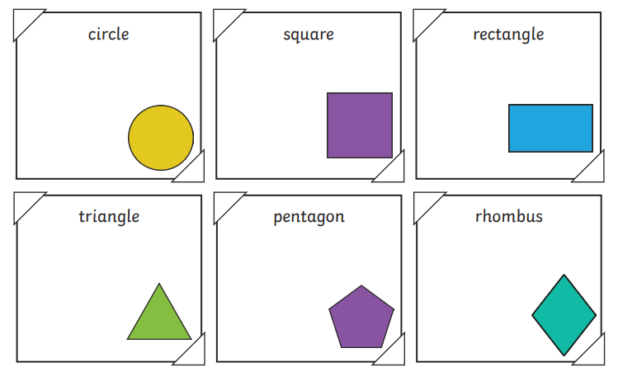
Now create a tally chart to show the number of times you saw the different shapes around you.
Tally
Circle
Square
Rectangle
Triangle
Pentagon
Rhombus

What was the most common shape?__________________________________
What was the least common shape? ___________________________________
23.2.21
To use a pictogram to complete a bar chart.
Favourite Colour
Green | 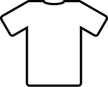
Red
Yellow
Blue
Purple
Each shirt = 1 child
Green Red Yellow Blue Purple

Questions
Which colour was the most popular?

Which colour was the least popular?

How many children were asked altogether?

What is the difference between the number of children who liked green and the number of children who liked red?

How many children liked red and yellow the best?

24.2.21
To read a pictogram and complete stem sentences.
Favourite ice cream flavour | Number of children
vanilla | 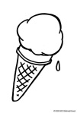
chocolate
mint
toffee
bubblegum
strawberry
= 2 child
There are ______ children altogether.
____ children liked mint the most.
____ children liked toffee the most.
_____ children liked strawberry the most.
_____ children liked mint and toffee.
_____ children liked strawberry and chocolate.
________________ was the least favourite flavour.
________________ was the favourite flavour.
______ children liked strawberry, mint, chocolate and bubblegum.

25.2.21
To recognise 2d and 3d shapes
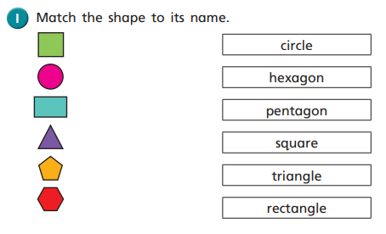
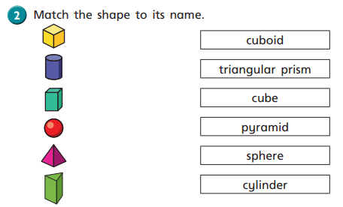
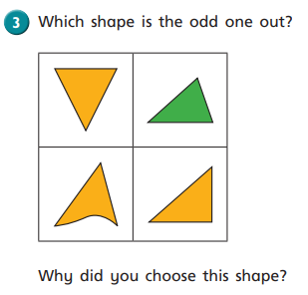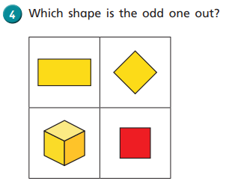

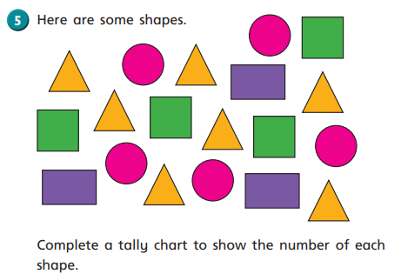
Shape | Tally
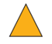

26.2.21 To count the sides of 2d shapes.
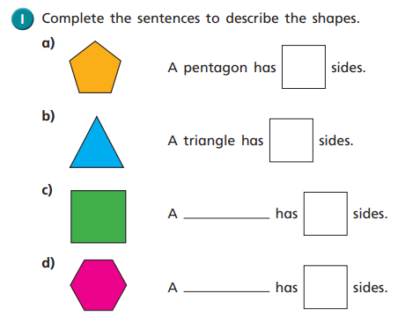
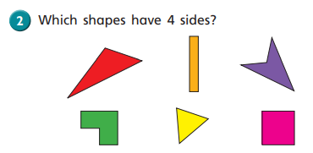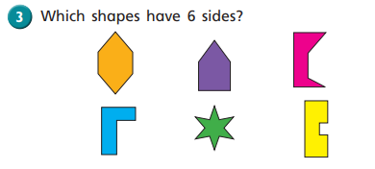
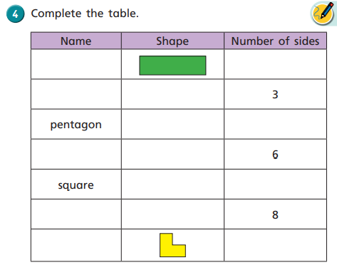

Friday Investigation
Use anything straight! Pens, pencils or strips of cut up paper!

Draw the shapes you have made.

What if you had 12 lolly sticks?
Draw the shapes you have made.

