1. transformed
2. resembles
3. vengefully
4. wove
5. gracious
6. winced
7. appeased
8. accrued
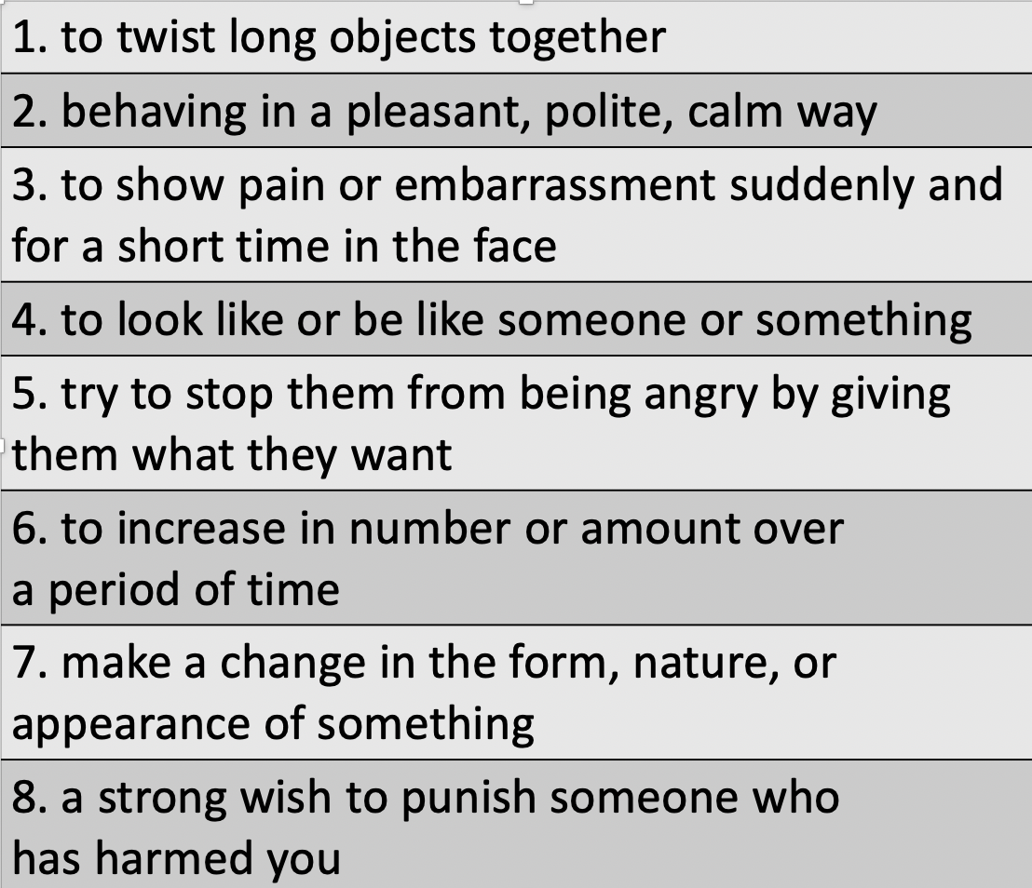
Match the definitions
- Vocabulary

