MAYAN LEGENDS: “How the king of birds was chosen”
Long ago, In Maya Land, flowers, birds, trees, butterflies and mammals appeared in other colors and shapes than those of today. Halach-Uinic, the Great Spirit guarded over all the Maya World.
His will was law. One day be grew tired of the constant chatter and fighting among the birds. At a meeting in the center of the forest, he announced that the birds must choose a king to keep peace.
Of course, each bird thought it possessed the best qualifications. Col-pol-che, the cardinal sang, “Look at me. No one else is bright red and so beautiful. All the birds admire me. I should he king.” And he strutted in front of the impressed bird audience, fluttering his wings and raising his crest.
X-col-col-chek, the tropical mockingbird, trilled out, “I’m the only bird with such a lovely voice. Everyone listens to me.” Enlarging his throat, X-col gave a short performance of enchanting and complicated melodies. This was a tremendous sensation among the birds and went far in convincing them that the mockingbird should be king.
Then the wild turkey, Cutz, strode into the circle and gobbled, “There’s no doubt that I should be king because I’m the biggest and strongest bird. With my size and strength, I can stop fights and also defend any bird. You need a powerful king. I’m the one!”
And so, throughout the day various birds displayed their qualities. The only one that kept quiet was Kukul, the quetzal. This bird was very ambitious and proud. He had elegant manners and a graceful body, but his plumage was shabby. Kukul thought it would be impossible to be chosen as king while he was dressed so poorly.
After thinking carefully he flew over to his friend, Xtuntun-kinil, the roadrunner. “I want to make you a proposition, my dear friend,” he said. “Your feathers are so handsome as any bird’s here, but you are too busy with your work as messenger of the roads to become king. Also, I don’t think you posses quite the flair and sophistication that is necessary for this job. I’m afraid I can’t loan these qualities to you, but you could loan me your feathers just for this occasion. After I’m elected king, I’ll share the wealth and honors with you.”
It was a tempting offer, yet the roadrunner did not feel too eager to part with his plumage. Kukul kept persuading and assuring Xtuntun of his integrity and fine intentions. He painted bright visions of the riches to come. At last, he convinced his trusting friend.
One by one, the feathers disappeared from Xtuntsun’s body and the clever quetzal adjusted them to his own. Within minutes, they had multiplied and grown so that the ambitious bird was attired in the most splendid costume imaginable. Kukul’s tail hung in a sweeping curve of jade green plumes. His body shimmered with soft, iridescent hues of blue and green like the Maya sky and jungle. His breast blazed with the colors of a tropical sunset. And his beak turned yellow as corn.
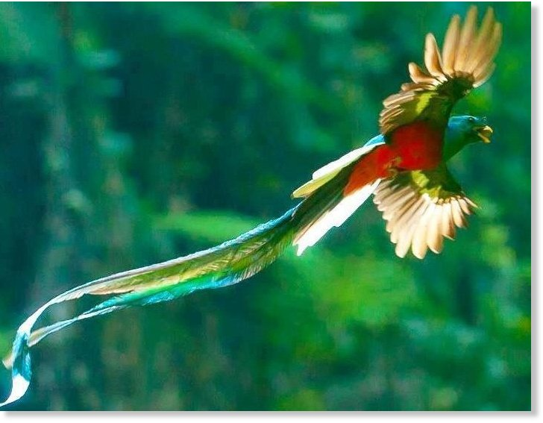
Swinging his exquisite 4-foot tail in an arc, the bold bird promenaded into the circle where the birds of Maya Land were congregated. His entrance caused a hush. Then cries of “Bravo,” “Hurrah,” “Oh” and “Ah” filled the forest.
Halach-Uinic was very pleased with the miraculous change from the quiet, drab bird to this radiant, proud creature before him. Calling the audience to order, the Great Spirit declared: “I name the quetzal to be king or the birds.”
A loud applause followed this announcement and each bird hopped over to the quetzal with congratulations.
Finally, they all flew home and left Kukul to begin his new duties. He found himself extremely busy so he never had time to return the borrowed feathers. In fact, he forgot all about his promise to the roadrunner.
One day, a group of birds noticed that the roadrunner had not appeared in several days. In fact, no one had seen him since the great election. They began to suspect Kukul of some trick, so they organized a search. Deep into the forest behind a bush, they found Xtuntun-kinil, naked, trembling with cold and almost dead of hunger. Quickly, the birds gave him some black (honey drink) to help him recover.
When he was able, the roadrunner told them of the cruel deception played by the quetzal. He kept saying, “Puhuy? Puhuy?” which means “Where is he? Where is he?” in the Maya language. All the birds felt sorry for the roadrunner and decided each should donate a few feathers to cover him. The mockingbird even sang a jolly song to raise the courage of the embarrassed bird.
That is why today the roadrunner’s feathers are so oddly colored and varied in pattern, and why he always watches the Maya roads. He is still searching for the quetzal that took away his plumage and still running anxiously in front of travelers asking, “Puhuy? Puhuy?”

