Tzunuum, the hummingbird, was created by the Great Spirit as a tiny, delicate bird with extraordinary flying ability. She was the only bird in the kingdom who could fly backwards and who could hover in one spot for several seconds. The hummingbird was very plain. Her feathers had no bright colors, yet she didn’t mind. Tzunuum took pride in her flying skill and was happy with her life despite her looks.
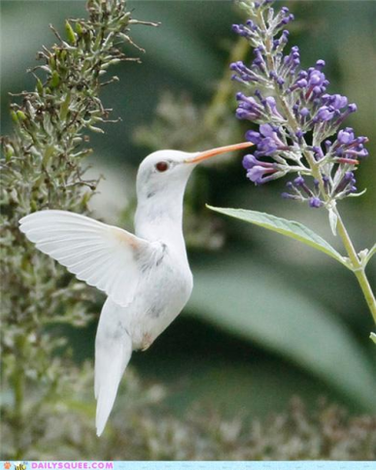

When it came time to be married, Tzunuum found that she had neither a wedding gown nor a necklace. She was so disappointed and sad that some of her best friends decided to create a wedding dress and jewelry as a surprise.
Ya, the vermilion-crowned flycatcher wore a gay crimson ring of feathers around his throat in those days. He decided to use it as his gift. So he tucked a few red plumes in his crown and gave the rest to the hummingbird for her necklace. Uchilchil, the bluebird, generously donated several blue feathers for her gown. The vain motmot, not to be outdone, offered more turquoise blue and emerald green. The cardinal, likewise, gave some red ones.
Then, Yuyum, the oriole, who was an excellent tailor as well as an engineer, sewed up all the plumage into an exquisite wedding gown for the little hummingbird. Ah-leum, the spider, crept up with a fragile web woven of shiny gossamer threads for her veil. She helped Mrs. Yuyum weave intricate designs into the dress. Canac, the honeybee, heard about the wedding and told all his friends who knew and liked the hummingbird. They brought much honey and nectar for the reception and hundreds of blossoms that were Tzunuum’s favorites.
Then the Azar tree dropped a carpet of petals over the ground where the ceremony would take place. She offered to let Tzunuum and her groom spend their honeymoon in her branches. Pakal, the orange tree, put out sweet-smelling blossoms, as did Nicte, the plumeria vine. Haaz (the banana bush), Op the custard apple tree) and Pichi and Put (the guava and papaya bushes) made certain that their fruits were ripe so the wedding guests would find delicious refreshments. And, finally, a large band of butterflies in all colors arrived to dance and flutter gaily around the hummingbird’s wedding site.
When the wedding day arrived, Tzunuum was so surprised, happy and grateful that she could barely twitter her vows. The Great Spirit so admired her humble, honest soul that he sent word down with his messenger, Cozumel, the swallow, that the hummingbird could wear her wedding gown for the rest of her life. And, to this day, she has. How did the humility of one long-ago hummingbird cause its descendants to sport brilliant colors?

