Tuesday 26th January 2021
To describe a setting (using senses).
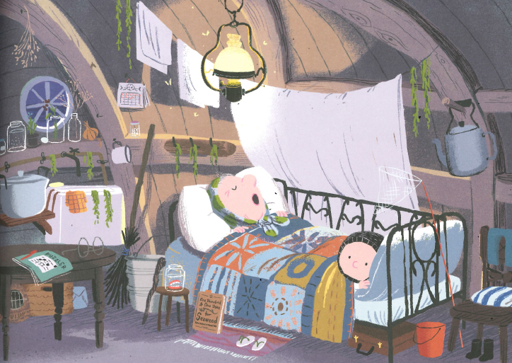
See | Hear | Feel | Smell

Now write sentences below. Try to include similes.
_______________________________________________________________________________________________________________________________________________________________________________________________________________________________________________________________
______________________________________________________________________________________________________
Wednesday 27th January 2021
To use similes to describe objects.

_________________________________________________
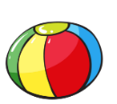_________________________________________________
_________________________________________________
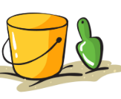_________________________________________________
______________________________________________________
____________________________________________________
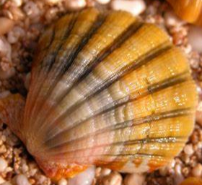___________________________________________________

Thursday 28th January 2021
To record facts about hummingbirds.

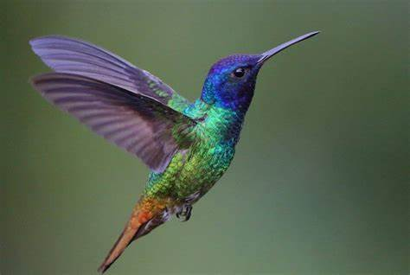

Friday 29th January 2021
To write in first person.
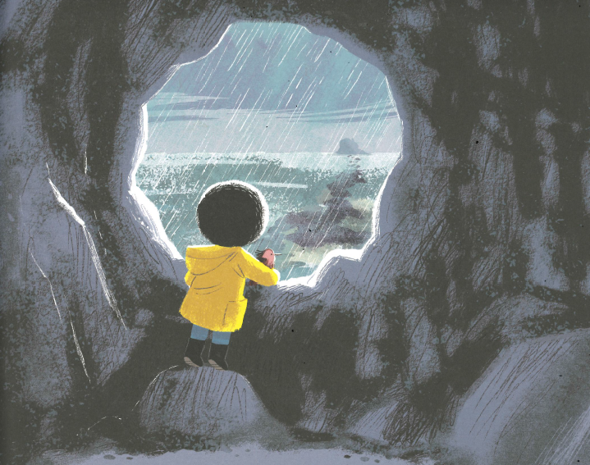
I feel _____________________ because __________________________
___________________________________________________________
I feel _____________________ so _______________________________
___________________________________________________________
I think _____________________ because __________________________
___________________________________________________________
I think _______________________ so_____________________________
___________________________________________________________
I hope _______________________ because________________________
___________________________________________________________
I hope_______________________ so_____________________________
___________________________________________________________

