Monday 8th February 2021

No live session: To use the suffixes er and est.

|  |  |  |  |
| --- | --- | --- | --- |
| **Just add er/est** | **Double the last letter and add er/est** | **Drop the e and add er/est** | **Change the y to an i and edd er/est** |
| slow 🡪  fast 🡪  tall 🡪  short 🡪 | big 🡪  flat 🡪  hot 🡪  thin 🡪 | cute 🡪  nice 🡪  late 🡪  large 🡪 | happy 🡪  tidy 🡪  silly 🡪  easy 🡪 |

Now write sentences using er and est words.

_____________________________________________________________________________________________________________________________________________________________________________________________________________________________________________________________________________________________________________________________________________________________________________________________________________________________

Tuesday 9th February 2021

To describe a setting.

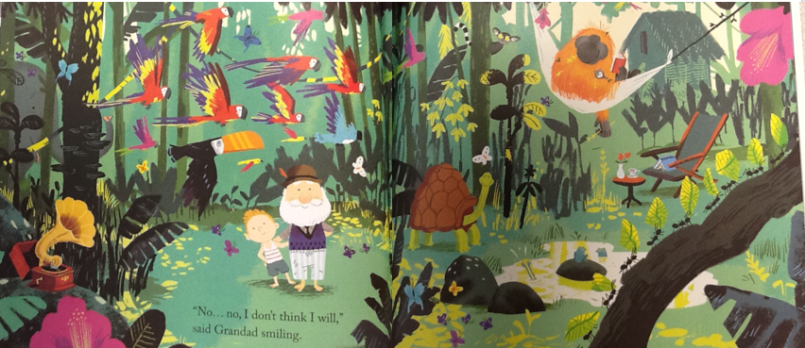

|  |  |  |
| --- | --- | --- |
| **Adjective** | **Noun** | **Verb** |
|  |  |  |
|  |  |  |
|  |  |  |
|  |  |  |
|  |  |  |
|  |  |  |
|  |  |  |

Now put your ideas in sentences.

_______________________________________________________________________________________________________________________________________________________________________________________________________________________________________________________________________________________________________

Wednesday 10th February 2021

To write a letter in role.

Dear ___________________________________,

I am having the best time with grandad!

When we arrived on the island, I saw _______________________________

___________________________________________________________

After that, __________________________________________________

___________________________________________________________

Then, _______________________________________________________

___________________________________________________________

The best thing was when ________________________________________

___________________________________________________________

I really liked _________________________________________________

___________________________________________________________

I hope ______________________________________________________

___________________________________________________________

See you soon.

Love From, Syd xxxx

Thursday 11th February 2021

To design an island and describe it.

|  |
| --- |
|  |

On my island there are __________________________________________

You will see __________________________________________________

___________________________________________________________

If you are quiet, you will hear _____________________________________

___________________________________________________________

If you walk North, you will find____________________________________

___________________________________________________________

If you walk South, you will find ____________________________________

___________________________________________________________

If you go out at night, you will see __________________________________

___________________________________________________________