Tuesday 23rd February 2021
To describe a setting.
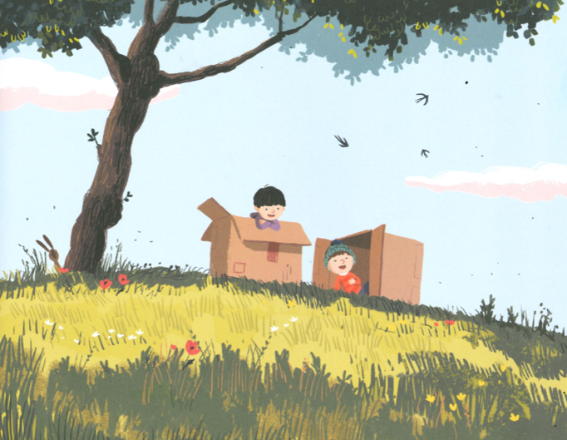

Nouns | Adjectives | Verbs
Now put your ideas in sentences.
_______________________________________________________________________________________________________________________________________________________________________________________________________________________________________________________________________________________________________

Wednesday 24th February 2021
To describe a good friend.

I try to be a good friend by…
A good friend is…
A good friend does not…
A good friend does…

Thursday 25th February 2021
To write about a character’s feelings.
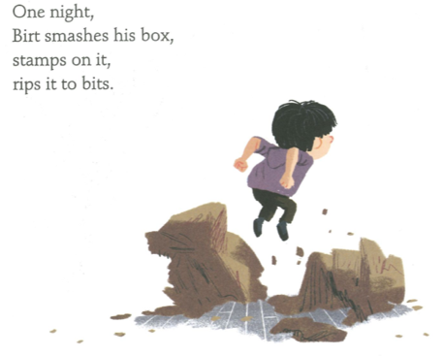

He is feeling _________ because _________________________________
___________________________________________________________
He is feeling _________ because _________________________________
___________________________________________________________

___________________________________________________________
___________________________________________________________
___________________________________________________________
___________________________________________________________
___________________________________________________________
___________________________________________________________
___________________________________________________________
___________________________________________________________

Friday 26th February 2021

To write thought and speech bubbles

