Monday 1.3.21 No live session
Highlight and label the features along with the video lesson.
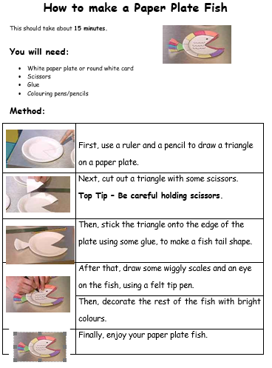

Tuesday 2nd March 2021
To use time connectives and bossy verbs,

_________________________  _________________________  _________________________ | _________________________  _________________________  _________________________ | _________________________  _________________________  _________________________
_________________________  _________________________  _________________________ | _________________________  _________________________  _________________________ | _________________________  _________________________  _________________________

Wednesday 3rd March
To plan an instruction text.
How to wash a woolly mammoth
What you will need:

Method:
First,

Next,

After that,

Later,

Then,

Finally.

TOP TIP: | BE CAREFUL:

Thursday 4th March 2021
To write an instruction text.
How to wash a woolly mammoth
What you will need:
- ________________________________
- ________________________________
- ________________________________
- ________________________________

Method:
First,______________________________________________________
__________________________________________________________
Next,______________________________________________________
__________________________________________________________
After that,_________________________________________________
___________________________________________________________
Later, __________________________________________________
___________________________________________________________
Then,_______________________________________________________

Finally,______________________________________________________
___________________________________________________________

TOP TIP:
BE CAREFUL:
_____________________________
_____________________________
_____________________________
_____________________________
_____________________________
_____________________________

Friday 5th March
WORLD BOOK DAY
Activity 1: Design a New Little Miss or Mr Men character and describe it!
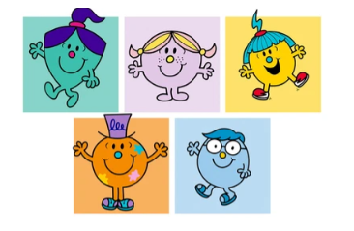

My character is called: ______________________________________________
My character likes _________________________________________________
________________________________________________________________
My character doesn’t like _____________________________________________
________________________________________________________________
I chose this character because ________________________________________
_________________________________________________________________

World Book Day Activity 2
Following the Masterclass with Jonny Duddle, we will describe the Gigantosaurus!
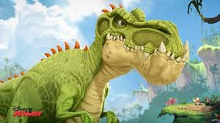

_______________________________________________________________
_______________________________________________________________
_______________________________________________________________
_______________________________________________________________
_______________________________________________________________
_______________________________________________________________
_______________________________________________________________

_______________________________________________________________
_______________________________________________________________
_______________________________________________________________
_______________________________________________________________
_______________________________________________________________
_______________________________________________________________
_______________________________________________________________

Activity 3 – World Book Day
I will set the children off to do this during the last live session. I will also run a little book themed quiz!
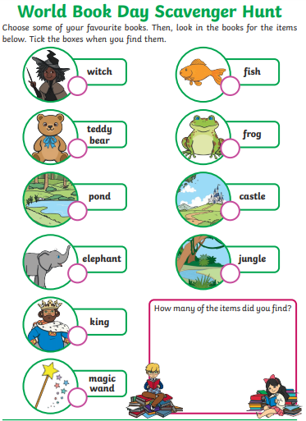

SELF LEAD OPTIONS FOR ANY TIME
Listen to some of these Audiobooks
https://www.worldbookday.com/world-of-stories/

Art Activity
Cardboard Tube Characters – design and make your own tube character!

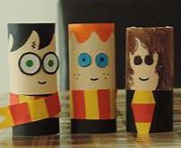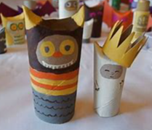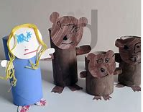
Share a Story Live
https://www.worldbookday.com/events/
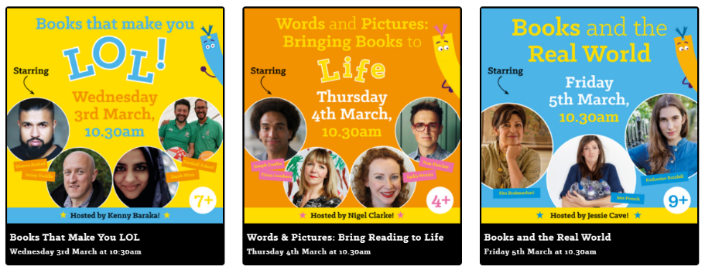
These will be on WBD Youtube channel so you don’t have to watch it that day!
Design and make a 3D story scene using a cereal box.
