[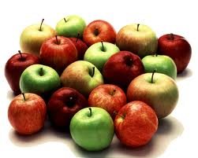](http://www.google.co.uk/imgres?q=apples&um=1&safe=active&rlz=1T4AURU_enGB503GB503&hl=en&tbm=isch&tbnid=s_Vd4Cid4YYmDM:&imgrefurl=http://www.gomammoth.co.uk/the-clubhouse/2012/07/16/an-apple-a-day&docid=PlzCm7Et_8qzIM&imgurl=http://www.gomammoth.co.uk/media/BAhbBlsHOgZmIh01MDA0MGYwNTZmNWU2YTAwMDIwMTlhNTg/apples.png%3Fsuffix%3D.png&w=750&h=600&ei=kR6nUvDUDIeqhAfckoGADA&zoom=1&iact=hc&vpx=716&vpy=157&dur=349&hovh=201&hovw=251&tx=101&ty=139&page=1&tbnh=140&tbnw=176&start=0&ndsp=15&ved=1t:429,r:12,s:0,i:119)[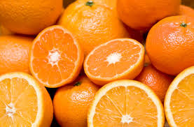](http://www.google.co.uk/imgres?q=oranges&um=1&safe=active&rlz=1T4AURU_enGB503GB503&hl=en&tbm=isch&tbnid=yQrFp1aGSXgSUM:&imgrefurl=http://www.howardandrewjones.com/uncategorized/oranges-smoranges&docid=i9TJeluU7y_3FM&imgurl=http://www.howardandrewjones.com/wp-content/uploads/2013/07/oranges.jpg&w=500&h=328&ei=-h6nUo7bMLGe7AaW1IHAAg&zoom=1&iact=hc&vpx=381&vpy=48&dur=508&hovh=182&hovw=277&tx=162&ty=46&page=1&tbnh=143&tbnw=223&start=0&ndsp=19&ved=1t:429,r:15,s:0,i:128)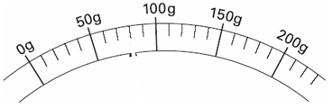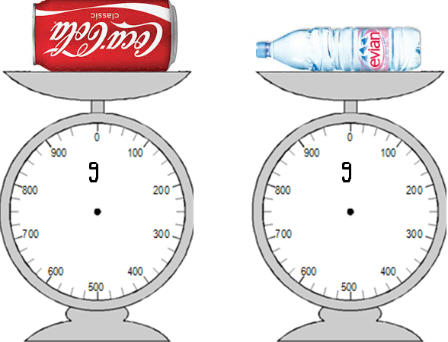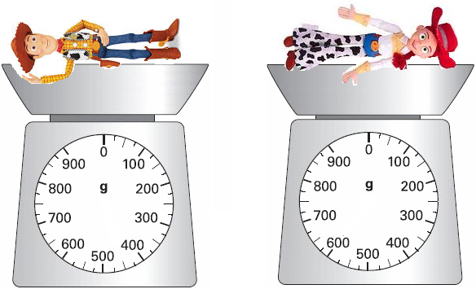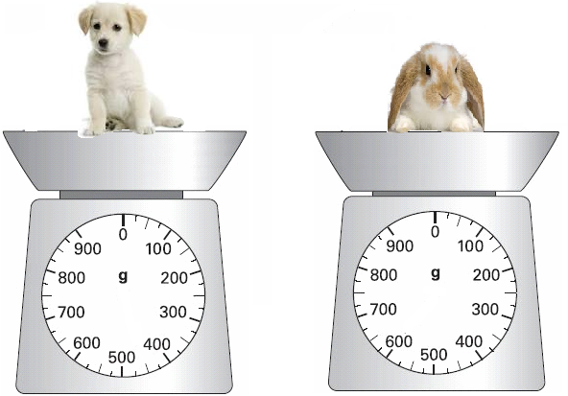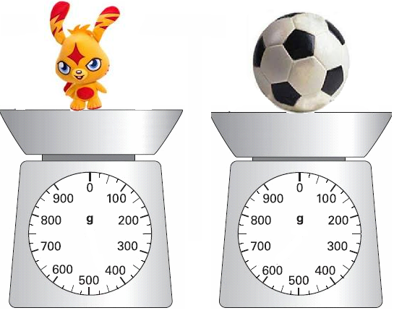

The oranges are

than the apples.

g

g

g

g

g

g

The is heavier than the .

is heavier than .

water

coke

Woody

Jesse

Bunny

Puppy

The is heavier than the .

g

g

Football

Monster

The is lighter than the .

g

g